

Defining the built environment considering people with disabilities: Building a Canadian-focused database of anthropometric space requirements

Final Report:
Accessibility Standards Canada, Advancing Accessibility Standards Grants and Contributions Research Program. ASC-22/23-027-C

March 31, 2026

Executive summary

The overarching goal of this project was to generate a Canadian-focused evidence base on the static and functional space requirements and operating control installation heights of mobility assistive device users, with the intent of informing the development and revision of accessibility codes and standards for the Canadian built environment. The work responds to the need for empirical, updated Canadian data to guide inclusive design practices that reflect the real-world dimensions, maneuverability, and functional capacities of mobility assistive device users.

Four specific aims guide the project. Aim 1 was to develop a comprehensive database of functional space requirements and operating control installation parameters for Canadian adult wheeled mobility device (WhMD) users. Aim 2 explored the lived experiences of individuals who use WhMDs in Canada, with particular attention to how spatial design influences maneuverability, lived experiences, and use of public environments. Aim 3 summarized the current state of knowledge related to design recommendations for children who use WhMDs. Aim 4 synthesized study findings into a set of evidence-informed recommendations to improve accessibility in the Canadian built environment.

Over a 2 year data collection period, data were collected from 222 assistive device users, across different mobility groups, including manual wheelchair users, power wheelchair users, mobility scooter users, walker/rollator users, and individuals travelling with guide dogs. While we collected data from the above described groups, the primary focus of our analysis was WhMD users, as they generally drive the largest space requirements, and therefore represent a critical reference population for accessibility standards development. However, our recommendations were developed to ensure that other user groups would not be negatively impacted or unintentionally excluded as a result of the recommended space requirements.

For the laboratory component of this project, we collected static measurements (e.g. device and user dimensions) and functional measurements (e.g. turning areas, reaching tasks) of users with their devices. Data are reported from our collected dataset, along with statistical estimates based on population-level distributions of devices in Canada. Our results are compared with current Canadian accessibility codes and standards, with recommendations based on inclusion of the 95th percentile of WhMD users in Canada. In addition to quantitative laboratory measures, lived-experience data (collected through interviews with WhMD users) highlight how space designs affect independence, safety, and usability in public spaces. Finally, although primary data collection focused on adults, this project also synthesized available evidence to inform guidance for spaces where considerations for children should be made.

Overall, this project provides a robust, Canadian-focused evidence base to support accessibility codes and standards development. By integrating static measurements, functional performance data, and lived experience perspectives, the findings offer evidence-informed recommendations to enhance the accessibility, usability, and inclusivity of the built environment for Canadians with disabilities. The data can support harmonization across existing standards and building codes, reduce barriers, and promote inclusive design. Beyond buildings and public spaces, these findings may be used to inform the design of transportation systems, products and furniture. Applying this evidence broadly will help ensure that both environments and the products people rely on are safe, functional, and inclusive for people with disabilities.

Authorship and contributions

The research team
Alison C. Novak, Senior Scientist, KITE Research Institute-University Health Network; Associate Professor, University of Toronto
David J. Houston, Research Associate, KITE Research Institute-University Health Network
Iris C. Levine, Scientific Associate, KITE Research Institute-University Health Network
Ranna P. Napoles, Research Analyst, KITE Research Institute-University Health Network
Hanaan Deen, Research Analyst, KITE Research Institute-University Health Network
Tilak Dutta, Senior Scientist, KITE Research Institute-University Health Network; Associate Professor, University of Toronto
Mary Forhan, Professor, University of Toronto
Timothy Ross, Scientist, Bloorview Research Institute-Holland Bloorview Kids Rehabilitation Hospital; Assistant Professor, University of Toronto

Acknowledgements

We would like to thank our valued project partners for their involvement in this work. Partners include the Canadian Disability Foundation, Obesity Canada Foundation, Rick Hansen Foundation, and the StopGap Foundation. We would also like to thank all participants for generously providing their time and shared experiences. Finally, we are grateful to the Accessibility Standards Canada Grants and Contributions program for funding this work.

Abbreviations:

WhMD: Wheeled mobility device
CSD: Canadian Survey on Disability
NBCC: National Building Code of Canada
CSA: Canadian Standards Association
ASC: Accessibility Standards Canada
Min: Minimum
SD: Standard deviation
%ile: Percentile
Max: Maximum

Table of contents
Executive summary 2
Authorship and contributions 4
List of tables 8
List of Figures 14
1. Introduction 16
1.1. Prevalence of mobility devices 16
1.2. Canadian accessibility standards related to the built environment 17
1.3. Evidence guiding the development of accessibility requirements for the built environment 18
2. Project objectives and approach 19
2.1. Report overview 19
Part A: Adult mobility device users: developing a database of anthropometric and functional measurements 20
1. Summary of existing built environment accessibility codes and standards 20
2. Evaluation of functional space requirements and anthropometric measures 29
2.1. Participant recruitment 29
2.1.1. Demographics and mobility device use 29
2.1.2. Determining anthropometric measurements 29
2.1.3. Determining minimum space requirements 30
2.1.4. Determining functional reach ranges 32
2.2. Boostrapping analysis 32
3. Results 35
3.1. Characteristics of adult mobility assistive device users 35
3.1.1. Age, sex, and gender 35
3.1.2. Social identity 35
3.1.3. Disability status 35
3.1.4. Experience with mobility device 35
3.2. Static measurements of adult mobility assistive device users 38
3.2.1. Clear floor space for occupied devices 38
3.2.2. Summary of recommendations, clear floor space 42
3.2.3. Clearances 43
3.2.4. Summary of recommendations, seat, knee, and toe clearances 48
3.2.5. Occupied device weight 49
3.2.6. Seated eye height 49
3.2.7. Summary of recommendations, seated eye height 51
3.3. Functional maneuvers of adult mobility assistive device users 52
3.3.1. Turning area 52
3.3.2. Impact of entry/exit location on turning area 54
3.3.3. Summary of recommendations, turning area for public spaces 58
3.3.4. Width of the path of travel 59
3.3.5. Summary of recommendations, path of travel 64
3.4. Functional reaching ranges of adult mobility assistive device users 66
3.4.1. Unobstructed Reaches 67
3.4.2. Summary of Recommendations, Unobstructed Reach Ranges 75
3.4.3. Obstructed reaches 76
3.4.4. Summary of Recommendations, Obstructed Reach Ranges 82
4. Implications of space requirements among adult wheeled mobility device users: qualitative report 84
4.1. Qualitative methods 84
4.2. Participant demographics 84
4.3. Summary of qualitative findings 85
Part B: Pediatric mobility device users: summary of the state of knowledge related to guidelines for pediatric space design 90
1. Environmental scan of literature regarding accessibility guidelines and standards for children and youth 90
1.1. Search strategy 90
1.2. Eligibility criteria and selection 91
1.3. Data extraction 91
1.4. Results, environmental scan 92
1.4.1. Design requirements in the built environment for pediatric populations 93
1.4.2. Additional considerations in current standards specific to pediatric design 96
1.4.3. Comparison of pediatric-specific measures and broader recommendations for inclusive space design of the built environment 96
2. Key sources for guiding space design and operating control recommendations for children and youth 97
2.1. Resources guiding existing accessibility requirements for pediatric-specific space design 97
2.2. Rapid literature review to guide pediatric-specific space designs 98
2.3. Results, rapid literature review and review of grey literature 99
2.4. Summary of findings, guidance for measurements applied to pediatric-specific spaces and operating controls. 101
Part C: Summary of recommendations, limitations, and future directions 102
1. Overview of findings 102
1.1. Defining minimum functional space and operating control placement in the built environment 103
1.2. Value of population-based bootstrapping 105
1.3. Relevance to existing Canadian codes and standards 105
1.4. Limitations and future directions 106
References 108
Appendix A: Configuration of tested wheeled mobility devices 113
Appendix B: Unoccupied vs. occupied measures of device width and length 114
B.1. Unoccupied device width 114
B.2. Unoccupied device length 115
Appendix C: Maneuvering space for residential and private dwellings 117
Appendix D: Turning and space demands of 3- and 4-wheel mobility scooters 121
Appendix E: Tolerances (distance from wall) associated with unobstructed functional reaching 123
Appendix F: Reach ranges over a 600 mm depth obstruction 125
F.1. Maximum reach heights over 600 mm depth obstruction for a touch task 125
F.2. Maximum reach heights over 600 mm depth obstruction for a grasp task 126
Appendix G: Confidence intervals for bootstrapping analysis 128
G.1. Confidence intervals for static measurements 128
G.2. Confidence intervals for functional maneuvers 131
G.3. Confidence intervals for reaching ranges 133

List of Tables

Table 1. Mobility device use among Canadians, summary of data from the Canadian Survey on Disability (2022) from Statistics Canada 17
Table 2. Summary of select codes and standards across Canada (and internationally) defining accessible clear floor space and clearance requirements 21
Table 3. Summary of select codes and standards across Canada (and internationally) defining accessible space requirements for circulation 23
Table 4. Summary of select codes and standards across Canada (and internationally) defining accessible design elements guided by reaching ranges 26
Table 5. Characteristics of adult mobility assistive device users 36
Table 6. Occupied device width (mm) 39
Table 7. Occupied device length (mm) 41
Table 8. Clear floor area (m²) 41
Table 9. Maximum width and length (mm) that would be accommodated by the 95th percentile occupied area 42
Table 10. Seat height (mm) 44
Table 11. Seat depth (mm) 45
Table 12. Knee height (mm) 46
Table 13. Knee depth (mm) 46
Table 14. Toe height (mm) 47
Table 15. Toe depth (mm) 47
Table 16. Occupied device weight (kg) 49
Table 17. Eye height range (mm) 50
Table 18. Eye height percentiles (mm) 50
Table 19. Continuous turning area (mm) 53
Table 20. Turning area for a three-point turn (mm) 54
Table 21. Turning area with a corner entry/exit (mm) 56
Table 23. Clear width path of travel (mm) 60
Table 24. Corridor width to perform a 90-degree or L-Turn (mm) 62
Table 25. U-Turn around a barrier (mm) 63
Table 26. Unobstructed forward reaching heights for a touch task (mm) 69
Table 27. Unobstructed lateral reaching heights for a touch task when reaching to the left side (mm) 70
Table 28. Unobstructed lateral reaching heights for a touch task when reaching to the right side (mm) 71
Table 29. Unobstructed forward reaching maximum heights for a grasp task (mm) 72
Table 30. Unobstructed lateral reaching maximum heights for a grasp task when reaching to the left side (mm) 72
Table 31. Unobstructed lateral reaching maximum heights for a grasp task when reaching to the right side (mm) 73
Table 32. Maximum forward reaching heights over a 500 mm depth obstruction, for a touch task (mm) 77
Table 33. Maximum lateral reaching maximum heights when reaching to the left over a 500 mm depth obstruction (mm), for a touch task 78
Table 34. Maximum lateral reaching maximum heights when reaching to the right over a 500 mm depth obstruction (mm), for a touch task 78
Table 35. Maximum forward reaching heights over a 500 mm depth obstruction, for a grasp task (mm) 79
Table 36. Maximum lateral reaching maximum heights when reaching to the left over a 500 mm depth obstruction (mm), for a grasp task 79
Table 37. Maximum lateral reaching maximum heights when reaching to the right over a 500 mm depth obstruction (mm), for a grasp task 80
Table 38. Summary of participant demographics included in the qualitative interviews 84
Table 39. Summary of guidance for pediatric-specific measurements in reviewed codes and standards 94
Table 40. Summary of recommendations for space and operating control built environment requirements and suggested application in accessibility standards 104
Table A-1. Description of mobility device configurations 113
Table A-2. Unoccupied device width (mm) 115
Table A-3. Unoccupied device length (mm) 116
Table A-4. Percentage change from laboratory-derived unoccupied to occupied measurements 116
Table A-5. Continuous Turning Area (mm), without imposed minimum space restriction 117
Table A-6. Turning area for a three-point turn (mm), without imposed minimum space restriction 118
Table A-7. Turning area with a corner entry/exit (mm), without an imposed minimum space restriction 118
Table A-8. Turning area with a middle entry/exit (mm), without an imposed minimum space restriction 119
Table A-9. Turning area (mm) for 3-wheel (MS_3W) vs. 4-wheel scooters (MS_4W) 121
Table A-10. Clear turning width for 3-wheel vs. 4-wheel scooters 122
Table A-11. Unobstructed Reach Tolerances (device/person distance from wall) (mm) 123
Table A-12. Maximum forward reaching heights over a 600 mm depth obstruction, for a touch task (mm) 125
Table A-13. Maximum lateral reaching heights when reaching to the left over a 600 mm depth obstruction (mm), for a touch task 125
Table A-14. Maximum lateral reaching maximum heights when reaching to the right over a 600 mm depth obstruction (mm), for a touch task 126
Table A-15. Maximum forward reaching heights over a 600 mm depth obstruction, for a grasp task (mm) 126
Table A-16. Maximum lateral reaching maximum heights when reaching to the left over a 600 mm depth obstruction (mm), for a grasp task 127
Table A-17. Maximum lateral reaching maximum heights when reaching to the right over a 600 mm depth obstruction (mm), for a grasp task 127
Table A-18. Confidence intervals for the unoccupied device width (mm) 128
Table A-19. Confidence intervals for the unoccupied device length (mm) 128
Table A-20. Confidence intervals for the occupied device width (mm) 128
Table A-21. Confidence intervals for the occupied device length (mm) 129
Table A-22. Confidence intervals for the clear floor area (m²) 129
Table A-23. Confidence intervals for the seat height (mm) 129
Table A-24. Confidence intervals for the seat depth (mm) 129
Table A-25. Confidence intervals for the knee height (mm) 129
Table A-26. Confidence intervals for the knee depth (mm) 130
Table A-27. Confidence intervals for the toe height (mm) 130
Table A-28. Confidence intervals for the toe depth (mm) 130
Table A-29. Confidence intervals for the eye height - minimum (mm) 130
Table A-30. Confidence intervals for the eye height - maximum (mm) 130
Table A-31. Confidence intervals for the continuous turning area (floor) (mm) 131
Table A-32. Confidence intervals for the three point turning area (floor) (mm) 131
Table A-33. Confidence intervals for the turning area, corner entrance (floor) (mm) 131
Table A-34. Confidence intervals for the turning area, middle entrance (floor) (mm) 131
Table A-35. Confidence intervals for the L-turn (mm) 132
Table A-36. Confidence intervals for the Barrier U-turn (mm) 132
Table A-37. Confidence intervals for the Clear width path of travel (mm) 132
Table A-38. Confidence intervals for the Continuous turning area, no restriction on minimum space (mm) 132
Table A-39. Confidence intervals for the three-point turning area, no restriction on minimum space (mm) 133
Table A-40. Confidence intervals for the corner entrance turning area, no restriction on minimum space (mm) 133
Table A-41. Confidence intervals for the turning area, middle entrance, no restriction on minimum space (mm) 133
Table A-42. Confidence intervals for the unobstructed forward touch – maximum reaching height (mm) 133
Table A-43. Confidence intervals for the unobstructed forward touch – minimum reaching height (mm) 134
Table A-44. Confidence intervals for the unobstructed forward grasp – maximum reaching height (mm) 134
Table A-45. Confidence intervals for the left unobstructed lateral touch – maximum reaching height (mm) 134
Table A-46. Confidence intervals for the left unobstructed lateral touch – minimum reaching height (mm) 135
Table A-47. Confidence intervals for the left unobstructed lateral grasp – maximum reaching height (mm) 135
Table A-48. Confidence intervals for the right unobstructed lateral touch – maximum reaching height (mm) 135
Table A-49. Confidence intervals for the right unobstructed lateral touch – minimum reaching height (mm) 135
Table A-50. Confidence intervals for the right unobstructed lateral grasp – maximum reaching height (mm) 136
Table A-51. Confidence intervals for the obstructed (500mm barrier) forward touch – maximum reaching height (mm) 136
Table A-52. Confidence intervals for the obstructed (500mm barrier) forward grasp – maximum reaching height (mm) 136
Table A-53. Confidence intervals for the left 500mm barrier lateral touch – maximum reaching height (mm) 136
Table A-54. Confidence intervals for the left 500mm barrier lateral grasp – maximum reaching height (mm) 137
Table A-55. Confidence intervals for the right 500mm barrier lateral touch – maximum reaching height (mm) 137
Table A-56. Confidence intervals for the right 500mm barrier lateral grasp – maximum reaching height (mm) 137
Table A-57. Confidence intervals for the obstructed (600mm barrier) forward touch – maximum reaching height (mm) 138
Table A-58. Confidence intervals for the obstructed (600mm barrier) forward grasp – maximum reaching height (mm) 138
Table A-59. Confidence intervals for the left 600mm barrier lateral touch – maximum reaching height (mm) 138
Table A-60. Confidence intervals for the left 600mm barrier lateral grasp – maximum reaching height (mm) 138
Table A-61. Confidence intervals for the right 600mm barrier lateral touch – maximum reaching height (mm) 139
Table A-62. Confidence intervals for the right 600mm barrier lateral grasp – maximum reaching height (mm) 139

List of Figures
Figure 1. Illustration of the various functional maneuvers completed by participants. a) Continuous (and non-continuous) turning in a bounded area; b, c) Non-continuous U-turn, with a fixed width entry/exit door centrally located (b) or located in the corner of the space (c); d) travel down a straight path; e) 90-degree or L-turn; f) turning around a barrier 32
Figure 2. Front-view image of a power wheelchair. The red, dashed arrows depict an example of the occupied measurement (e.g. from widest points on the person or device, with consideration of personal items and accessories) 39
Figure 3. Side-view image of a power wheelchair. The red, dashed arrows depict an example of the occupied measurement (e.g. from front-most to rear-most point of the person or device, with consideration of personal items and accessories) 40
Figure 4. Side-view image of a manual wheelchair. The red, dashed arrows depict an example of seat height (left) and seat depth (right). 44
Figure 5. Side-view image of a power wheelchair. The red, dashed arrows depict an example of knee height (left) and knee depth (right). 45
Figure 6. Side-view image of a power wheelchair. The red, dashed arrows depict an example of toe height (left) and toe depth (right). 47
Figure 7. Image of square space bounded by foam walls, used for continuous and non-continuous turning area. The walls are movable, allowing the space to progressively reduce in size 53
Figure 8. Image of square space bounded by foam walls. A left-corner entry/exit door is shown in the image, created using a pylon. The walls are movable, allowing the space to progressively reduce in size. The door width remained fixed at 850 mm. 55
Figure 9. Image of square space bounded by foam walls. A middle entry/exit door is shown in the image, created using two pylons. The walls are movable, allowing the space to progressively reduce in size. The door width remained fixed at 850 mm. 57
Figure 10. Image of straight corridor, bounded by foam walls. The walls are movable, allowing the corridor width to progressively reduce in size. 60
Figure 11. Image of corridor with a 90-degree turn, bounded by foam walls. The walls are movable, allowing the space to progressively reduce in size. 61
Figure 12. Image of square space bounded by three walls, with a centrally positioned barrier, bounded by foam walls. The walls are movable, allowing the space to progressively reduce in size. 63
Figure 13. Percentage of our total participant sample who were unable to complete the various reaching tasks (unobstructed reaching, left; 500 mm depth obstructed reaching, middle; 600 mm depth obstructed reaching, right). Data are summarized for All WhMD users, completing the touch (blue bars) and grasp (orange bars) tasks 66
Figure 14. Image of a manual wheelchair user performing an unobstructed lateral touch reach (left) and an unobstructed forward grasp reach (right). 68
Figure 15. Unobstructed reaching ranges of mobility device users (mm), for reaching in the following directions: forward (top), lateral reaching to the left (middle), and lateral reaching to the right (bottom). Data are presented for the reaching ranges associated with the touch task (blue bars) that accommodate 90%, 95%, and 99% of participants; all WhMD users are presented as a summary, with each device type also presented individually. The maximum reaching height for the grasp task (black line) is included for comparison. 74
Figure 16. Image of a manual wheelchair user performing an obstructed lateral touch reach (left) and an obstructed forward grasp reach (right). 77
Figure 17. Obstructed reaching ranges of mobility device users (mm), across a 500 mm depth barrier, for reaching in the following directions: forward (top), lateral reaching to the left (middle), and lateral reaching to the right (bottom). Data are presented for the reaching ranges associated with the touch task (blue bars) that accommodate 90%, 95%, and 99% of participants; all WhMD users are presented as a summary, with each device type also presented individually. The maximum reaching height for the grasp task (black line) is included for comparison. Horizontal dashed line represents table height (860mm). 81
Figure 18. Summary of documents reviewed for inclusion in the environmental scan 92
Figure A-1. Rear-view image of a scooter. The red, dashed arrows depict an example of the unoccupied measurement (e.g. from arm rest to arm rest, without considering the person) 114
Figure A-2. Side-view image of a scooter. The red, dashed arrows depict an example of the unoccupied measurement (e.g. from front-most to rear-most point on device, without considering the person) 115

Introduction
Anthropometry refers to the measurement of human body size, shape, and functional capacity. In the design of the built environment, anthropometric data serve as a foundation for defining space requirements that safely and effectively accommodate end users. Design standards often prioritize the largest space requirements, which typically reflect the needs of individuals who use wheeled mobility devices (WhMD). For these users, measurements must account for the individual, their mobility device or aid, and the functional movements required for use, such as reaching and maneuvering. However, barrier-free design must also address the needs of other users, including individuals who rely on different forms of assistance or aids to safely navigate their environments.

Accessible built environments are essential to enabling participation, independence, and inclusion. While built environment accessibility benefits all Canadians, it is particularly critical for individuals who require on mobility aids such as canes, walkers, and wheelchairs, as well as those with visual, auditory, or balance-related impairments. Access to community infrastructure supports independence, social participation, and active living, which are associated with improved health and well-being (Clarke, Ailshire, Bader, Morenoff, & House, 2008; Clarke, Ailshire, & Lantz, 2009; Hirsch, et al., 2014; Kim & Clarke, 2015; Bowling, Barber, Morris, & Ebrahim, 2006; Fratiglioni, Paillard-Borg, & Winblad, 2004; Greaves & Farbus, 2006). Appropriately defined and applied accessibility standards are therefore foundational to ensuring equitable participation in public spaces for people living with current or future disabilities. Consistent with national priorities, built environment barriers have been identified as a leading concern among Canadians with disabilities (Lau, et al., 2020) underscoring the need for robust, evidence-informed standards.

Prevalence of mobility devices
In establishing the space requirements in accessibility codes and standards, particular attention is often given to users with the largest space needs, including individuals who use WhMDs such as manual wheelchairs, powered wheelchairs, and scooters. According to the 2012 Canadian Survey on Disability (CSD), it was estimated that roughly 288,800 individuals used a wheelchair or scooter (Smith, Giesbrecht, Mortenson, & Miller, 2016), while approximately 465,340 used a walker (Charette, Best, Smith, Miller, & Routhier, 2018). New CSD data was released in 2022, enabling an updated summary of mobility device use among individuals who reported a mobility disability and used one or more of the selected mobility aids (walker, manual wheelchair, power wheelchair, scooter; individuals could report multiple devices). This analysis conducted by our research team is summarized in Table 1 below, with prevalence estimates presented for individuals aged 15 years and older, and separately for those aged 65 years and older.

Table 1. Mobility device use among Canadians, summary of data from the Canadian Survey on Disability (2022) from Statistics Canada
 |  | Prevalence of Mobility Devices, 2022 (%)
Age Group |  | All Device Users | Walker | Scooter | MWC | PWC
15 years and over | Total, All Gender | 860,240 | 707,260 | 121,420 | 201,950 | 51,650
15 years and over | Total, All Gender | 2.9%ª | 2.4% ª | 0.4% ª | 0.7% ª | 0.2% ª
15 years and over | Men | 303,430 | 225,060 | 60,570 | 80,380 | 24,940^{c}
15 years and over | Men | 2.1%^{b} | 1.6% ^{b} | 0.4% ^{b} | 0.6% ^{b} | 0.2% ^{b}
15 years and over | Women | 556,820 | 482,200 | 60,850 | 121,570 | D
15 years and over | Women | 3.7%^{b} | 3.2% ^{b} | 0.4% ^{b} | 0.8% ^{b} | 0.2% ^{b}
65 years and over | Total, All Gender | 602,050 | 531,340 | 71,580 | 121,980 | 23,490 ^{c}
65 years and over | Total, All Gender | 9.7%^{b} | 8.5% | 1.2% | 2.0% | 0.4%
65 years and over | Men | 195,280 | 158,090 | 43,910^{c} | 42,930 | D
65 years and over | Men | 6.8%^{b} | 5.5% ^{b} | 1.5% ^{b} | 1.5% ^{b} | 0.3% ^{b}
65 years and over | Women | 406,770 | 373,260 | 27,680^{c} | 79,050 | D
65 years and over | Women | 12.2%^{b} | 11.2% ^{b} | 0.8% ^{b} | 2.4% ^{b} | 0.4% ^{b}
MWC, manual wheelchair; PWC, power wheelchair
ªProportion of Canadians aged 15 years or over.
^{b}Proportion of respondents in age group.
^{C} Use with Caution. D Too unreliable to publish, as reported by Statistics Canada, 2022

Mobility device usage has increased since 2012. As Table 1 shows, among community-dwelling Canadians aged 15 years or older, there were approximately 860,240 (95% CI=807,610; 911, 220) individuals who used at least one of the selected mobility aids (i.e. walker, scooter, manual wheelchair, power wheelchair) in 2022, representing 2.9% of the total population. Of these individuals, 64.7% identified as women and 70% were over the age of 65 years.

Within mobility aid users, 707,260 (95% CI=658,780; 756, 040) used a walker, 121,420 (95% CI=101,040; 143, 570) used a scooter, 201,950 (95% CI=178,140; 228, 020) used a manual wheelchair (MWC), and 51,650 (95% CI=39,110; 65, 560) used a power wheelchair (PWC). Individuals over the age of 65 years accounted for 45.5% of PWC use, 59% of scooter use, 60.4% of MWC use, and 75.1% of walker use within each mobility aid category. Among the types of WhMDs used, 53.9% of devices were manual wheelchairs, 32.4% were mobility scooters, and 13.8% were power wheelchairs (Statistics Canada, 2022).

Canadian accessibility standards related to the built environment
Accessibility standards related to the built environment in Canada have evolved significantly over the past decades. Technical accessibility requirements have existed in the National Building Code of Canada (NBCC) since 1980 and have been progressively expanded and refined in subsequent editions. Within the NBCC, accessibility provisions are primarily located in Section 3.8 (Barrier-Free Design). As a model code, the NBCC establishes minimum requirements for safety and access.

As a widely recognized resource, Canadian Standards Association (CSA) has provided a national voluntary technical standard for barrier-free design of the built environment since 1990. While there is increasing alignment between the NBCC and CSA standards, CSA B651 provides detailed technical guidance and may exceed NBCC minimum requirements. In 2019, the passing of the Accessible Canada Act and the establishment of Accessibility Standards Canada (ASC), led to the development of new standards across Canada. In 2021, ASC announced its collaboration with the Canadian Standards Association (CSA), followed up with a joint release of the sixth edition of the Canadian National Standard for Accessible design for the built environment (CSA/ASC B651:23) in 2023.

Evidence guiding the development of accessibility requirements for the built environment
To inform the space requirements in accessibility standards, many Canadian codes and standards have relied on a decades-old database of US-based anthropometric measurements of adult WhMD users to guide defined indoor and outdoor space requirements of the built environment (Steinfeld, Paquet, D'Souza, & Maisel, 2010). For example, CSA/ASC B651:23 generally considers designs based on performance of the 95th percentile of WhMD users included in this dataset; other codes and standards rely on this available data, though are guided by other considerations (e.g. inclusion of 90th percentile of WhMD users in NBCC 2025). While a substantial number of devices were evaluated to establish static dimensions (e.g., occupied length and width), far fewer were assessed for maneuverability space (e.g. for performing a 180-degree turn). Importantly, scooter users were minimally represented in the functional testing sample, which was heavily weighted toward manual wheelchair users. More recent studies in Australia (Caple, Morris, Oakman, Atherton, & Herbstreit, 2014) and the United Kingdom (Atkins-Jacobs Joint Venture, 2021; ARUP Consultants, 2022) have also examined the spatial requirements of WhMD users, though to date, Canadian-specific data concerning WhMD maneuverability is lacking.

While expanding the scope of WhMD types is necessary to ensure the built environment spaces meet the needs of people using such devices, to ensure a universal design approach, consideration of other users of the space (beyond WhMD users) is necessary. For example, people who travel with a sighted guide or guide dog may require additional width along a barrier-free path of travel, yet there is currently limited empirical data to inform these spatial requirements. Similarly, individuals who use walkers/rollators may have reduced reach capacity due to stability demands, which may influence how they interact with elements of the built environment.

Developing an updated, Canadian-focused anthropometric database is required to better inform standards development across the country and help ensure that spatial requirements accurately reflect the diversity of users. This would support efforts to harmonize recommendations across existing standards and building codes, remove barriers, and promote inclusive design in the built environment. Updated data could inform not only accessibility standards for buildings and public spaces, but also the design of transportation systems, healthcare and recreational environments, emergency evacuation plans, assistive technologies, mobility devices, and accessible vehicles, as well as related products such as scooters, wheelchairs, grab bars, or furniture. By applying this evidence across these areas, the dataset can help ensure that both the environments and the products people require are safe, usable, and inclusive for all mobility device users.

Project objectives and approach
The overarching goal of this project was to generate a Canadian-focused evidence base on the static and functional space and operating control installation requirements of mobility assistive device users, with the intent to guide the development and revision of accessibility codes and standards for the built environment. Focusing on four specific aims helped to achieve the project goal:
Aim 1: To develop a database of functional space and operating control installation requirements from Canadian adult wheeled mobility device (WhMD) users.
Aim 2: To explore the lived experience of people who use WhMDs in Canada, and the impact of space design on maneuverability and use of their device in public spaces.
Aim 3: To summarize the state of knowledge considering design recommendations for children who use WhMD
Aim 4: To develop a set of recommendations for improved accessibility of the built environment for Canadians using WhMDs.

Report overview
This report is subdivided into three parts:
- Part A focuses on adult WhMD users. First, a summary of the landscape of Canadian standards and codes that relate to accessibility space and operating control installation requirements is provided. Select international standards are included for comparison. The static and functional anthropometric measurements, collected from different WhMD and other assistive device users, are then provided. Finally, we present our qualitative study exploring the lived experiences of WhMD users in Canada to better understand how design characteristics of existing environments (e.g., layout, features, spatial constraints) shape maneuverability, use, and navigation of WhMDs.
- Part B focuses on pediatric design considerations. A summary of the state of knowledge related to guidelines for pediatric space design is provided.
- Key findings, study limitations, and areas for future work are provided in Part C.

Part A: Adult mobility device users: developing a database of anthropometric and functional measurements

Part A of this project aimed to establish an updated data source to inform space requirements in accessibility codes and standards. Part A is sub-divided into several sections, including a summary of current accessibility standards and codes that relate to space requirements and operating control installation guidance, static and functional anthropometric measurements collected from different WhMD and other assistive device users, and qualitative exploration of lived experience of WhMD users.

Summary of existing built environment accessibility codes and standards
To contextualize the findings of the current study, a review was conducted to summarize the current landscape of accessibility standards related to spatial requirements and the installation of operating controls. Accessibility codes and standards from Canada were examined and summarized in Tables 2 to 4. Select resources from the United States, the United Kingdom, and Australia were included.

This summary allows for evaluation of how our results from our laboratory data collection and population-level estimates (3.0, Results) align with existing standards and highlights opportunities to strengthen harmonization of design guidance in Canada.

Table 2. Summary of select codes and standards across Canada (and internationally) defining accessible clear floor space and clearance requirements
 | Clear floor area (width and length) | Knee clearance (height and depth) | Toe clearance (height and depth)
CSA/ASC B651: 2023 – Accessible Design for the Built Environment | 820mm x 1390mm (for a stationary position) | 685mm x 200mm | 230mm x 230mm
CSA/ASC B652: 2023 – Accessible Dwellings | 820mm x 1390mm (for a stationary position)  900mm x 1500mm (for bathroom transfer space) | 685-730mm x 200mm | 230mm x 230mm
CAN-ASC-2.1 – Outdoor Spaces (Draft) | 900mm x 1500mm (for a stationary position)  2200mm x 900mm (for lateral approach parallel to item or object) | 685mm x 280-480mm | 230mm x 430mm
CAN-ASC-2.3 – Model Standard for the Built Environment (Draft) | 900mm x 1500mm (for forward approach)  2200mm x 900mm (for parallel approach)  2100mm x 2100mm (for approach and transfer) | 685mm x 300mm | 350mm x 500mm
CAN-ASC-2.2 – Emergency Egress (Draft) | 900mm x 1500mm (for a stationary position) | Not defined in standard | Not defined in standard
CAN-ASC-2.8:2025 – Accessible-Ready Housing | 820mm x 1390mm (for a stationary position) | Comply with ASC/CSA B652 | Comply with ASC/CSA B652
National Building Code of Canada (2025) | 800mm x 1350mm (for a stationary position)  900mm x 1500mm (for bathroom transfer space) | 685-735mm x 200mm | 230mm x 280-430mm
ICC/ANSI A117.1:2017 – Accessible and Usable Buildings | 760mm x 1320mm (for a stationary position) | 685mm x 205-280mm | 230mm x 430mm
2010 ADA Standards for Accessible Design | 760mm x 1220mm (for a stationary position) | 685mm x 205-280mm | 230mm x 430mm
AS-1428.1:2021 – Design for Access and Mobility | 800mm x 1300mm (for a stationary position) | 720mm x 240mm | 300mm x 200mm
Approved Document M (2015): Access to and Use of Buildings, Volume 2 | 900mm x 1400mm (for a stationary position)  1200mm x 1800mm (for forward approach to reception desk or counter)  1400mm x 2200mm (for lateral approach to reception desk or counter) | 700mm x 500mm | Not defined in standard

Table 3. Summary of select codes and standards across Canada (and internationally) defining accessible space requirements for circulation
 | Clear width, path of travel | Passing area, path of travel | Short restrictions, path of travel | Door width | Turning area | T-turns | U-turn around a barrier
CSA/ASC B651: 2023 – Accessible Design for the Built Environment | 1200mm (interior) | 1800mm x 1800mm (every 24m) | 860mm (up to 600mm in length)  1000mm (checkout lanes) | 860mm | 2100mm x 2100mm (interior) | 1200mm x 1800mm x 1200mm | 1200mm x 1200mm x 1200mm
CSA/ASC B652: 2023 – Accessible Dwellings | 1200mm (interior)  1500mm (exterior)  1000mm (home alterations) | Not defined in standard | 860mm (up to 600mm in length) | 860mm | Turning diameter: 1800mm (new); 1500mm (home alterations)  2100mm x 2100mm (short-term accommodations) | 1200mm x 1800mm x 1200mm (new)  1000mm x 1500mm x 1000mm (home alterations) | Not defined in standard
CAN-ASC-2.1 – Outdoor Spaces (Draft) | 2000mm (exterior) | 2000mm x 2000mm (every 100m) for outdoor surfaces  1700mm x 1700mm (every 100m) for trails | 1200mm (outdoor surfaces)  1000mm (trails) | 850mm | 2100mm x 2100mm | Not defined in standard | 900mm x 2000mm x 900mm (300mm wide obstacle)
CAN-ASC-2.3 – Model Standard for the Built Environment (Draft) | 1800mm (interior)  2500mm (exterior) | Not defined in standard | 1100mm (up to 600mm in length)  1000mm (checkout lanes) | 950mm | 2500mm diameter | Not defined in standard | Not defined in standard
CAN-ASC-2.2 – Emergency Egress (Draft) | Comply with ASC/CSA B651 | Not defined in standard | Not defined in standard | Comply with ASC/CSA B651 | 2100mm radius | Not defined in standard | Not defined in standard
CAN-ASC-2.8:2025 – Accessible-Ready Housing | 1200mm (interior)  1500mm (exterior) | Not defined in standard | 860mm (up to 600mm in length) | 860mm | 1800mm diameter | 1200mm x 1800mm x 1200mm | Not defined in standard
National Building Code of Canada (2025) | 1000mm (interior)  1600mm (exterior) | 1700mm x 1700mm (every 24m) | 850mm (up to 600mm in length) | 850mm | 1700mm diameter  1700mm x 1500mm | 1000mm x 1700mm x 1000mm | Not defined in standard
ICC/ANSI A117.1:2017 – Accessible and Usable Buildings | 915mm (interior)  1220mm (exterior) | 1525mm x 1525mm (every 61m) | 815mm (up to 610mm in length) | 815mm | 1700mm diameter (new)  1525mm diameter (existing) | 915mm x 915mm x 915mm  965mm x 1065mm x 965mm  1015mm x 1015mm x 1015mm | For obstacle <1320mm wide:  915mm x 1525mm x 915mm  1065mm x 1220mm x 1065mm  1090mm x 1090mm x 1090mm
2010 ADA Standards for Accessible Design | 915mm (interior) | 1525mm x 1525mm (every 61m) | 815mm (up to 610mm in length) | 815mm | 1525mm diameter | 915mm x 1525mm x 915mm | For obstacle <1220mm wide:  1065mm x 1220mm x 1065mm
AS-1428.1:2021 – Design for Access and Mobility | 1000mm (interior)  1500mm (exterior) | 1800mm x 2000mm | Not defined in standard | 850mm | 2070mm x 1540mm | Not defined in standard | Not defined in standard
Approved Document M (2015): Access to and Use of Buildings, Volume 2 | 1200mm (interior)  1800mm (exterior) | 1800mm x 1800mm | Not defined in standard | 800mm (interior)  1000mm (exterior) | 1800mm x 1800mm | Not defined in standard | Not defined in standard

Table 4. Summary of select codes and standards across Canada (and internationally) defining accessible design elements guided by reaching ranges
 | General operating control installation height range (mm)* | Max reach height (mm) over obstruction | Door hardware installation height range (includes power door operators)
CSA/ASC B651: 2023 – Accessible Design for the Built Environment | 400mm – 1200mm | 1100mm (if forward reach, for 600mm depth using touch or 500mm depth using grasp);  1200mm (if lateral reach, for 600mm depth using touch or 500mm depth using grasp) | 900mm – 1100mm
CSA/ASC B652: 2023 – Accessible Dwellings | 400mm – 1100mm | 1100mm (for 600mm depth using touch or 500mm depth using grasp) | 900mm – 1100mm
CAN-ASC-2.1 – Outdoor Spaces (Draft) | 460mm – 1100mm | 1100mm (for max 500mm depth) | 460mm – 1100mm
CAN-ASC-2.3 – Model Standard for the Built Environment (Draft) | 400mm – 1100mm | 1100mm (if forward reach)  860mm (if lateral reach) | 900mm – 1100mm
CAN-ASC-2.2 – Emergency Egress (Draft) | 1200mm (max) | Not defined in standard | Not defined in standard
CAN-ASC-2.8:2025 – Accessible-Ready Housing | 400mm – 1100mm | Not defined in standard | Comply with CSA/ASC B652
National Building Code of Canada (2025) | 400mm – 1200mm | 1100mm (for depth <500mm) | 900mm – 1100mm
ICC/ANSI A117.1:2017 – Accessible and Usable Buildings | 380mm – 1220mm | For forward reach: 1220mm (if depth <510mm) or 1120mm (if depth >510mm and <635mm)  For lateral reach: 1220mm (if depth <255mm) or 1170mm (if depth >255mm and <610mm) | 865mm – 1220mm
2010 ADA Standards for Accessible Design | 380mm – 1220mm | For forward reach: 1220mm (if depth <510mm) or 1120mm (if depth >510mm and <635mm)  For lateral reach: 1220mm (if depth <255mm) or 1170mm (if depth >255mm and <610mm) | 865mm – 1220mm
AS-1428.1:2021 – Design for Access and Mobility | 900mm – 1100mm | Not defined in standard | 900mm – 1100m (grasp & turn)  900mm – 1200mm (push in direction of travel)  900mm – 1200mm (touch only)  500mm – 1000mm (power-door operators)
Approved Document M (2015): Access to and Use of Buildings, Volume 2 | 400mm – 1200mm  750mm – 1200mm (for controls requiring precise hand movements) | Not defined in standard | 750mm – 1000mm
*General operating range installation is provided in this table; modified specifications may exist for specific control types (e.g. faucets, hand-dryers, visual displays, etc)

Evaluation of functional space requirements and anthropometric measures
As a major component of this project, we sought to collect static and functional anthropometric from adult users of mobility assistive devices. We primarily focused on wheeled mobility device users (manual wheelchairs, power wheelchairs, scooters), but also included individuals who used walkers/rollators, or travelled with guide dogs. General methods are provided in 2.1.2 to 2.1.4, with detailed descriptions for each static measurement/functional maneuver provided alongside the collected results (3.0, Results).

Participant recruitment
Anthropometric and functional measurements were collected from individuals with disability using walkers/rollators, manual wheelchairs, power wheelchairs, mobility scooters, and/or those travelling with service animals.

Data was collected from participants across Ontario, Canada by members of the research team who were trained in the data collection protocol. This project used community convenience sampling to recruit and enrol participants. We aimed to recruit an equal number of participants for each type of mobility device/aid as well as an equal number of male and female participants. Eligible participants included: adults (18 years or over) who regularly used a mobility device/aid during everyday functional activities and were able to communicate in English.

Demographics and mobility device use
A questionnaire was used to collect the demographic information of each participant. Participants were asked to provide the following demographic details:
- Age
- Sex
- Gender
- Disability type
- Social Identity

Information was also collected related to each participant’s use of mobility devices and/or aids. Details regarding the make and model of each mobility device used by participants during our testing were documented. Participants also reported the number and types of mobility devices they used, along with their level of experience operating each device.

Determining anthropometric measurements
Anthropometric measurements of each participant and their mobility device/aid were recorded under static conditions. All dimensions were measured using a tape measure and recorded in millimetres (mm) while participants were positioned in their preferred configuration, including any accessories, personal items, or equipment typically used. User weight was collected using a portable scale designed specifically for the purposes of this study and recorded in kilograms (kg). Photographs of the participant and their mobility device/aid were taken from anterior (front), sagittal (side), and overhead views to capture their set-up.

The static measurements collected for this study are described below:

- Unoccupied device width: horizontal distance between the most lateral points of the mobility device.
- Unoccupied device length: horizontal distance between the most anterior and posterior points of the mobility device.
- Occupied device width: horizontal distance between the most lateral points of the mobility device user for functional tasks.
- Occupied device length: horizontal distance between the most anterior and posterior points of the mobility device user.
- Seat height: vertical distance between the floor and top of the thigh in a seated position
- Seat depth: horizontal distance between the most anterior point of the mobility device/occupant and the midline of the hips.
- Knee height: vertical distance between the floor and the top of the knee
- Knee depth: horizontal distance between the most anterior point of the mobility device/occupant and the centre of the knee.
- Toe height: vertical distance between the floor and the highest point on the foot
- Toe depth: horizontal distance between the most anterior point of the mobility device/occupant and the midline of the ankle.
- Eye height: vertical distance between the floor and the midline of the eyes
- Occupied device weight: combined weight of the occupant seated in their mobility device.

Determining minimum space requirements
To better guide functional space requirements in the built environment, all participants completed a series of functional maneuvers using their own mobility device/aid. For each maneuver evaluated in this study, participants were instructed to proceed at their preferred speed and in their preferred direction of travel (i.e., clockwise or counter-clockwise).

Foam walls were used to create the boundaries that defined the testing space for each maneuver. Participants performed each maneuver within the space that was progressively being reduced by 100 mm following each successful attempt. A maneuver was considered successful if the participant completed it without contacting the walls. Testing continued until the participant was unable to complete the maneuver within the bounded space or until a pre-defined minimum dimension was reached. The smallest successfully completed dimension was recorded as the participant’s minimum space requirement for that maneuver. Given that the primary aim of this work was to inform public space design, predefined minimum dimensions were established to limit participant burden by reducing the number of maneuvers required. This approach also enabled identification of devices that required more space than is currently permitted under minimum accessibility standards (i.e., participants unable to meet existing minimums). However, a subsample of participants completed the maneuvers without a predefined minimum restriction, continuing until their absolute minimum space requirement was reached. These data are summarized in Appendix C.

The functional maneuvers collected for this study are briefly described below and illustrated in Figure 1. Details for each maneuver can be found alongside the results.

- Continuous and non-continuous (e.g. three-point) U-turn within a bounded space: participants were instructed to complete both a continuous (if possible) and non-continuous (three-point) U-turn, within the defined space.
- Turning within a bounded space, with a fixed width, middle entry/exit: participants were instructed to complete a turn within a bounded space (continuous or non-continuous) that includes a fixed width, middle entry/exit door.
- Turning within a bounded space, with a fixed width, corner entry/exit: participants were instructed to complete a turn within a bounded space (continuous or non-continuous) that includes a fixed width, corner entry/exit door.
- Navigating a straight, clear path of travel: participants were instructed to travel straight, down a short corridor.
- 90-degree turn around a corner (L-Turn): participants were to complete a turn around a corner.
- Turning around a barrier: participants were instructed to complete a turn around a centrally located barrier (3” width), with three equidistant widths between the barrier and the outer boundary walls.

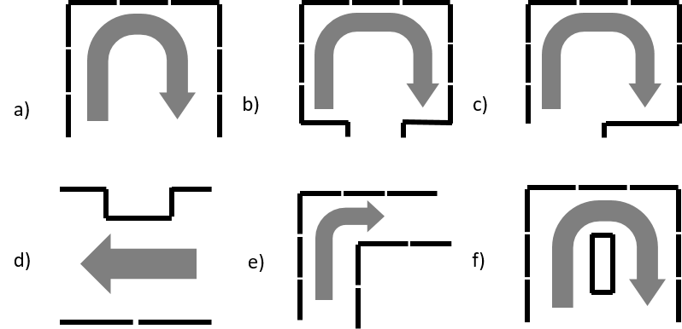

Figure 1. Illustration of the various functional maneuvers completed by participants. a) Continuous (and non-continuous) turning in a bounded area; b, c) Non-continuous U-turn, with a fixed width entry/exit door centrally located (b) or located in the corner of the space (c); d) travel down a straight path; e) 90-degree or L-turn; f) turning around a barrier

Determining functional reach ranges
To guide placement ranges for operating controls and devices (e.g., light switches, door handles, faucets), participants completed a series of functional reaching tasks. Where possible, reaching was assessed in forward and lateral directions, with and without an obstruction. For obstructed reaching, a foam table (height: 860 mm; width: 800 mm; depth: 500 mm and 600 mm; under surface clearance: 730mm) was positioned between the participant and the wall. Participants self-selected their preferred starting distance from the wall to complete each task; this distance was measured from the most proximal point of the participant or their mobility device/aid to the wall and recorded as “tolerance.”

Once in a preferred position, participants were instructed to reach as high or low as comfortable in a safe and controlled manner, using their preferred arm. For both maximum and minimum heights, the reaching tasks included pressing a button (“Touch” task) and placing an object on a shelf (“Grasp” task). Height was measured as the vertical distance from the centre of the button or the top surface of the shelf to the floor, respectively.

Boostrapping analysis
To enhance and strengthen the generalizability of our findings to the Canadian population, a statistical bootstrapping approach was applied to generate proportionally representative samples of the Canadian population based on mobility device type (i.e., manual wheelchair, power wheelchair, and scooter). This approach was adapted from Paquet et al., (2012) using population-level distributions derived from the 2022 Canadian Survey on Disability (CSD; see 1.1). According to summary statistics using CSD 2022 data, 53.9% of wheeled mobility devices were manual wheelchairs, 32.4% were mobility scooters, and 13.8% were power wheelchairs. These proportions were compared to the distribution observed in our collected sample (37.2% manual wheelchairs, 48.2% power wheelchairs, and 14.7% scooters), revealing notable differences. Given this discrepancy, bootstrapped resampling was conducted to better align our collected participant sample with national prevalence estimates and support population-level recommendations.
Bootstrapping is one of many different resampling methods where the objective is to create multiple samples from a single dataset to infer the sampling distribution of an estimate of the data. This can allow for an estimate of a population to be produced from sample data. The bootstrap method of resampling is advantageous as it does not require an assumption of normality; however, is limited by the available sample size and relies on the assumption that the data being resampled is representative of the population it is trying to simulate (Diciccio & Romano, 1988; Chong & Choo, 2011).
To determine the number of each device that should be included in the simulated dataset, the 2022 CSD percentage for each device type was multiplied by the sample size of the original dataset. This determined the number of times each device type from the original sample should be included when creating each simulated dataset. Due to the high prevalence of walkers among the types of mobility devices used, only manual wheelchairs, power wheelchairs and mobility scooters (i.e. wheeled mobility devices) were resampled proportionally to the Canadian population; this was done to prevent the suppression of wheeled mobility devices.
MATLAB software (MATLAB R2025a) was used to complete the bootstrapping analysis, wherein the original sample was resampled to create simulated datasets of the same size as the original sample. To ensure the dataset was proportionately representative of device use among Canadians, the simulated datasets resampled more scooter and manual wheelchair users and fewer power wheelchair users. Bootstrapping with replacement was used to allow data points (i.e. devices) to be represented more than once in each simulated dataset. Each simulated dataset is created independently of each other and populated through random selection of data point from the original sample. This resampling process was repeated 4000 times to create 4000 simulated datasets as done by Paquet et al., (2012) with each dataset proportionally representing the distribution of wheeled mobility device use among Canadians with a disability.
Descriptive statistics (e.g. mean, standard deviation, and percentiles) were evaluated following the creation of each simulated dataset. The average of each descriptive statistic across the 4000 simulated datasets was evaluated to produce the final statistical values along with their corresponding confidence intervals. Descriptive statistics for the individual device subgroups were presented separately to understand their contributions to the final bootstrapped estimates.
Bootstrapping analysis was completed for the static measures, functional maneuvers and reaching ranges for the group of wheeled mobility devices (i.e. manual wheelchairs, power wheelchairs, and scooters). Modifications to the bootstrapping approach were made for Static Measures due to restrictions in certain devices when completing tasks. Specifically, manual wheelchairs and power wheelchairs were the only devices evaluated for some static measures (i.e. seat, knee, and toe clearances did not include mobility scooters due to steering columns). Therefore, a different percentage was used to determine the number of manual wheelchairs versus power wheelchairs that should be resampled. For all bootstrapped measures of “Wheelchairs Only”, the simulated datasets were resampled to be 80% manual wheelchairs and 20% power wheelchairs to maintain a proportionally representative subsample. No modifications were required for the Functional Maneuvers and Reaching Ranges.

Results

Characteristics of adult mobility assistive device users
A total of 222 participants who used a mobility assistive device were included in our final sample, including: Adults using walkers/rollators (n=30); Adults using mobility scooters (n =28); Adults using manual wheelchairs (n =70); Adults using power wheelchairs (n =91); Adults using guide dogs (n =3). Participant demographics for each group are summarized in Table 5 below.

Age, sex, and gender
The mean (SD) age of all participants was 57.9 (16.8) years old. Approximately 55% of participants identified as women, with ~42% as men, and the remainder identifying as non-binary or not sharing their gender identity. Among mobility device sub-groups, gender distribution was similar to the overall group except walker users, which had a high proportion of participants who identified as women (80%).

Social identity
Participants self-reported social identity groups to which they belonged. While ~70% of the sample did not identify with the available options or preferred not to disclose that information, approximately 30% identified with at least one of the social identity options. More than 1 in 5 participants identified as being a visible minority, while nearly 1 in 10 identified as belonging to an LGBTQI2S+ identity.

Disability status
Participants self-reported types of disability they experienced. In addition to mobility, participants primarily experienced other physical disabilities: flexibility (63.5%), pain (57.2%), and dexterity (49.5%). Other disabilities (mental health, visual, memory, hearing, learning, developmental, other) did not exceed 30% in the total study population or in any mobility device sub-group. Nearly half of all participants reported experiencing two to three disability types, while ~45% reported experiencing four or more disabilities.

Experience with mobility device
Overall, 21% of participants reported having less than a year of experience with their mobility device type. Among participants with more than a year of experience, the average level of experience with the tested device type was 13.5 (12.2) years. Details pertaining to the tested WhMDs can be found in Appendix A

Table 5. Characteristics of adult mobility assistive device users
 | All Device Users | All WhMDs | Manual Wheelchair | Power Wheelchair | Mobility Scooter | Walker Users | Guide Dog Users
Number of participants
Total, N | 222 | 189 | 70 | 91 | 28 | 30 | 3
Age
Mean (SD) | 57.9 (16.8) | 55.4 (16.1) | 53.2 (17.5) | 54.2 (15.4) | 64.6 (10.5) | 74.4 (12.5) | 57.0 (8.0)
Sex
Male | 41.9% | 45.5% | 54.3% | 40.7% | 39.3% | 20.0% | 33.3%
Female | 56.8% | 52.9% | 45.7% | 57.1% | 57.1% | 80.0% | 66.7%
Prefer not to answer | 0.9% | 1.6% | 0.0% | 2.2% | 3.6% | 0.0% | 0.0%
Gender
Man | 41.4% | 45.0% | 54.3% | 39.6% | 39.3% | 20.0% | 33.3%
Woman | 55.0% | 50.8% | 44.3% | 54.9% | 53.6% | 80.0% | 66.7%
Non-binary | 3.2% | 3.7% | 1.4% | 5.5% | 3.6% | 0.0% | 0.0.%
Prefer not to answer | 0.5% | 0.5% | 0.0% | 0.0% | 3.6% | 0.0% | 0.0.%
Social identity
Visible minorities | 19.4% | 21.2% | 12.9% | 27.5% | 21.4% | 10.0% | 0.0%
LGBTQI2S+ | 8.1% | 9.5% | 7.1% | 13.2% | 3.6% | 0.0% | 0.0%
Indigenous peoples | 4.1% | 4.8% | 4.3% | 4.4% | 7.1% | 0.0% | 0.0%
Newcomers to Canada | 3.6% | 4.2% | 8.6% | 2.2% | 0.0% | 0.0% | 0.0%
Gender-diverse individuals | 2.3% | 2.6% | 1.4% | 4.4% | 0.0% | 0.0% | 0.0%
People in official language minority | 1.4% | 1.6% | 0.0% | 3.3% | 0.0% | 0.0% | 0.0%
I do not identify | 64.4% | 60.3% | 70.0% | 51.6% | 64.3% | 86.7% | 100.0%
Prefer not to answer | 4.5% | 4.8% | 5.7% | 3.3% | 7.1% | 3.3% | 0.0%
Other: | 0.5% | 0.5% | 1.4% | 0.0% | 0.0% | 0.0% | 0.0%
Number of social identities
None identified | 69.4% | 65.6% | 77.1% | 54.9% | 71.4% | 90.0% | 100.0%
1 | 23.9% | 26.5% | 14.3% | 36.3% | 25.0% | 10.0% | 0.0%
2 or more | 6.8% | 7.9% | 8.6% | 8.8% | 3.6% | 0.0% | 0.0%
Disability type
Mobility | 98.6% | 100.0% | 100.0% | 100.0% | 100.0% | 96.7% | 33.3%
Flexibility | 63.5% | 63.5% | 52.9% | 70.3% | 67.9% | 66.7% | 33.3%
Pain | 57.2% | 55.6% | 48.6% | 58.2% | 64.3% | 70.0% | 33.3%
Dexterity | 49.5% | 49.2% | 28.6% | 65.9% | 46.4% | 53.3% | 33.3%
Visual | 19.8% | 18.5% | 20.0% | 20.9% | 7.1% | 20.0% | 100.0%
Mental Health | 17.6% | 19.0% | 18.6% | 19.8% | 17.9% | 6.7% | 33.3%
Hearing | 14.4% | 12.2% | 14.3% | 8.8% | 17.9% | 30.0% | 0.0%
Memory | 13.5% | 14.3% | 14.3% | 15.4% | 10.7% | 10.0% | 0.0%
Learning | 11.7% | 12.2% | 12.9% | 13.2% | 7.1% | 10.0% | 0.0%
Developmental | 6.3% | 6.9% | 7.1% | 7.7% | 3.6% | 3.3% | 0.0%
Other | 8.1% | 9.0% | 11.4% | 5.5% | 14.3% | 3.3% | 0.0%
Number of disability types
1 | 7.2% | 7.4% | 11.4% | 3.3% | 10.7% | 0.0% | 66.7%
2 to 3 | 47.7% | 49.2% | 52.9% | 46.2% | 50.0% | 43.3% | 0.0%
4 to 5 | 32.0% | 31.2% | 28.6% | 35.2% | 25.0% | 40.0% | 0.0%
6+ | 12.6% | 12.2% | 7.1% | 15.4% | 14.3% | 13.3% | 33.3%
No response | 0.5% | 0.5% | 0.0% | 0.0% | 0.0% | 3.3% | 0.0%
Experience with mobility device
<1 year | 20.5% | 22.8% | 42.9% | 11.0% | 10.7% | 6.7% | ---
1-5 years | 33.3% | 30.2% | 22.9% | 36.3% | 28.6% | 53.3% | ---
5+ years | 45.2% | 46.0% | 31.4% | 52.7% | 60.7% | 40.0% | ---
No response | 0.9% | 1.1% | 2.9% | 0.0% | 0.0% | 0.0% | ---

Static measurements of adult mobility assistive device users
Static measurements were recorded from 222 adult mobility assistive device users across all device user groups. Reported sample sizes varied by outcome due to measurement-specific applicability, with some device groups not contributing data to certain outcomes (e.g., knee and toe clearances do not include scooter users). For some participants using device attachments (e.g., front-powered attachments) or accompanied by a service animal or support person, static measures were repeated under configuration-specific conditions (e.g., with and without the attachment, service animal, or support person).
Static measures of interest include those associated with clear floor space (i.e. occupied length/width; occupied clear floor area), static clearances (i.e. seat, knee, and toe clearance), occupied weight, and seated eye height. Measurement procedures for each outcome are detailed in the sections below. Descriptive statistics (minimum, maximum, mean, percentiles) are presented for each of the static measures, including laboratory-derived data and via bootstrapping analysis using resampled data based on the distribution of mobility devices among the Canadian population. Primary results are presented for WhMD users (manual wheelchairs, power wheelchairs, and mobility scooters) and wheelchairs only (e.g. excluding scooter users). Comparative results for participants using other mobility aids (e.g., walkers) are reported, when applicable, but are not included in WhMD summary statistics.

Clear floor space for occupied devices
Occupied measurements were collected with the device configured for use, reflecting the participant’s typical/preferred positioning during functional activities (e.g. seat tilted back, foot rests extended), and included any attachments or other personal belongings added to the device. Occupied measurements are separately reported for walker users, and WhMD users when accompanied by service/support animals, support person, and/or when using a white cane (i.e. WhMD+); the WhMD+ comparative data are not included in WhMD summary statistics. Unoccupied static measurements are available in Appendix B and are reported for comparative purposes.

Occupied device width
Occupied width was measured as the lateral distance between the widest points of the participant and/or their mobility device when in use, including accessories such as bags or other personal items attached to the sides or back of the device (Figure 2). For manual wheelchair users, participants who self-propelled were asked to place their hands on the push rims, whereas those using front-powered attachment placed their hands on the handlebars. Power wheelchair users were asked to place their hands on the controls (e.g. joystick), and mobility scooter users on the steering controls. These positions were intended to reflect typical independent operation of each mobility device. Descriptive statistics of occupied device width (minimum, maximum, mean, percentiles) are presented in Table 6.

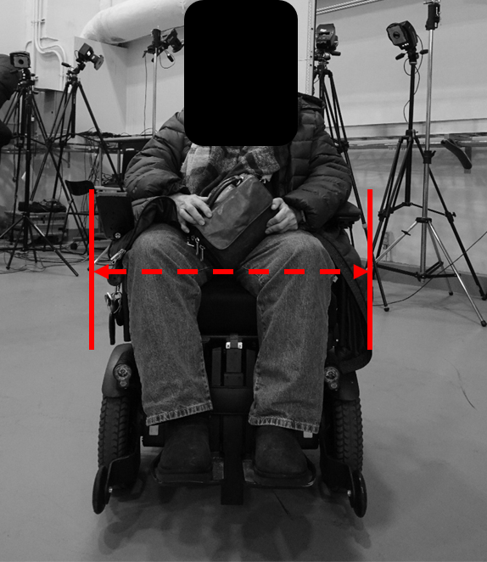

Figure 2. Front-view image of a power wheelchair. The red, dashed arrows depict an example of the occupied measurement (e.g. from widest points on the person or device, with consideration of personal items and accessories)

Table 6. Occupied device width (mm)
Data Source | N | Min | Mean | SD | 90th %ile | 95th  %ile | 99th %ile | Max
Laboratory-derived data
All WhMDs | 187 | 495 | 707 | 73 | 797 | 824 | 894 | 990
Manual Wheelchair | 70 | 590 | 731 | 64 | 811 | 828 | 859 | 890
Power Wheelchair | 89 | 605 | 713 | 65 | 794 | 823 | 928 | 990
Mobility Scooter | 28 | 495 | 624 | 63 | 703 | 717 | 727 | 730
Wheelchairs Only | 159 | 590 | 721 | 65 | 810 | 826 | 903 | 990
Walker Users | 30 | 570 | 621 | 40 | 681 | 688 | 694 | 695
WhMD+ | 6 | 840 | 1040 | 207 | 1300 | 1300 | 1300 | 1300
Bootstrapped estimates
All WhMDs | 187 | 495 | 695 | 80 | 793 | 820 | 864 | 990
Manual Wheelchair | 101 | 590 | 732 | 64 | 812 | 830 | 863 | 890
Power Wheelchair | 26 | 605 | 713 | 65 | 785 | 818 | 871 | 990
Mobility Scooter | 60 | 495 | 624 | 62 | 700 | 717 | 727 | 730
Wheelchairs Only | 127 | 590 | 728 | 64 | 810 | 829 | 875 | 990

Occupied device length
Occupied length (Figure 3) was measured as the maximum anterior–posterior distance encompassing the participant and their mobility device, including any attached accessories such as bags or other personal items affixed to the back or sides of the device. Descriptive statistics of occupied device length (minimum, maximum, mean, percentiles) are presented in Table 7.
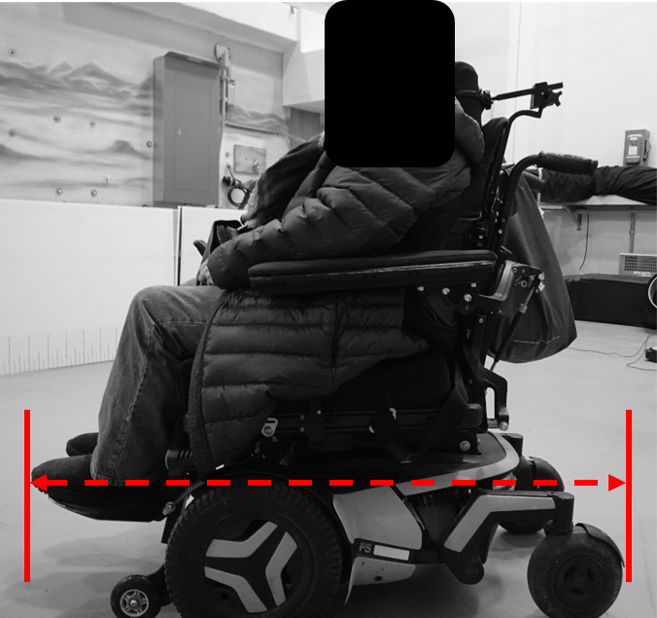

Figure 3. Side-view image of a power wheelchair. The red, dashed arrows depict an example of the occupied measurement (e.g. from front-most to rear-most point of the person or device, with consideration of personal items and accessories)

Table 7. Occupied device length (mm)
Data Source | N | Min | Mean | SD | 90th %ile | 95th  %ile | 99th %ile | Max
Laboratory-derived data
All WhMDs | 187 | 860 | 1189 | 133 | 1347 | 1425 | 1511 | 1560
Manual Wheelchair | 68 | 860 | 1097 | 116 | 1212 | 1220 | 1446 | 1560
Power Wheelchair | 91 | 1000 | 1238 | 99 | 1345 | 1415 | 1510 | 1510
Mobility Scooter | 28 | 860 | 1254 | 151 | 1443 | 1457 | 1504 | 1520
Wheelchairs Only | 159 | 860 | 1177 | 127 | 1325 | 1371 | 1510 | 1560
Walker Users | 30 | 735 | 842 | 77 | 946 | 995 | 999 | 1000
WhMD+ | 5 | 1200 | 1396 | 119 | 1492 | 1506 | 1517 | 1520
Bootstrapped estimates
All WhMDs | 187 | 860 | 1167 | 146 | 1364 | 1430 | 1517 | 1560
Manual Wheelchair | 101 | 860 | 1097 | 115 | 1209 | 1234 | 1432 | 1560
Power Wheelchair | 26 | 1000 | 1237 | 98 | 1349 | 1393 | 1445 | 1510
Mobility Scooter | 60 | 860 | 1255 | 148 | 1435 | 1465 | 1504 | 1520
Wheelchairs Only | 127 | 860 | 1126 | 125 | 1260 | 1331 | 1483 | 1560

Clear floor area
A low correlation between occupied length and width has previously been reported (D'Souza, Steinfeld, Paquet, & Feathers, 2010), suggesting that larger widths do not imply larger length and vice versa. Thus, space dimensions derived from occupied length and width considered independently may fail to accommodate devices that are long and narrow or short and wide. To prevent under or overestimating the required length and widths, clear floor area was calculated (Table 8) using established methods (D'Souza, Steinfeld, Paquet, & Feathers, 2010). Occupied length and width measurements were paired to compute individual occupied clear floor areas, from which percentile distributions were derived. Maximum occupied width and length values corresponding to the 95th percentile were then identified, providing a minimum clear floor space sufficient for at least 95% of wheeled mobility device users (Table 9).
Table 8. Clear floor area (m²)
Data Source | N | Min | Mean | SD | 90th %ile | 95th  %ile | 99th %ile | Max
Laboratory-derived data
All WhMDs | 186 | 0.46 | 0.8 | 0.13 | 0.99 | 1.07 | 1.22 | 1.26
Manual Wheelchair | 69 | 0.48 | 0.8 | 0.12 | 0.94 | 0.96 | 1.09 | 1.19
Power Wheelchair | 89 | 0.69 | 0.9 | 0.12 | 1.04 | 1.14 | 1.23 | 1.26
Mobility Scooter | 28 | 0.46 | 0.8 | 0.15 | 0.94 | 0.97 | 1.06 | 1.09
Wheelchairs Only | 158 | 0.48 | 0.8 | 0.13 | 1.00 | 1.08 | 1.23 | 1.26
Bootstrapped estimates
All WhMDs | 186 | 0.46 | 0.8 | 0.13 | 0.95 | 1.01 | 1.15 | 1.26
Manual Wheelchair | 100 | 0.48 | 0.8 | 0.12 | 0.94 | 0.97 | 1.09 | 1.19
Power Wheelchair | 26 | 0.69 | 0.9 | 0.12 | 1.04 | 1.10 | 1.17 | 1.26
Mobility Scooter | 60 | 0.46 | 0.8 | 0.15 | 0.95 | 0.99 | 1.06 | 1.09
Wheelchairs Only | 126 | 0.48 | 0.8 | 0.12 | 0.96 | 1.01 | 1.16 | 1.26

Table 9. Maximum width and length (mm) that would be accommodated by the 95th percentile occupied area
Data Source | Max Width | Max Length
Laboratory-derived data
All WhMDs | 890 | 1470
Manual Wheelchair | 845 | 1390
Power Wheelchair | 830 | 1470
Mobility Scooter | 730 | 1460
Wheelchairs Only | 890 | 1470
Bootstrapped estimates
All WhMDs | 845 | 1470
Manual Wheelchair | 845 | 1390
Power Wheelchair | 830 | 1470
Mobility Scooter | 730 | 1460
Wheelchairs Only | 845 | 1470

Summary of recommendations, clear floor space
The following summarizes our recommendations for guiding space design that applies measures of clear floor width and clear floor length
- Prioritize occupied, functionally realistic measurements in accessibility standards
Occupied dimensions collected with users in their preferred, functional position better reflect real-world wheeled mobility device use than unoccupied, manufacturer-reported dimensions. While mobility scooters tend to be longer with limited variability constrained by device design, manual and power wheelchairs show greater variability due to user fit, functional adaptations, and the addition of accessories or personal items (e.g., bags, backpacks). Collecting measurements in this manner captures how devices are actually used in community settings and supports the development of more flexible and inclusive spatial requirements.
- Comparison with current Canadian standards and codes
Current Canadian standards and codes specify clear floor width and length requirements ranging from 800 mm to 900 mm and 1350 mm to 1500 mm (see Table 2), respectively. Based on the collected sample, the lower bound of both the clear floor width and length range (as specified in NBCC, 2025), would accommodate approximately 90% of wheeled mobility device users. These recommended values fall below the 95th percentile observed in both our collected and resampled datasets.
- Minimum occupied width and length to accommodate 95% of users
When resampled to reflect the population distribution of wheeled mobility devices, the findings suggest that current clear floor width and length requirements in building codes (800 mm x 1350mm) are insufficient to accommodate a user in the 95th percentile. To accommodate 95% of users would require increasing the minimum stationary width to 820mm and minimum stationary length to 1430 mm.
- Use occupied area–based dimensions to address device shape variability
Defining clear floor space using the 95th percentile of occupied width and length independently may not adequately accommodate devices that are long and narrow or short and wide. To better reflect real-world device configurations and increase inclusivity, it is recommended that clear floor space be defined using the maximum occupied width and length values within the 95th percentile occupied area, resulting in recommended minimum dimensions of 845 mm (width) × 1470 mm (length).

Clearances
Clearance measurements were collected with mobility devices configured for use, reflecting participants’ typical or preferred positioning during functional activities (e.g., seat tilted back, footrests extended). For all clearance measures (seat height, seat depth, knee clearance, and toe clearance), data are not reported for users of wheeled mobility devices with steering columns (e.g., mobility scooters, front-powered attachments), as these device features would directly influence the measurements of interest.

Seat clearance
Seat height (Figure 4) was measured as the vertical distance from the midpoint of the upper thigh to the floor, while seat depth (Figure 4) was measured from the posterior hips to the most forward point of the participant or mobility device. Descriptive statistics of seat clearance and seat depth (minimum, maximum, mean, percentiles) are presented in Table 10 and 11, respectively.

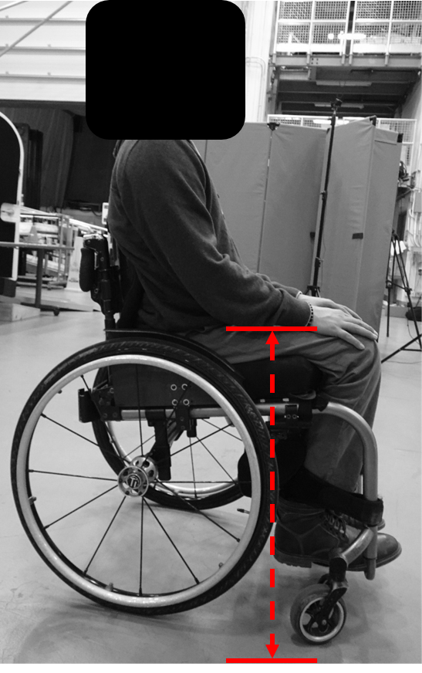
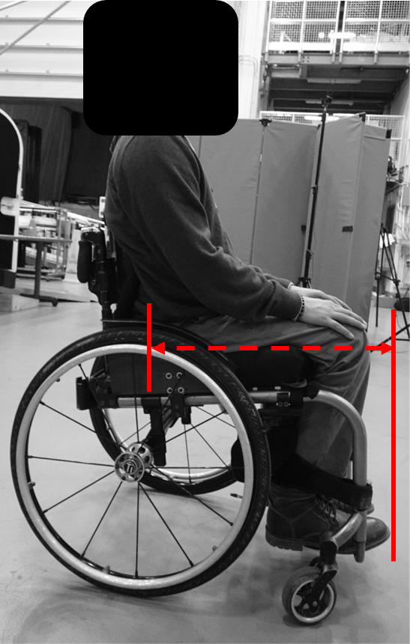

Figure 4. Side-view image of a manual wheelchair. The red, dashed arrows depict an example of seat height (left) and seat depth (right).

Table 10. Seat height (mm)
Data Source | N | Min | Mean | SD | 90th %ile | 95th  %ile | 99th %ile | Max
Laboratory-derived data
Wheelchairs Only | 156 | 490 | 675 | 62 | 760 | 775 | 812 | 835
Manual Wheelchair | 65 | 490 | 636 | 44 | 685 | 700 | 707 | 710
Power Wheelchair | 91 | 575 | 702 | 58 | 770 | 798 | 817 | 835
Bootstrapped estimates
Wheelchairs Only | 156 | 490 | 649 | 54 | 708 | 745 | 787 | 835
Manual Wheelchair | 125 | 490 | 636 | 44 | 687 | 700 | 707 | 710
Power Wheelchair | 31 | 575 | 703 | 58 | 772 | 788 | 807 | 835

Table 11. Seat depth (mm)
Data Source | N | Min | Mean | SD | 90th %ile | 95th  %ile | 99th %ile | Max
Laboratory-derived data
Wheelchairs Only | 156 | 470 | 712 | 91 | 828 | 843 | 932 | 990
Manual Wheelchair | 65 | 470 | 693 | 95 | 802 | 838 | 915 | 960
Power Wheelchair | 91 | 490 | 725 | 86 | 830 | 845 | 918 | 990
Bootstrapped estimates
Wheelchairs Only | 156 | 470 | 699 | 94 | 815 | 850 | 928 | 990
Manual Wheelchair | 125 | 470 | 693 | 95 | 806 | 849 | 923 | 960
Power Wheelchair | 31 | 490 | 725 | 86 | 825 | 849 | 893 | 990

Knee clearance
Knee height (Figure 5) was measured as the vertical distance from the top of the knee to the floor, while knee depth (Figure 5) was measured as the horizontal distance from the centre of the knee to the most forward point of the participant or mobility device. Descriptive statistics of knee clearance and knee depth (minimum, maximum, mean, percentiles) are presented in Table 12 and 13, respectively.
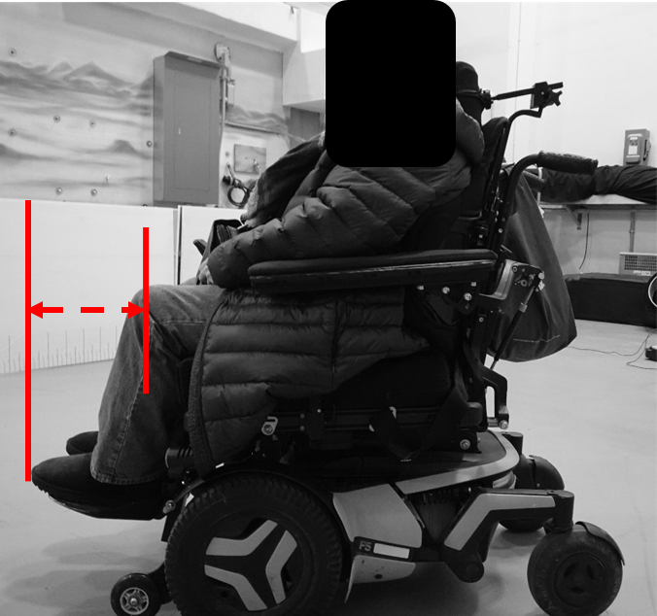
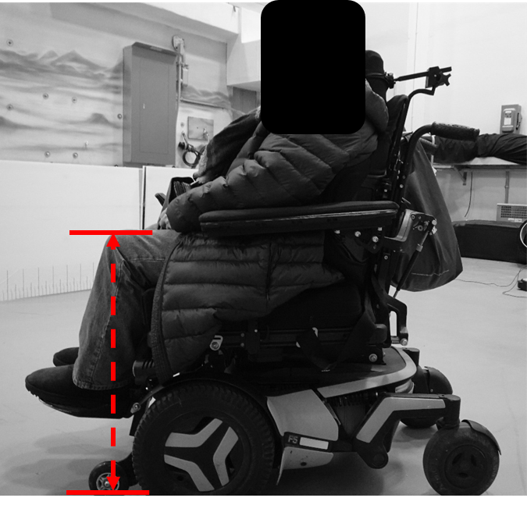

Figure 5. Side-view image of a power wheelchair. The red, dashed arrows depict an example of knee height (left) and knee depth (right).

Table 12. Knee height (mm)
Data Source | N | Min | Mean | SD | 90th %ile | 95th  %ile | 99th %ile | Max
Laboratory-derived data
Wheelchairs Only | 155 | 510 | 663 | 65 | 750 | 778 | 819 | 855
Manual Wheelchair | 64 | 510 | 629 | 49 | 680 | 702 | 716 | 725
Power Wheelchair | 91 | 525 | 687 | 63 | 765 | 793 | 833 | 855
Bootstrapped estimates
Wheelchairs Only | 155 | 510 | 641 | 57 | 707 | 732 | 787 | 855
Manual Wheelchair | 124 | 510 | 629 | 49 | 680 | 699 | 717 | 725
Power Wheelchair | 31 | 525 | 688 | 63 | 768 | 787 | 813 | 855

Table 13. Knee depth (mm)
Data Source | N | Min | Mean | SD | 90th %ile | 95th  %ile | 99th %ile | Max
Laboratory-derived data
Wheelchairs Only | 155 | 105 | 273 | 78 | 365 | 400 | 470 | 485
Manual Wheelchair | 64 | 105 | 270 | 82 | 369 | 396 | 432 | 470
Power Wheelchair | 91 | 110 | 275 | 76 | 360 | 395 | 472 | 485
Bootstrapped estimates
Wheelchairs Only | 155 | 105 | 271 | 80 | 368 | 393 | 450 | 485
Manual Wheelchair | 124 | 105 | 270 | 81 | 368 | 392 | 440 | 470
Power Wheelchair | 31 | 110 | 274 | 76 | 363 | 393 | 432 | 485

Toe clearance
Toe height (Figure 6) was measured as the vertical distance from the top of the foot to the floor, while toe depth (Figure 6) was measured as the distance from the centre of the ankle to the most forward point of the participant or mobility device. Descriptive statistics of toe clearance and toe depth (minimum, maximum, mean, percentiles) are presented in Table 14 and 15, respectively.

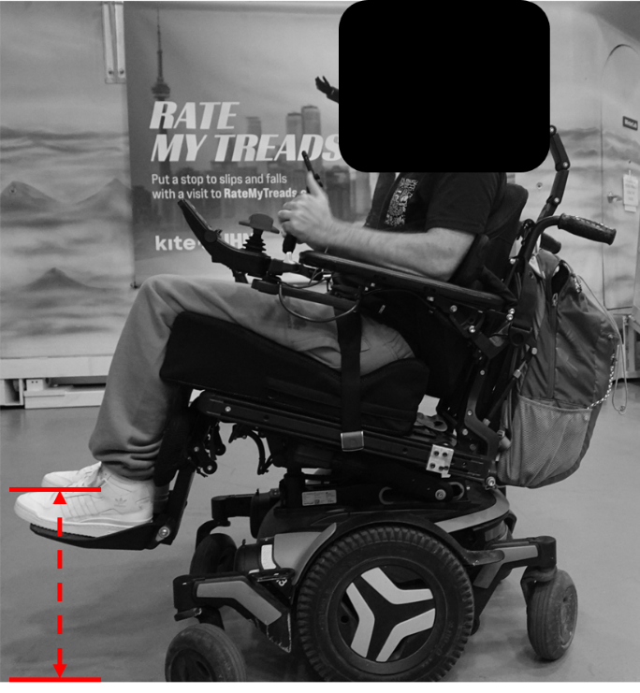
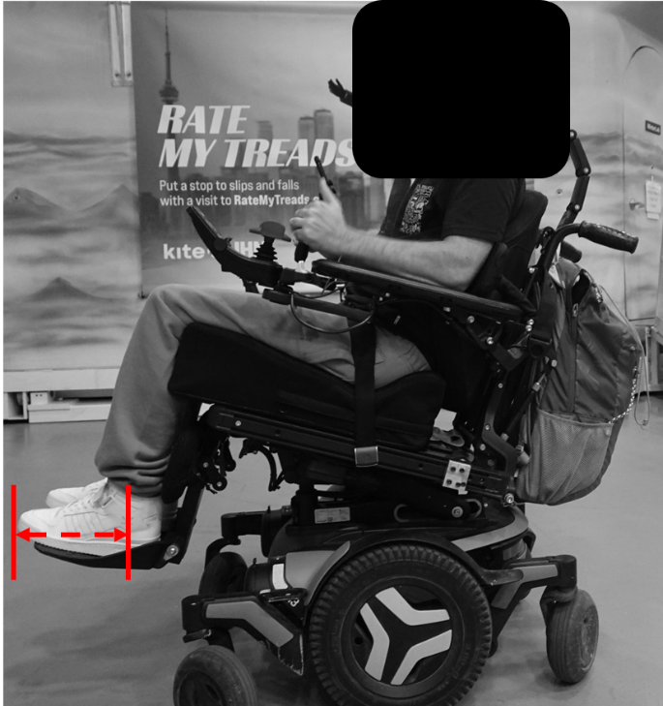

Figure 6. Side-view image of a power wheelchair. The red, dashed arrows depict an example of toe height (left) and toe depth (right).

Table 14. Toe height (mm)
Data Source | N | Min | Mean | SD | 90th %ile | 95th  %ile | 99th %ile | Max
Laboratory-derived data
Wheelchairs Only | 155 | 50 | 225 | 84 | 333 | 395 | 465 | 595
Manual Wheelchair | 64 | 50 | 182 | 54 | 259 | 270 | 277 | 280
Power Wheelchair | 91 | 125 | 256 | 88 | 380 | 420 | 482 | 595
Bootstrapped estimates
Wheelchairs Only | 155 | 50 | 197 | 69 | 273 | 296 | 404 | 595
Manual Wheelchair | 124 | 50 | 182 | 54 | 258 | 270 | 277 | 280
Power Wheelchair | 31 | 125 | 256 | 87 | 364 | 406 | 464 | 595

Table 15. Toe depth (mm)
Data Source | N | Min | Mean | SD | 90th %ile | 95th  %ile | 99th %ile | Max
Laboratory-derived data
Wheelchairs Only | 155 | 130 | 228 | 26 | 260 | 267 | 289 | 315
Manual Wheelchair | 64 | 130 | 229 | 27 | 259 | 265 | 287 | 300
Power Wheelchair | 91 | 165 | 227 | 25 | 260 | 268 | 284 | 315
Bootstrapped estimates
Wheelchairs Only | 155 | 130 | 228 | 26 | 258 | 268 | 290 | 315
Manual Wheelchair | 124 | 130 | 229 | 27 | 258 | 268 | 289 | 300
Power Wheelchair | 31 | 165 | 227 | 25 | 255 | 264 | 279 | 315

Summary of recommendations, seat, knee, and toe clearances
The following summarizes our recommendations for guiding space design that applies seated knee and toe clearances
- Applicability of seated clearance findings
The application of seated clearance findings for accessibility primarily apply to manual and power wheelchair users, as steering columns on devices such as mobility scooters can restrict close approach to tables, counters, sinks, and workstations. Consequently, data from users of devices with steering columns are not reported, since these features directly influence or exceed available space under tables/surfaces. For these users, it is important to also consider the clear floor space provided in front of these surfaces to ensure that a lateral approach is available for accessible use.
- Comparison with current Canadian standards and codes
Because seat clearance is not explicitly addressed in most accessibility standards, knee height clearance can be used as a practical proxy for defining the vertical space required to approach tables, counters, sinks, or workstations, etc. Current Canadian standards and codes specify minimum knee height clearances ranging from 685 mm to 735 mm (see Table 2). At the lower bound of this range, the minimum height would accommodate only 67% of all wheelchair users in the collected sample, and fewer than half of power wheelchair users. While it is possible for our power wheelchair users to potentially lower or tilt their device, depending on provided features, many individuals intentionally position their device to help with pain management. Requiring a change in one’s preferred position to approach underneath desks, tables or counters for prolonged periods may cause discomfort.

For knee clearance depths, current standards generally suggest 200 mm, with an additional 230 mm for toe clearance (see Table 2). Based on our collected data, a combined depth of 430 mm would accommodate approximately 97% of wheelchair users, supporting the retention of this combined clearance depth in design guidance.

Finally, the minimum toe height clearance in current standards is 230 mm. This value is lower than both our laboratory-derived data and our bootstrapped estimates, accommodating only 57% of all wheelchair users, 78% of manual wheelchair users, and 43% of power wheelchair users in their preferred, functional position.
- Minimum seated clearances to accommodate 95% of users
When resampled to reflect the population distribution of wheeled mobility devices, the findings suggest the combined knee and toe depth of 430 mm, currently recommended in Canadian standards (see Table 2), is sufficient to accommodate 95% of users. However, achieving comparable accommodation for knee and toe heights would require increasing the minimum knee clearance height above 685 mm and minimum toe clearance height above 296mm.

Occupied device weight
Occupied device weight was determined as the total weight of the user and their mobility device, including any attached accessories such as bags or other personal items affixed to the back or sides of the device (kg). Descriptive statistics of occupied device weight (minimum, maximum, mean, percentiles) are presented in Table 16.
Table 16. Occupied device weight (kg)
Data Source | N | Min | Mean | SD | 90th %ile | 95th  %ile | 99th %ile | Max
Laboratory-derived data
All WhMDs | 124 | 66 | 182 | 76 | 277 | 306 | 318 | 359
Manual Wheelchair | 45 | 66 | 104 | 26 | 138 | 142 | 176 | 199
Power Wheelchair | 61 | 93 | 244 | 45 | 307 | 313 | 335 | 359
Mobility Scooter | 18 | 79 | 171 | 53 | 228 | 236 | 249 | 253
Wheelchairs Only | 106 | 66 | 184 | 79 | 282 | 309 | 319 | 359
Walker Users | 30 | 55 | 89 | 26 | 126 | 141 | 155 | 158
Guide Dog Users | 3 | 98 | 126 | 36 | 156 | 162 | 166 | 167

Seated eye height
Seated eye height for adult mobility device users was measured with participants seated comfortably and looking straight ahead. A flat edge was positioned adjacent to the participant’s face, aligned with the centre of the eye, and eye height was recorded as the vertical distance from this centreline to the floor (mm). Descriptive statistics of seated eye height (minimum, maximum, mean, percentiles) are presented in Tables 17 & 18. For comparative purposes, eye height measurements are reported separately for standing participants (e.g., walker users and guide dog users).
Table 17. Eye height range (mm)
Data Source | N | Min | Mean | SD | Max
Laboratory-derived data
All WhMDs | 189 | 915 | 1204 | 86 | 1375
Wheelchairs Only | 161 | 915 | 1196 | 87 | 1375
Manual Wheelchair | 70 | 915 | 1164 | 80 | 1315
Power Wheelchair | 91 | 960 | 1222 | 85 | 1375
Mobility Scooter | 28 | 1090 | 1245 | 65 | 1360
Walker/Guide Dog Users | 33 | 1300 | 1487 | 89 | 1730
Bootstrapped estimates
All WhMDs | 188 | 915 | 1198 | 84 | 1375
Wheelchairs Only | 128 | 915 | 1176 | 83 | 1375
Manual Wheelchair | 102 | 915 | 1164 | 79 | 1315
Power Wheelchair | 26 | 960 | 1221 | 84 | 1375
Mobility Scooter | 60 | 1090 | 1245 | 64 | 1360

Table 18. Eye height percentiles (mm)
Data Source | N | 1st %ile | 5th %ile | 10th %ile | 90th %ile | 95th % ile | 99th %ile
Laboratory-derived data
All WhMDs | 189 | 958 | 1065 | 1090 | 1305 | 1345 | 1365
Wheelchairs Only | 161 | 952 | 1065 | 1085 | 1300 | 1345 | 1365
Manual Wheelchair | 70 | 932 | 1055 | 1065 | 1256 | 1291 | 1312
Power Wheelchair | 91 | 974 | 1083 | 1130 | 1330 | 1358 | 1366
Mobility Scooter | 28 | 1094 | 1119 | 1163 | 1313 | 1346 | 1360
Walker/Guide Dog Users | 33 | 1311 | 1350 | 1366 | 1563 | 1626 | 1704
Bootstrapped estimates
All WhMDs | 188 | 969 | 1065 | 1088 | 1298 | 1319 | 1359
Wheelchairs Only | 128 | 953 | 1052 | 1074 | 1281 | 1304 | 1343
Manual Wheelchair | 102 | 951 | 1046 | 1070 | 1261 | 1287 | 1310
Power Wheelchair | 26 | 1045 | 1092 | 1124 | 1319 | 1340 | 1356
Mobility Scooter | 60 | 1096 | 1120 | 1157 | 1318 | 1344 | 1358

Summary of recommendations, seated eye height
- Comparison with current Canadian standards and codes
While not numerous, there is direct application in Canadian accessibility standards where seated eye heights could be considered (e.g periscope/telescope viewing heights, controls with visual displays).

- Minimum seated clearances to accommodate 95% of users
Using the 5th and 95th percentiles for all adult wheeled mobility device users to inform design elements governed by seated eye height, it is recommended that viewing features be located no lower than 1065 mm and no higher than ~1320 mm above the finished floor.

Functional maneuvers of adult mobility assistive device users
Functional measurements (e.g. maneuvers) were recorded from 222 adult mobility assistive device users across all device user groups. Reported sample sizes varied by outcome due to some participants repeating maneuvers under configuration-specific conditions (e.g., with and without front-powered attachments).
For functional maneuvers, the measures of interest include those associated with turning area (i.e. space required for a continuous turn, 3-point/non-continuous turn, and impact of entry/exit location on turning area space requirements), clear path along a corridor, L-Turn (i.e. 90-degree turn), U-turn around a barrier. Measurement procedures for each outcome are detailed in the sections below. All maneuver measures were collected with the device configured for use, reflecting the participant’s typical/preferred positioning during functional activities (e.g. seat tilted back, foot rests extended), and included any attachments or other personal belongings added to the device. The minimum space was recorded for the maneuver performed in both clockwise and counter-clockwise directions, unless otherwise specified; reported values reflect the larger of the two measurements.
Descriptive statistics (minimum, maximum, mean, percentiles) are presented for each of the maneuvers, including laboratory-derived data and via bootstrapping analysis using resampled data based on the distribution of mobility devices among the Canadian population. Primary results are presented for WhMD users (manual wheelchairs, power wheelchairs, and mobility scooters). Comparative results for participants using other mobility aids (e.g., walkers, guide dogs) and WHMD users accompanied by service/support animals (i.e., WhMD+) are reported, when applicable, but are not included in WhMD summary statistics.

Turning area
Turning area was assessed under two conditions: continuous turning and non-continuous (3-point) turning. As described in 2.1.3, participants performed each maneuver within a square space (see Figure 7) that was progressively reduced following each successful attempt. Testing continued until the participant could no longer complete the turn without contacting the walls or until a pre-set minimum space was reached. For both continuous and 3-point turning area, the minimum allowable space was set at 1700 mm × 1700 mm, consistent with the turning space requirements outlined in the NBCC (2025).
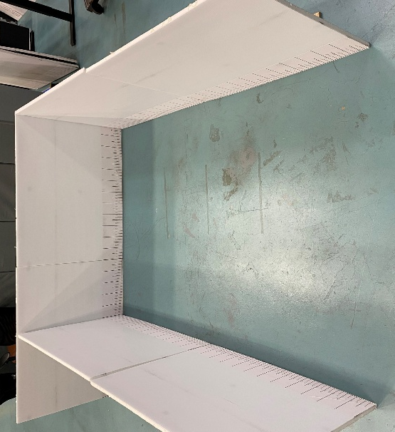
Figure 7. Image of square space bounded by foam walls, used for continuous and non-continuous turning area. The walls are movable, allowing the space to progressively reduce in size

Continuous turning area
Continuous turning area represents the minimum space required for the participant to complete a 180-degree turn in one, continuous motion, without contact with the walls. Descriptive statistics for a continuous turning area (minimum, maximum, mean, percentiles) are presented in Table 19.

Table 19. Continuous turning area (mm)
Data Source | N | Min | Mean | SD | 90th %ile | 95th  %ile | 99th %ile | Max
Laboratory-derived data
All WhMDs | 185 | 1700 | 1800 | 276 | 2130 | 2340 | 2948 | 3400
Manual Wheelchair | 71 | 1700 | 1720 | 121 | 1700 | 1750 | 2140 | 2700
Power Wheelchair | 86 | 1700 | 1707 | 32 | 1700 | 1700 | 1850 | 1850
Mobility Scooter | 28 | 1700 | 2291 | 426 | 2900 | 3095 | 3346 | 3400
Wheelchairs Only | 157 | 1700 | 1713 | 85 | 1700 | 1720 | 1872 | 2700
WhMD+ | 5 | 1700 | 1700 | 0 | 1700 | 1700 | 1700 | 1700
Walker Users | 30 | 1700 | 1700 | 0 | 1700 | 1700 | 1700 | 1700
Guide Dog Users | 3 | 1700 | 1767 | 116 | 1860 | 1880 | 1896 | 1900
Bootstrapped estimates
All WhMDs | 185 | 1700 | 1900 | 368 | 2363 | 2752 | 3226 | 3400
Manual Wheelchair | 100 | 1700 | 1720 | 121 | 1703 | 1761 | 2215 | 2700
Power Wheelchair | 26 | 1700 | 1707 | 32 | 1712 | 1743 | 1792 | 1850
Mobility Scooter | 59 | 1700 | 2290 | 418 | 2912 | 3123 | 3335 | 3400
Wheelchairs Only | 126 | 1700 | 1717 | 109 | 1702 | 1756 | 2166 | 2700

Turning area for a three-point turn
The three-point (non-continuous) turning area represents the minimum space required for a participant to complete a 180-degree turn using a non-continuous, three-point maneuver without contacting the walls. Descriptive statistics for a three-point turning area (minimum, maximum, mean, percentiles) are presented in Table 20.
Table 20. Turning area for a three-point turn (mm)
Data Source | N | Min | Mean | SD | 90th %ile | 95th  %ile | 99th %ile | Max
Laboratory-derived data
All WhMDs | 185 | 1700 | 1727 | 89 | 1800 | 1850 | 2124 | 2300
Manual Wheelchair | 71 | 1700 | 1710 | 54 | 1700 | 1700 | 1960 | 2100
Power Wheelchair | 86 | 1700 | 1707 | 32 | 1700 | 1700 | 1850 | 1850
Mobility Scooter | 28 | 1700 | 1832 | 173 | 2100 | 2198 | 2287 | 2300
Wheelchairs Only | 157 | 1700 | 1708 | 43 | 1700 | 1700 | 1872 | 2100
WhMD+ | 5 | 1700 | 1700 | 0 | 1700 | 1700 | 1700 | 1700
Walker Users | 30 | 1700 | 1700 | 0 | 1700 | 1700 | 1700 | 1700
Guide Dog Users | 3 | 1700 | 1767 | 116 | 1860 | 1880 | 1896 | 1900
Bootstrapped estimates
All WhMDs | 185 | 1700 | 1748 | 119 | 1859 | 2035 | 2241 | 2300
Manual Wheelchair | 100 | 1700 | 1710 | 53 | 1700 | 1733 | 1952 | 2100
Power Wheelchair | 26 | 1700 | 1707 | 32 | 1711 | 1743 | 1793 | 1850
Mobility Scooter | 59 | 1700 | 1831 | 170 | 2098 | 2201 | 2278 | 2300
Wheelchairs Only | 126 | 1700 | 1709 | 50 | 1700 | 1733 | 1945 | 2100

Impact of entry/exit location on turning area
Entry and exit with a fixed width door, in a varied location, was assessed to determine its effect on turning space requirements. A fixed-width opening (850 mm) was positioned either at the left or right corner, or at the center of the space. Participants were instructed to enter through the opening, complete the turn, and exit without contacting the walls or the opening. The available turning space was gradually reduced until the participant could no longer complete the maneuver through the space given the entry/exit location. Participants were allowed to use their preferred turning method (continuous or three-point turn). Several participants were unable to complete the task according to protocol and were excluded from summary tables. For corner entrances, reported values represent the larger of the measurements from the left- or right-corner entry/exit positions. For middle entrances, values reflect the larger measurement required to complete the turn in both clockwise and counter-clockwise directions.

Turning area, corner entry/exit
To determine the turning area required with a left- or right-sided entry/exit, openings were created at both the left and right corners of the space (see Figure 8) using a pylon and pylon cover. Participants were instructed to enter through the opening, complete a 180-degree turn, and exit through the same opening. Once their minimum turning space was identified on one side, the opening was repositioned to the opposite corner and the maneuver was repeated to confirm performance in the alternate direction. Reported values reflect the minimum turning space required to successfully complete the maneuver from both left and right corner entry/exit positions (i.e. the larger of the two minimum measurements). Descriptive statistics for a turning area with a corner entry/exit (minimum, maximum, mean, percentiles) are presented in Table 21.
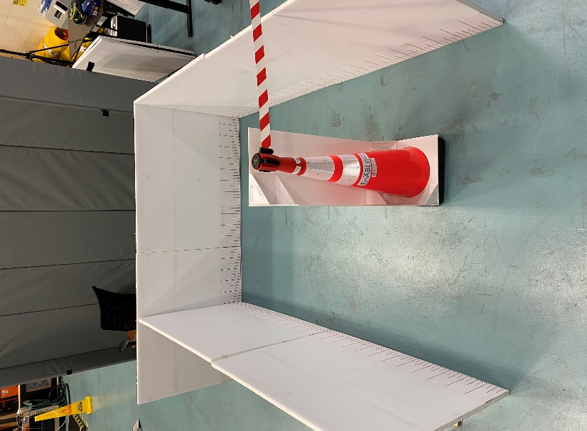
Figure 8. Image of square space bounded by foam walls. A left-corner entry/exit door is shown in the image, created using a pylon. The walls are movable, allowing the space to progressively reduce in size. The door width remained fixed at 850 mm.

Table 21. Turning area with a corner entry/exit (mm)
Data Source | N | Min | Mean | SD | 90th %ile | 95th  %ile | 99th %ile | Max
Laboratory-derived data
All WhMDs | 175 | 1700 | 1792 | 223 | 2000 | 2200 | 2713 | 3200
Manual Wheelchair | 67 | 1700 | 1722 | 114 | 1700 | 1800 | 2138 | 2600
Power Wheelchair | 81 | 1700 | 1725 | 73 | 1800 | 1900 | 2020 | 2100
Mobility Scooter | 27 | 1700 | 2167 | 332 | 2580 | 2735 | 3083 | 3200
Wheelchairs Only | 148 | 1700 | 1724 | 94 | 1765 | 1850 | 2053 | 2600
WhMD+ | 5 | 1700 | 1720 | 45 | 1760 | 1780 | 1796 | 1800
Walker Users | 30 | 1700 | 1700 | 0 | 1700 | 1700 | 1700 | 1700
Guide Dog Users | 3 | 1700 | 1833 | 231 | 2020 | 2060 | 2092 | 2100
Bootstrapped estimates
All WhMDs | 176 | 1700 | 1864 | 291 | 2252 | 2488 | 2917 | 3200
Manual Wheelchair | 95 | 1700 | 1722 | 114 | 1714 | 1801 | 2195 | 2600
Power Wheelchair | 25 | 1700 | 1726 | 74 | 1783 | 1854 | 1944 | 2100
Mobility Scooter | 56 | 1700 | 2166 | 326 | 2595 | 2798 | 3074 | 3200
Wheelchairs Only | 120 | 1700 | 1723 | 107 | 1727 | 1823 | 2192 | 2600

Turning area, middle entrance
To determine the turning area required with a centrally located entry/exit, an opening was positioned at the midpoint of one wall of the space (see Figure 9) using a pylon and pylon cover. Participants were instructed to enter through the opening, complete a 180-degree turn, and exit through the same opening without contacting the walls or the opening. The maneuver was first performed in the participant’s preferred direction (e.g., clockwise). After establishing the minimum space required in that direction, the task was repeated in the opposite direction (e.g., counter-clockwise) to confirm performance. Reported values therefore represent the minimum turning space required to complete the maneuver in both directions when entering and exiting through a central opening (i.e., the larger of the two minimum measurements). Descriptive statistics for a turning area with a middle entry/exit (minimum, maximum, mean, percentiles) are presented in Table 22.
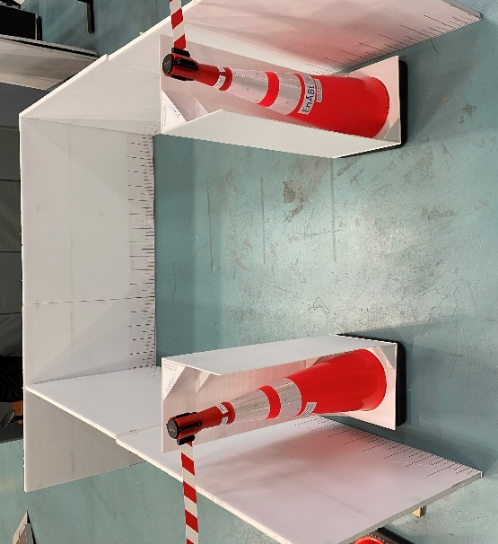
Figure 9. Image of square space bounded by foam walls. A middle entry/exit door is shown in the image, created using two pylons. The walls are movable, allowing the space to progressively reduce in size. The door width remained fixed at 850 mm.

Table 22. Turning area with a middle entry/exit (mm)
Data Source | N | Min | Mean | SD | 90th %ile | 95th  %ile | 99th %ile | Max
Laboratory-derived data
All WhMDs | 178 | 1700 | 1798 | 248 | 2065 | 2330 | 2823 | 2950
Manual Wheelchair | 67 | 1700 | 1719 | 102 | 1700 | 1770 | 2104 | 2500
Power Wheelchair | 83 | 1700 | 1717 | 59 | 1780 | 1845 | 1936 | 2100
Mobility Scooter | 28 | 1700 | 2229 | 372 | 2800 | 2865 | 2937 | 2950
Wheelchairs Only | 150 | 1700 | 1718 | 81 | 1700 | 1827 | 2002 | 2500
WhMD+ | 5 | 1700 | 1730 | 67 | 1790 | 1820 | 1844 | 1850
Walker Users | 30 | 1700 | 1700 | 0 | 1700 | 1700 | 1700 | 1700
Guide Dog Users | 3 | 1700 | 1833 | 231 | 2020 | 2060 | 2092 | 2100
Bootstrapped estimates
All WhMDs | 178 | 1700 | 1882 | 325 | 2378 | 2719 | 2901 | 2950
Manual Wheelchair | 96 | 1700 | 1718 | 101 | 1705 | 1778 | 2145 | 2500
Power Wheelchair | 25 | 1700 | 1717 | 58 | 1749 | 1802 | 1885 | 2100
Mobility Scooter | 57 | 1700 | 2229 | 366 | 2802 | 2871 | 2930 | 2950
Wheelchairs Only | 121 | 1700 | 1718 | 94 | 1708 | 1794 | 2130 | 2500

Summary of recommendations, turning area for public spaces
The following summarizes our recommendations for space design where a turning area would be applied.
- Permit three-point (non-continuous) turning where feasible
Allowing participants to perform a three-point turn reduces required turning space and enables accommodation of a greater proportion of users, consistent with prior literature (King, Dutta, Gorski, Holliday, & Fernie, 2011). Standards that assume only continuous turning may overestimate space requirements for some users while underestimating maneuverability strategies commonly used in practice. Designing to accommodate continuous turning requirements for scooter users may be impractical in many built environments due to the large spatial footprint required. In such contexts, permitting three-point turns may provide a more feasible approach, which better accommodate scooter users, though would still permit continuous turns for wheelchair users.

Continuous turning space may be most relevant in specific environments, such as washrooms or housing, where individuals may prefer to avoid multi-point turns.

- Impact of door location on maneuverability in turning spaces
As shown by our data, the majority of individuals can maneuver within smaller spaces if allowed a three-point turn. However, difficulty arose when attempting to align and exit through a doorway of a smaller fixed width. In other words, restricting the entry/exit of a space increased the area required to accommodate 95% of WhMD users compared to unrestricted three-point turning. Design guidance should consider these differences when establishing maneuvering clearances for doors and vestibules, where smaller, fixed width doorways may impact maneuverability and required turning areas, with corner entrances potentially more favourable if spaces are restricted, particularly for scooter users.

- Comparison with current Canadian standards and codes
In public spaces, a provided turning area of 1700 mm × 1700 mm would accommodate approximately 82% of all WhMD users in our collected sample to perform a continuous turn. This space requirement aligns with NBCC (2025). CSA/ASC B651:23 updated requirement of 2100 mm × 2100 mm improves accommodation to approximately 90% of all WhMD users in our collected dataset performing a continuous turn. This includes nearly 100% of wheelchair users, but only 36% of scooter users. Thus, for continuous turns, current requirements are largely adequate for wheelchair users but remain insufficient for many scooter users.

If a three-point turn is considered allowable, rather than a requirement for a continuous turn, current accessibility standards of 2100 mm x 2100 mm (CSA/ASC B651:23) will accommodate the 95th percentile of our resampled dataset.

- Minimum turning area to accommodate 95% of users
For spaces without fixed-width doorways: When resampled to reflect the population distribution of wheeled mobility devices, a turning area of approximately 2750 mm × 2750 mm would be required to accommodate 95% of all WhMD users performing a continuous 180-degree turn. However, if a three-point (non-continuous) turn is permitted, a space of 2035 mm × 2035 mm is sufficient to accommodate the 95th percentile of all WhMD users. This estimate aligns closely with current accessibility standards specifying a turning area of 2100 mm × 2100 mm.

For spaces with smaller, fixed width doorways: When spaces are restricted by a fixed-width doorway, maneuverability is impacted. When resampled to reflect the population distribution of wheeled mobility devices, the recommended turning area, where entry/exit must occur through a fixed-width doorway (~850 mm), is at least 2720 mm x 2720 mm to accommodate 95% of all WhMD users if the door is centrally located, and 2490 mm x 2490 mm if the door is located to either side of the bounded space.

Width of the path of travel
Participants completed a series of maneuvers to examine the impact of minimum width of the path of travel (or corridor width) on maneuverability. These tasks included forward movement along a straight path of travel, an L-turn (90-degree turn), and a U-turn around a barrier. Where available, measures related to corridor widths are separately reported for WHMD users when accompanied by service/support animals (i.e. WhMD+) and/or individuals using a Guide Dog or Walker.

Straight clear width path of travel
Participants travelled along a 2400 mm-long corridor (i.e., between two foam walls) to determine the minimum clear path of travel width (Figure 10). The lowest width tested (850 mm) aligns with several current accessibility standards (see
Table 3). Descriptive statistics for clear width path of travel (minimum, maximum, mean, percentiles) are presented in Table 23.
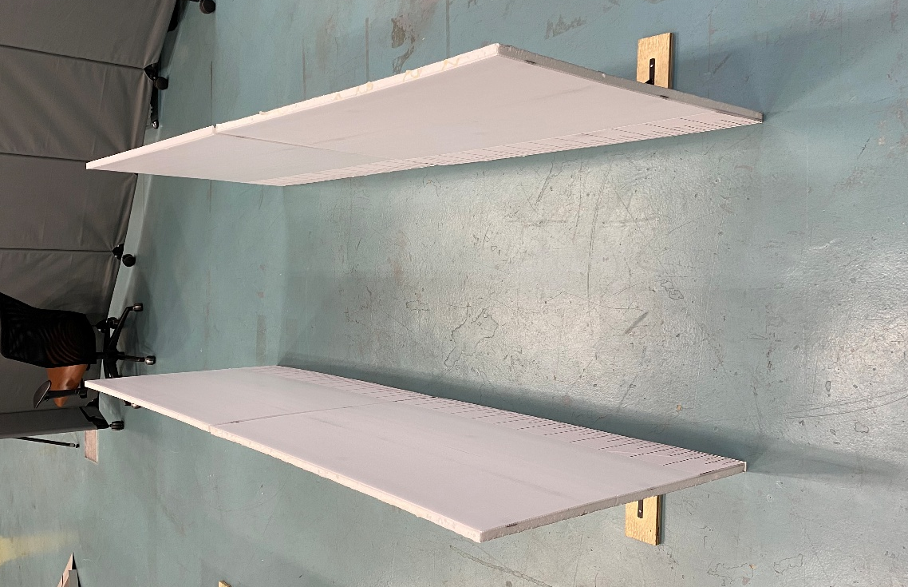
Figure 10. Image of straight corridor, bounded by foam walls. The walls are movable, allowing the corridor width to progressively reduce in size.

Table 23. Clear width path of travel (mm)
Data Source | N | Min | Mean | SD | 90th %ile | 95th  %ile | 99th %ile | Max
Laboratory-derived data
All WhMDs | 184 | 850 | 864 | 31 | 900 | 900 | 1000 | 1050
Manual Wheelchair | 70 | 850 | 866 | 30 | 900 | 900 | 966 | 1000
Power Wheelchair | 86 | 850 | 867 | 35 | 900 | 900 | 1008 | 1050
Mobility Scooter | 28 | 850 | 850 | 0 | 850 | 850 | 850 | 850
Wheelchairs Only | 156 | 850 | 866 | 33 | 900 | 900 | 1000 | 1050
WhMD+ | 5 | 850 | 1030 | 168 | 1200 | 1250 | 1290 | 1300
Walker Users | 30 | 850 | 850 | 0 | 850 | 850 | 850 | 850
Guide Dog Users | 3 | 850 | 900 | 87 | 970 | 985 | 997 | 1000
Bootstrapped estimates
All WhMDs | 184 | 850 | 861 | 27 | 900 | 902 | 965 | 1050
Manual Wheelchair | 99 | 850 | 866 | 30 | 900 | 914 | 967 | 1000
Power Wheelchair | 26 | 850 | 867 | 35 | 902 | 920 | 960 | 1050
Mobility Scooter | 59 | 850 | 850 | 0 | 850 | 850 | 850 | 850
Wheelchairs Only | 125 | 850 | 866 | 31 | 900 | 915 | 976 | 1050

L-turn
An L-turn represents a 90-degree change in direction within a corridor. Participants were instructed to complete both right and left 90-degree turns within our bounded space (Figure 11). The corridor width was progressively reduced until the participant could no longer complete the turn without contacting the walls, or until a predetermined minimum corridor width was reached. This minimum allowable width was set at 1000 mm, consistent with NBCC 2025. The recorded outcome reflects the minimum corridor width required to successfully complete both left and right turns, with the final reported value corresponding to the larger of the two measurements. Descriptive statistics for the corridor width required for a 90-degree or L-turn (minimum, maximum, mean, percentiles) are presented in Table 24.

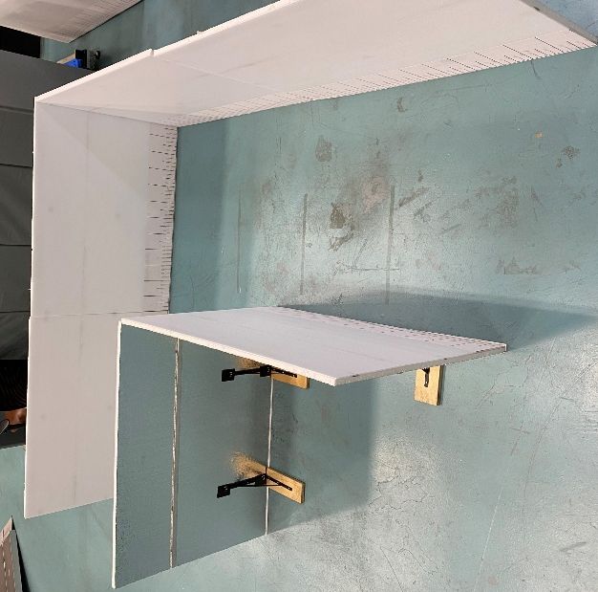
Figure 11. Image of corridor with a 90-degree turn, bounded by foam walls. The walls are movable, allowing the space to progressively reduce in size.

Table 24. Corridor width to perform a 90-degree or L-Turn (mm)
Data Source | N | Min | Mean | SD | 90th %ile | 95th  %ile | 99th %ile | Max
Laboratory-derived data
All WhMDs | 184 | 1000 | 1019 | 42 | 1050 | 1100 | 1200 | 1200
Manual Wheelchair | 70 | 1000 | 1014 | 33 | 1050 | 1050 | 1131 | 1200
Power Wheelchair | 86 | 1000 | 1016 | 39 | 1050 | 1100 | 1150 | 1150
Mobility Scooter | 28 | 1000 | 1041 | 64 | 1150 | 1183 | 1200 | 1200
Wheelchairs Only | 156 | 1000 | 1015 | 36 | 1050 | 1100 | 1150 | 1200
WhMD+ | 5 | 1000 | 1080 | 130 | 1220 | 1260 | 1292 | 1300
Walker Users | 30 | 1000 | 1000 | 0 | 1000 | 1000 | 1000 | 1000
Guide Dog Users | 3 | 1000 | 1000 | 0 | 1000 | 1000 | 1000 | 1000
Bootstrapped estimates
All WhMDs | 184 | 1000 | 1023 | 47 | 1077 | 1135 | 1197 | 1200
Manual Wheelchair | 99 | 1000 | 1014 | 33 | 1050 | 1064 | 1140 | 1200
Power Wheelchair | 26 | 1000 | 1015 | 38 | 1057 | 1091 | 1123 | 1150
Mobility Scooter | 59 | 1000 | 1041 | 63 | 1146 | 1181 | 1198 | 1200
Wheelchairs Only | 125 | 1000 | 1014 | 34 | 1050 | 1074 | 1152 | 1200

U-turn around a barrier
Participants were instructed to complete a turn around a centrally positioned barrier (3″) within a bounded space (Figure 12). Three corridors were configured to equal widths, which were progressively reduced until the participant could no longer complete the maneuver successfully or until the minimum width specified by current accessibility standards was reached. The minimum set width for this maneuver was 1100 mm, aligning with the version of CSA B651 that was current at the time of data collection (CSA B651:2018).

Participants performed the turn around the barrier in both clockwise and counter-clockwise directions. The recorded outcome represents the minimum corridor width required to complete the maneuver in both directions; when different widths were required for each direction, the larger value was retained as the minimum required width. Descriptive statistics for the corridor width to perform a U-turn around a barrier (minimum, maximum, mean, percentiles) are presented in Table 25.

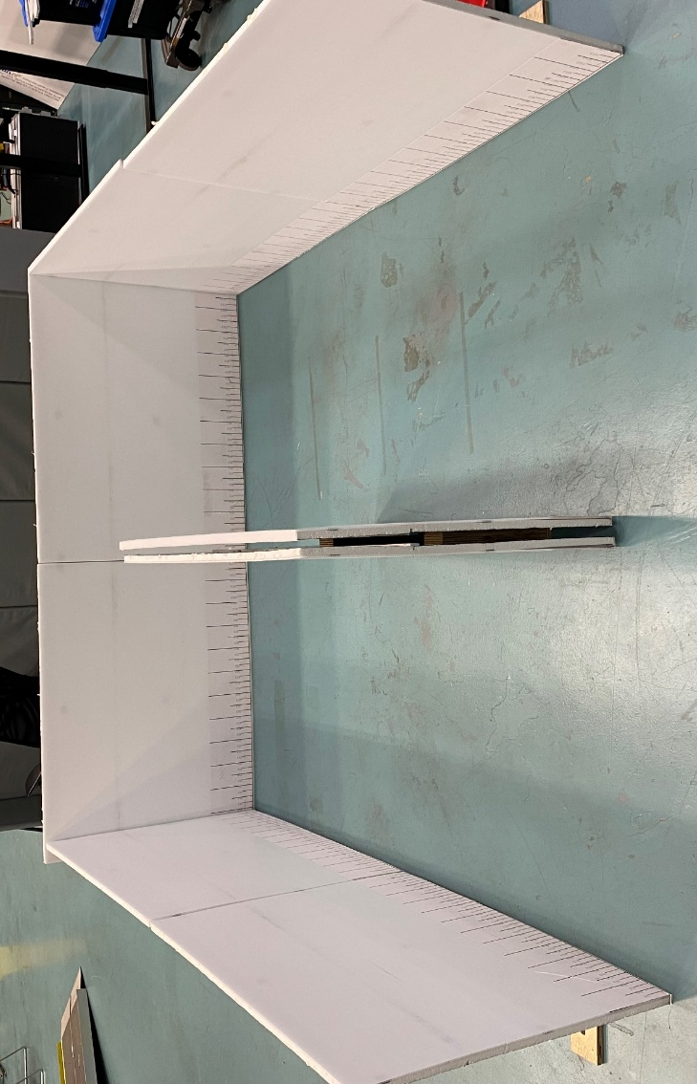

Figure 12. Image of square space bounded by three walls, with a centrally positioned barrier, bounded by foam walls. The walls are movable, allowing the space to progressively reduce in size.

Table 25. U-Turn around a barrier (mm)
Data Source | N | Min | Mean | SD | 90th %ile | 95th  %ile | 99th %ile | Max
Laboratory-derived data
All WhMDs | 184 | 1100 | 1115 | 47 | 1150 | 1200 | 1359 | 1400
Manual Wheelchair | 70 | 1100 | 1103 | 14 | 1100 | 1100 | 1166 | 1200
Power Wheelchair | 86 | 1100 | 1106 | 21 | 1125 | 1150 | 1165 | 1250
Mobility Scooter | 28 | 1100 | 1170 | 98 | 1315 | 1383 | 1400 | 1400
Wheelchairs Only | 156 | 1100 | 1105 | 19 | 1100 | 1150 | 1173 | 1250
WhMD+ | 5 | 1100 | 1130 | 45 | 1180 | 1190 | 1198 | 1200
Walker Users | 30 | 1100 | 1100 | 0 | 1100 | 1100 | 1100 | 1100
Guide Dog Users | 3 | 1100 | 1100 | 0 | 1100 | 1100 | 1100 | 1100
Bootstrapped estimates
All WhMDs | 184 | 1100 | 1125 | 64 | 1194 | 1277 | 1389 | 1400
Manual Wheelchair | 99 | 1100 | 1103 | 14 | 1100 | 1113 | 1168 | 1200
Power Wheelchair | 26 | 1100 | 1106 | 21 | 1120 | 1138 | 1165 | 1250
Mobility Scooter | 59 | 1100 | 1170 | 96 | 1327 | 1376 | 1397 | 1400
Wheelchairs Only | 125 | 1100 | 1104 | 16 | 1101 | 1125 | 1173 | 1250

Summary of recommendations, path of travel
The following summarizes our recommendations for space design where a width of the path of travel is used (e.g. straight path navigation, 90-degree or L-turn, U-turn around a barrier).
- Comparison with current Canadian standards and codes
In public spaces, the required clear width path of travel varies across accessibility standards. The CSA/ASC B651:23 standard specifies a minimum clear width of 1200 mm, whereas several other standards require greater widths (see Table 3). This minimum width may also apply to spaces with an L-turn (90-degree turn) or turning around an obstacle. In contrast, NBCC (2025) permits a reduced width of 1000 mm.
For both our collected and resampled data, the clear width path of travel of 1200 mm accommodates 100% of wheeled mobility device (WhMD) users when navigating a straight line or L-turn. A reduced width of 1000 mm, as permitted by the NBCC (2025), would accommodate approximately 90th percent of WhMD users performing an L-turn, and 100% of users navigating a straight path of travel, though this is without consideration of, or accounting for, a passerby.

- Minimum width of the path of travel to accommodate 95% of users
When resampled to reflect the population distribution of wheeled mobility devices, the recommended minimum width of the path of travel is 1200 mm, consistent with the current standard outlined in CSA/ASC B651:23. In our dataset, while this width accommodates 100% of wheeled mobility device users navigating a straight line, and performing the L-turn maneuver, this also closely aligns with the space requirements observed for other users, including WhMD users travelling with a service animal. This recommended width supports navigation when other users of the space, such as passersby, are taken into account. However, if a U-turn around a barrier is required, according to our resampled dataset, a minimum width of at least 1280 mm is recommended to accommodate 95% of WhMD users.

- Implications of clear width path of travel findings for doorway width requirements and passing widths for multiple mobility device users
Although navigation through doorways was not explicitly evaluated in this study, the clear width path of travel measurements provide insight that may inform accessible doorway widths. For example, the 900 mm width identified as accommodating approximately 95% of users for straight path navigation exceeds the minimum clear opening of many doorway standards (see Table 3).
It is important to note that our clear width path of travel measurement reflected straight navigation over a brief distance, and does not reflect the short movement through doorway widths, where the same preferred tolerances for space may not necessarily apply. Translating clear width path of travel findings to doorway design therefore warrants careful consideration.

The clear width path of travel findings also have implications for situations in which two wheeled mobility device (WhMD) users must pass one another along a pathway. Current standards typically define passing widths for multiple mobility device users as 1800 mm or greater (Table 3). Our findings indicate that a minimum path of travel width of 1800 mm would accommodate approximately 95% of WhMD users passing one another.

Functional reaching ranges of adult mobility assistive device users
A total of 218 participants completed some or all functional reaching tasks. Participants were instructed to reach toward their maximum and minimum heights, but emphasis was placed on ensuring participants could perform a “comfortable” reach for each task (e.g. not lifting off seat, no excessive bending). All reaching tasks were collected with the device configured for use, reflecting the participant’s typical/preferred positioning during functional activities (e.g. seat tilted back, foot rests extended). Participants using power wheelchairs with elevating features were instructed to avoid raising the height of their device to accomplish the task. Each participant completed as many reaching conditions as possible using their preferred hand, though completion rates differed by task (Figure 13). Additionally, several manual wheelchair users completed the reaching tasks with and without their front-powered attachments. For these reasons, sample sizes vary across measurement outcomes.

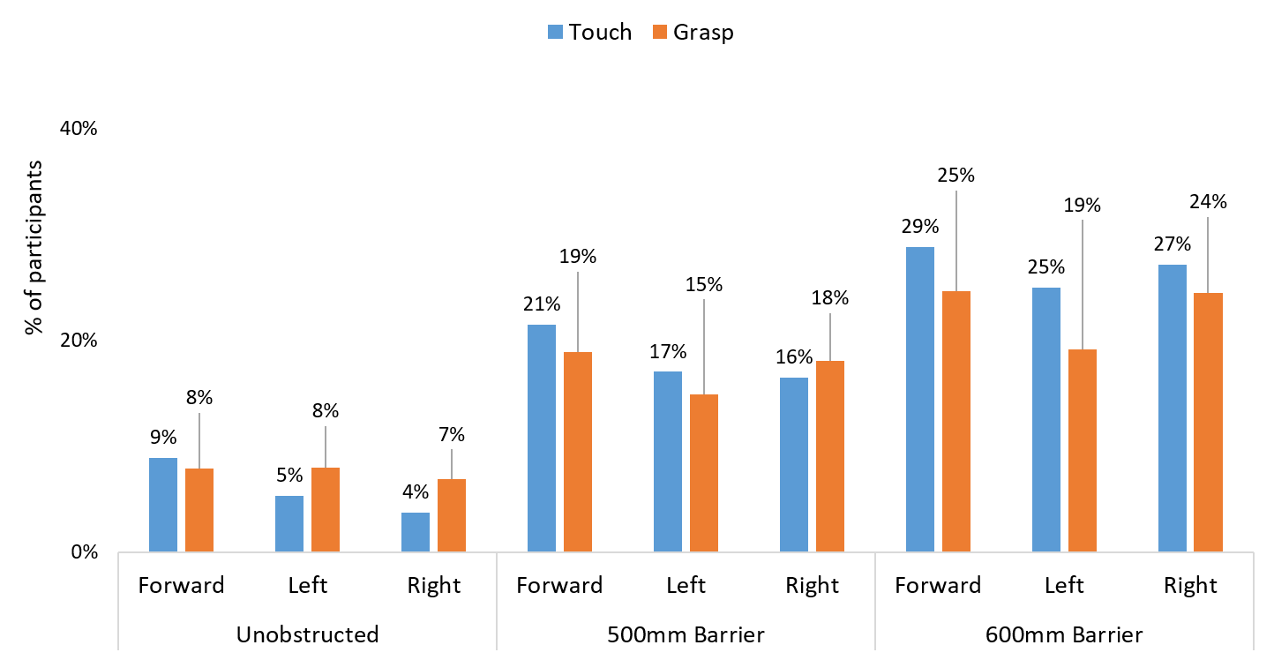

Figure 13. Percentage of our total participant sample who were unable to complete the various reaching tasks (unobstructed reaching, left; 500 mm depth obstructed reaching, middle; 600 mm depth obstructed reaching, right). Data are summarized for All WhMD users, completing the touch (blue bars) and grasp (orange bars) tasks

Descriptive statistics (minimum, maximum, mean, percentiles) are presented for each of the reaching task, including laboratory-derived data and via bootstrapping analysis using resampled data based on the distribution of mobility devices among the Canadian population. For reach ranges, bootstrapped estimates are presented for completeness but are not used to inform recommendations. Instead, recommendations are based on laboratory-derived data due to the functional demands of reaching tasks. This approach was taken, as our laboratory collected data included a higher proportion of power wheelchair users relative to population prevalence. Grounding recommendations in the collected laboratory data is therefore more functionally relevant and supports greater accommodation for wheeled mobility device users, particularly those using power wheelchairs. This is also consistent with our conservative approach used for static measurements and functional maneuvers, where we prioritize inclusivity in generating recommendations. In this case, relying on bootstrapped estimates would underrepresent power wheelchair users and potentially exclude their functional needs. Accordingly, we apply a consistent decision-making framework, using bootstrapped or non-bootstrapped data as appropriate, to ensure recommendations are both conservative and inclusive.
Primary results are presented for WhMD users (manual wheelchairs, power wheelchairs, and mobility scooters). Comparative results for participants using other mobility aids (e.g., walkers) are reported, when applicable, but are not included in WhMD summary statistics.

Unobstructed Reaches
Unobstructed reaches (Figure 14) were performed with participants facing the wall directly (forward) and, where possible, in parallel to the wall (left- and right-side facing). Direction is defined relative to the participant (e.g., left lateral reach = participant’s left side facing the board), not the reaching hand.

Participants reached using their preferred hand to either press a 3-inch diameter button (“touch” task) or place a 0.6 kg weighted cup on a 4” deep shelf (“grasp” task). For consistency, participants were encouraged to use the same hand across successive conditions when feasible (e.g., right hand for all forward reaches). Reaching height was recorded in millimeters (mm) from the floor to the center of the button (touch task) or to the shelf height (grasp task; maximum reach height only). All reaches were performed at a self-selected distance from the wall. The distance from the wall to the nearest point of the individual, or their mobility device, was recorded as a measure of tolerance (Appendix E).

Maximum reaching heights are reported at the 1st, 5th, and 10th percentiles, representing thresholds that 99%, 95%, and 90% of participants can exceed, respectively. Minimum reaching heights are reported at the 90th, 95th, and 99th percentiles, indicating the proportion of participants able to reach below each value. Descriptive statistics for maximum and minimum unobstructed reaching heights, are presented separately for touch and grasp, and for forward vs. lateral reaching, tasks (Tables 26-31). Reach ranges across all mobility device types are summarized in Figure 15.

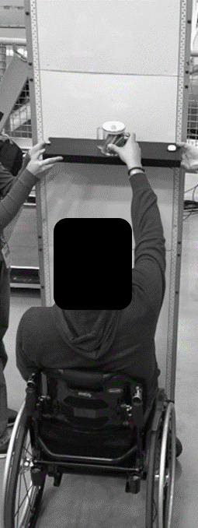
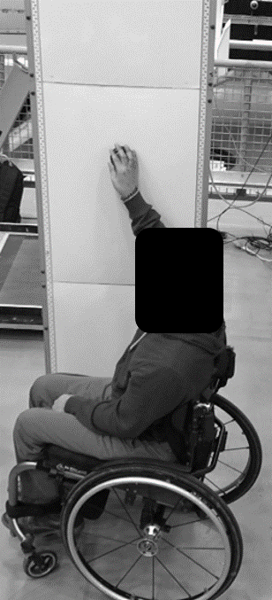

Figure 14. Image of a manual wheelchair user performing an unobstructed lateral touch reach (left) and an unobstructed forward grasp reach (right).

Table 26. Unobstructed forward reaching heights for a touch task (mm)
Data Source |  | Maximum reaching height (mm) |  |  |  |  |  |  | Minimum reaching height (mm)
 | N | Min | Mean | SD | 10th %ile | 5th %ile | 1st %ile | Max | Min | Mean | SD | 90th %ile | 95th %ile | 99th %ile | Max
Laboratory-derived data
All WhMDs | 174 | 820 | 1382 | 200 | 1102 | 1047 | 919 | 1820 | 30 | 489 | 226 | 789 | 860 | 968 | 1000
Manual Wheelchair | 71 | 1090 | 1446 | 180 | 1190 | 1130 | 1097 | 1820 | 30 | 376 | 199 | 655 | 725 | 909 | 930
Power Wheelchair | 76 | 820 | 1335 | 219 | 1033 | 958 | 891 | 1765 | 80 | 537 | 206 | 788 | 830 | 889 | 960
Mobility Scooter | 27 | 1050 | 1349 | 146 | 1170 | 1139 | 1070 | 1595 | 150 | 652 | 206 | 860 | 951 | 997 | 1000
Wheelchairs Only | 147 | 820 | 1388 | 208 | 1096 | 1030 | 917 | 1820 | 30 | 459 | 218 | 762 | 807 | 916 | 960
Walker Users | 30 | 1150 | 1694 | 208 | 1439 | 1408 | 1220 | 1980 | 270 | 640 | 222 | 934 | 987 | 1000 | 1000
Bootstrapped estimates
All WhMDs | 174 | 820 | 1399 | 181 | 1163 | 1103 | 1004 | 1820 | 30 | 487 | 236 | 809 | 866 | 982 | 1000
Manual Wheelchair | 94 | 1090 | 1445 | 179 | 1200 | 1139 | 1099 | 1820 | 30 | 376 | 198 | 652 | 733 | 876 | 930
Power Wheelchair | 24 | 820 | 1335 | 218 | 1049 | 991 | 932 | 1765 | 80 | 537 | 204 | 778 | 814 | 859 | 960
Mobility Scooter | 56 | 1050 | 1349 | 143 | 1168 | 1127 | 1072 | 1595 | 150 | 653 | 202 | 877 | 948 | 991 | 1000
Wheelchairs Only | 118 | 820 | 1423 | 193 | 1162 | 1100 | 987 | 1820 | 30 | 409 | 209 | 704 | 779 | 896 | 960

Table 27. Unobstructed lateral reaching heights for a touch task when reaching to the left side (mm)
Data Source |  | Maximum reaching height (mm) |  |  |  |  |  |  | Minimum reaching height (mm)
 | N | Min | Mean | SD | 10th %ile | 5th %ile | 1st %ile | Max | Min | Mean | SD | 90th %ile | 95th %ile | 99th %ile | Max
Laboratory-derived data
All WhMDs | 178 | 780 | 1493 | 233 | 1155 | 1077 | 841 | 1940 | 0 | 408 | 220 | 712 | 801 | 917 | 980
Manual Wheelchair | 69 | 900 | 1536 | 212 | 1246 | 1142 | 1009 | 1940 | 0 | 293 | 189 | 526 | 660 | 796 | 830
Power Wheelchair | 81 | 780 | 1423 | 254 | 1105 | 980 | 804 | 1895 | 80 | 502 | 210 | 770 | 820 | 948 | 980
Mobility Scooter | 28 | 1130 | 1588 | 159 | 1407 | 1387 | 1198 | 1830 | 100 | 416 | 194 | 710 | 713 | 777 | 800
Wheelchairs Only | 150 | 780 | 1475 | 241 | 1148 | 1060 | 830 | 1940 | 0 | 406 | 225 | 721 | 808 | 925 | 980
Walker Users | 30 | 1130 | 1659 | 265 | 1305 | 1262 | 1159 | 2100 | 260 | 575 | 236 | 877 | 907 | 984 | 1010
Bootstrapped estimates
All WhMDs | 178 | 780 | 1537 | 208 | 1243 | 1135 | 958 | 1940 | 0 | 362 | 207 | 679 | 737 | 833 | 980
Manual Wheelchair | 96 | 900 | 1537 | 210 | 1239 | 1140 | 997 | 1940 | 0 | 293 | 188 | 539 | 652 | 785 | 830
Power Wheelchair | 25 | 780 | 1423 | 252 | 1112 | 1017 | 914 | 1895 | 80 | 503 | 208 | 754 | 816 | 883 | 980
Mobility Scooter | 57 | 1130 | 1587 | 156 | 1408 | 1342 | 1199 | 1830 | 100 | 417 | 191 | 701 | 728 | 776 | 800
Wheelchairs Only | 121 | 780 | 1513 | 224 | 928 | 1098 | 928 | 1940 | 0 | 336 | 210 | 627 | 733 | 846 | 980

Table 28. Unobstructed lateral reaching heights for a touch task when reaching to the right side (mm)
Data Source |  | Maximum reaching height (mm) |  |  |  |  |  |  | Minimum reaching height (mm)
 | N | Min | Mean | SD | 10th %ile | 5th %ile | 1st %ile | Max | Min | Mean | SD | 90th %ile | 95th %ile | 99th %ile | Max
Laboratory-derived data
All WhMDs | 181 | 825 | 1478 | 248 | 1080 | 1015 | 888 | 1970 | 0 | 413 | 216 | 720 | 790 | 882 | 895
Manual Wheelchair | 69 | 880 | 1548 | 214 | 1290 | 1172 | 975 | 1970 | 0 | 295 | 195 | 572 | 622 | 833 | 840
Power Wheelchair | 84 | 825 | 1394 | 264 | 1017 | 963 | 879 | 1910 | 80 | 505 | 191 | 771 | 810 | 882 | 890
Mobility Scooter | 28 | 1020 | 1556 | 199 | 1237 | 1198 | 1063 | 1830 | 95 | 429 | 206 | 710 | 723 | 850 | 895
Wheelchairs Only | 153 | 825 | 1464 | 254 | 1068 | 1010 | 885 | 1970 | 0 | 410 | 219 | 720 | 798 | 864 | 890
Walker Users | 30 | 1110 | 1702 | 278 | 1339 | 1226 | 1119 | 2140 | 270 | 612 | 236 | 879 | 985 | 1017 | 1020
Bootstrapped estimates
All WhMDs | 181 | 825 | 1530 | 221 | 1221 | 1078 | 944 | 1970 | 0 | 367 | 213 | 669 | 748 | 866 | 895
Manual Wheelchair | 98 | 880 | 1548 | 212 | 1284 | 1161 | 976 | 1970 | 0 | 294 | 194 | 567 | 655 | 808 | 840
Power Wheelchair | 25 | 825 | 1396 | 262 | 1045 | 988 | 929 | 1910 | 80 | 506 | 190 | 745 | 790 | 834 | 890
Mobility Scooter | 58 | 1020 | 1556 | 195 | 1261 | 1175 | 1066 | 1830 | 95 | 430 | 202 | 701 | 753 | 850 | 895
Wheelchairs Only | 123 | 825 | 1517 | 232 | 1199 | 1060 | 925 | 1970 | 0 | 337 | 211 | 627 | 739 | 836 | 890

Table 29. Unobstructed forward reaching maximum heights for a grasp task (mm)
Data Source | N | Min | Mean | SD | 10th %ile | 5th %ile | 1st %ile | Max
Laboratory-derived data
All WhMDs | 176 | 735 | 1314 | 202 | 1060 | 945 | 875 | 1740
Manual Wheelchair | 71 | 930 | 1369 | 184 | 1110 | 1055 | 993 | 1730
Power Wheelchair | 78 | 735 | 1268 | 227 | 945 | 929 | 831 | 1740
Mobility Scooter | 27 | 960 | 1305 | 129 | 1193 | 1187 | 1019 | 1615
Wheelchairs Only | 149 | 735 | 1316 | 213 | 1048 | 942 | 870 | 1740
Walker Users | 30 | 1100 | 1541 | 224 | 1252 | 1175 | 1120 | 1970
Bootstrapped estimates
All WhMDs | 176 | 735 | 1334 | 178 | 1111 | 1029 | 928 | 1740
Manual Wheelchair | 95 | 930 | 1369 | 182 | 1111 | 1055 | 989 | 1730
Power Wheelchair | 25 | 735 | 1268 | 225 | 990 | 937 | 875 | 1740
Mobility Scooter | 56 | 960 | 1305 | 127 | 1190 | 1141 | 993 | 1615
Wheelchairs Only | 120 | 735 | 1348 | 196 | 1080 | 1017 | 831 | 1740

Table 30. Unobstructed lateral reaching maximum heights for a grasp task when reaching to the left side (mm)
Data Source | N | Min | Mean | SD | 10th %ile | 5th %ile | 1st %ile | Max
Laboratory-derived data
All WhMDs | 173 | 835 | 1355 | 234 | 1012 | 936 | 857 | 1800
Manual Wheelchair | 69 | 835 | 1412 | 223 | 1110 | 1008 | 852 | 1785
Power Wheelchair | 76 | 850 | 1283 | 244 | 960 | 890 | 861 | 1765
Mobility Scooter | 28 | 1010 | 1412 | 182 | 1188 | 1125 | 1034 | 1800
Wheelchairs Only | 145 | 835 | 1345 | 242 | 990 | 898 | 854 | 1785
Walker Users | 30 | 1035 | 1477 | 245 | 1177 | 1150 | 1068 | 2040
Bootstrapped estimates
All WhMDs | 172 | 835 | 1394 | 217 | 1095 | 995 | 867 | 1800
Manual Wheelchair | 93 | 835 | 1412 | 222 | 1104 | 992 | 867 | 1785
Power Wheelchair | 24 | 850 | 1282 | 242 | 980 | 933 | 894 | 1765
Mobility Scooter | 55 | 1010 | 1412 | 178 | 1184 | 1114 | 1040 | 1800
Wheelchairs Only | 117 | 835 | 1385 | 232 | 1057 | 948 | 858 | 1785

Table 31. Unobstructed lateral reaching maximum heights for a grasp task when reaching to the right side (mm)
Data Source | N | Min | Mean | SD | 10th %ile | 5th %ile | 1st %ile | Max
Laboratory-derived data
All WhMDs | 175 | 700 | 1355 | 244 | 1014 | 927 | 817 | 1835
Manual Wheelchair | 69 | 830 | 1415 | 228 | 1058 | 986 | 891 | 1835
Power Wheelchair | 78 | 700 | 1289 | 260 | 947 | 864 | 762 | 1835
Mobility Scooter | 28 | 960 | 1394 | 191 | 1147 | 1082 | 984 | 1765
Wheelchairs Only | 147 | 700 | 1348 | 253 | 982 | 892 | 803 | 1835
Walker Users | 30 | 970 | 1503 | 252 | 1196 | 1130 | 1011 | 2070
Bootstrapped estimates
All WhMDs | 176 | 700 | 1390 | 224 | 1069 | 975 | 860 | 1835
Manual Wheelchair | 95 | 830 | 1414 | 227 | 1077 | 984 | 888 | 1835
Power Wheelchair | 25 | 700 | 1289 | 260 | 970 | 899 | 826 | 1835
Mobility Scooter | 56 | 960 | 1395 | 187 | 1154 | 1072 | 990 | 1765
Wheelchairs Only | 120 | 700 | 1388 | 239 | 1040 | 950 | 843 | 1835

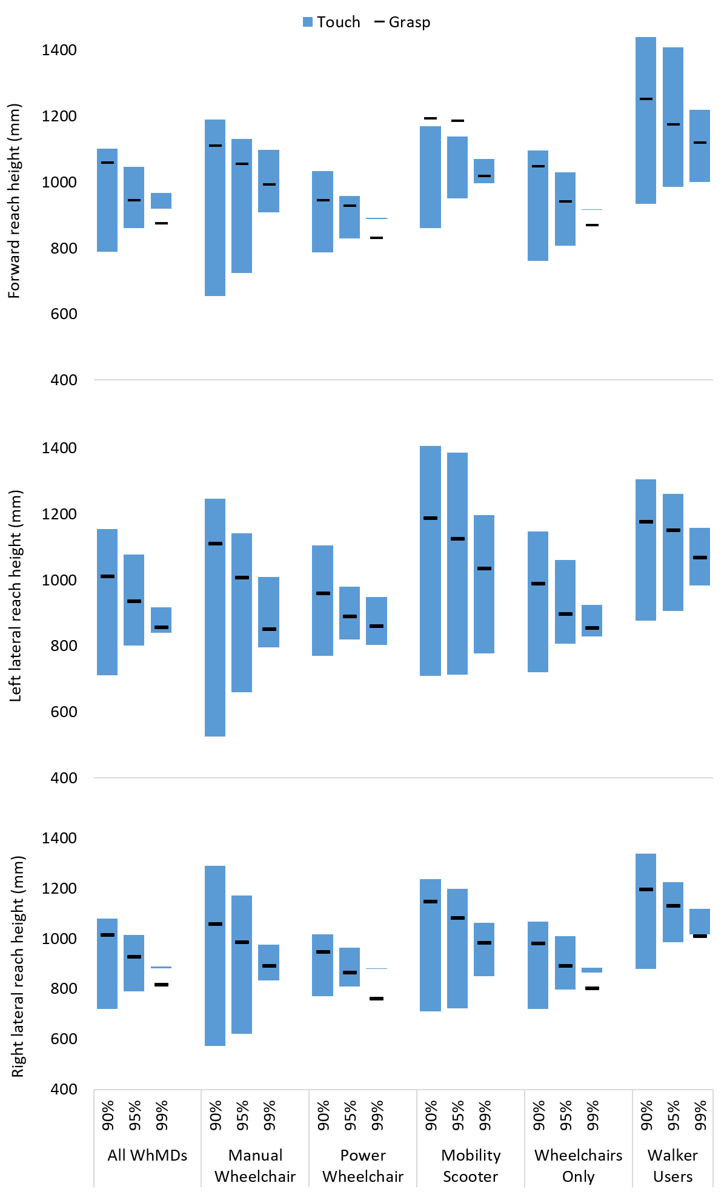
Figure 15. Unobstructed reaching ranges of mobility device users (mm), for reaching in the following directions: forward (top), lateral reaching to the left (middle), and lateral reaching to the right (bottom). Data are presented for the reaching ranges associated with the touch task (blue bars) that accommodate 90%, 95%, and 99% of participants; all WhMD users are presented as a summary, with each device type also presented individually. The maximum reaching height for the grasp task (black line) is included for comparison.

Summary of Recommendations, Unobstructed Reach Ranges
The following summarizes our recommendations for space design where unobstructed reach ranges be applied.
- Considerations of forward vs. lateral reaching, and clear floor area for unobstructed reaches
Forward reaches were often performed with participants’ toes contacting the wall surface indicating that participants preferred to minimize their distance to achieve optimal reach height. This suggests that any obstruction within the clear floor space can meaningfully reduce effective forward reach capacity. In contrast, lateral reaches showed slightly higher sample size (e.g. greater proportion of participants able to complete lateral reaching vs. forward reaching) and greater tolerances with respect to the wall. These findings suggest that permitting a parallel approach may enhance accessibility for some users, provided that the clear floor space is designed to consider the preferred clearance from the wall (see Appendix E).

- Functional reach ranges for operating controls based on touching vs. grasping tasks
Observationally, the participants reach performance differed only slightly between touching and grasping tasks, with maximum grasp heights generally lower than maximum touch heights, reflecting the additional strength, coordination, and postural control required to functionally place or manipulate an object rather than simply make contact. These reduced grasp capacities should be carefully considered when establishing installation heights for controls or fixtures that require grasping or other tasks involving higher levels of strength, coordination, or motor control.

- Comparison with current Canadian standards and codes
The reach range envelope specified in current standards generally provides a minimum height of 400 mm from the floor and a maximum height of approximately 1100–1200 mm (see Table 4. Summary of select codes and standards across Canada (and internationally) defining accessible design elements guided by reaching ranges). These ranges are intended to guide the placement of operating controls and other accessibility features, though specific elements, such as faucets, door hardware, or visual display controls, may impose more restrictive height requirements and require a smaller installation range than the general guiding recommendations. Based on our collected sample, using a minimum height of 400 mm would accommodate fewer than 50% of participants for forward or lateral touch tasks. In contrast, a maximum height of 1100 mm, consistent with several current standards, would accommodate approximately 90% of participants for touch tasks in either direction, but fewer than 90% for grasp tasks.

- Reaching range to accommodate 95% of users
As a conservative approach, we are basing our reach range recommendations on laboratory-collected data rather than on bootstrapped estimates. In practice, it may be difficult to anticipate whether a user will adopt a forward or lateral approach. Accordingly, our general recommendations are intended to accommodate both directions. To accommodate 95% of WhMD users in our collected sample, we recommend a maximum height of approximately 1015 mm and a minimum height of 860 mm, supporting both forward and lateral approaches for touch tasks.

Note: these recommendations are primarily based on touch activities, such as operating push buttons. Maximum grasp heights are slightly lower than touch heights, reflecting the additional strength and control required to lift or place objects, particularly at upper reach limits. Consequently, while the touch-based reach ranges can serve as the primary guide for design, the grasp task values should be used to define the upper limits of operable controls or storage areas where more demanding grasping tasks are expected, ensuring functional usability for the majority of WhMD users.

Obstructed reaches
Obstructed reaches (Figure 16) were assessed to determine the maximum heights participants could achieve when reaching above a fixed height counter or table surface for touch or grasp tasks. Participants completed reaching tasks over a table with a width of 800 mm, surface height of 860 mm above the floor, and an under-table clearance of 730 mm along the full depth. Two counter/table depths, 500 mm and 600 mm, were evaluated for all reaching conditions. Results were generally similar across the two evaluated depths although a greater number of participants were unable to complete the task at the 600 mm depth (see Figure 13 above), therefore we present here only the findings from the 500 mm depth condition. Results for the 600 mm depth obstruction are provided in Appendix F.

All obstructed reaches were performed at a self-selected distance from the counter/table edge. Similar to unobstructed reaching (3.4.1), maximum reaching heights are reported at the 1st, 5th, and 10th percentiles, representing thresholds that 99%, 95%, and 90% of participants can exceed, respectively. Descriptive statistics for maximum obstructed reaching heights, are presented separately for touch and grasp, and for forward vs. lateral reaching, tasks (Tables 32-37). For our obstructed reaching, several participants were unable to complete the task, reflected by the varying participant sample size presented in the summary tables. Obstructed reach ranges across all mobility device types are presented in Figure 17.

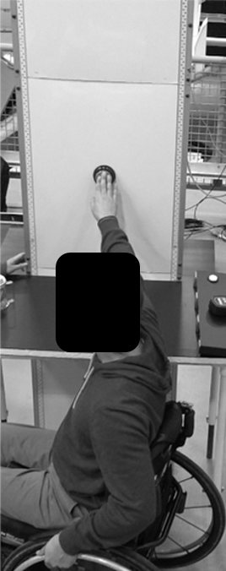
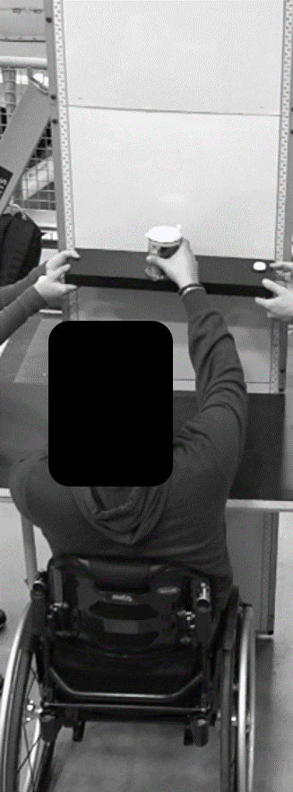

Figure 16. Image of a manual wheelchair user performing an obstructed lateral touch reach (left) and an obstructed forward grasp reach (right).

Table 32. Maximum forward reaching heights over a 500 mm depth obstruction, for a touch task (mm)
Data Source | N | Min | Mean | SD | 10th %ile | 5th %ile | 1st %ile | Max
Laboratory-derived data
All WhMDs | 146 | 860 | 1326 | 199 | 1058 | 983 | 944 | 1760
Manual Wheelchair | 66 | 935 | 1387 | 190 | 1148 | 1063 | 977 | 1760
Power Wheelchair | 68 | 860 | 1285 | 201 | 1008 | 972 | 924 | 1755
Mobility Scooter | 12 | 970 | 1219 | 127 | 1071 | 1022 | 980 | 1420
Wheelchairs Only | 134 | 860 | 1335 | 202 | 1057 | 987 | 942 | 1760
Walker Users | 29 | 1000 | 1508 | 235 | 1228 | 1161 | 1038 | 2020
Bootstrapped estimates
All WhMDs | 146 | 860 | 1319 | 189 | 1077 | 1012 | 955 | 1760
Manual Wheelchair | 79 | 935 | 1387 | 190 | 1137 | 1070 | 987 | 1760
Power Wheelchair | 20 | 860 | 1286 | 200 | 1045 | 1001 | 959 | 1755
Mobility Scooter | 47 | 970 | 1218 | 122 | 1049 | 999 | 974 | 1420
Wheelchairs Only | 99 | 860 | 1367 | 196 | 1105 | 1037 | 957 | 1760

Table 33. Maximum lateral reaching maximum heights when reaching to the left over a 500 mm depth obstruction (mm), for a touch task
Data Source | N | Min | Mean | SD | 10th %ile | 5th %ile | 1st %ile | Max
Laboratory-derived data
All WhMDs | 152 | 945 | 1281 | 184 | 1060 | 986 | 953 | 1780
Manual Wheelchair | 63 | 980 | 1321 | 185 | 1064 | 1032 | 980 | 1780
Power Wheelchair | 64 | 945 | 1238 | 179 | 1030 | 976 | 945 | 1565
Mobility Scooter | 25 | 1050 | 1321 | 171 | 1108 | 1092 | 1060 | 1705
Wheelchairs Only | 127 | 945 | 1279 | 186 | 1050 | 980 | 949 | 1780
Walker Users | 28 | 1140 | 1548 | 248 | 1178 | 1144 | 1140 | 2000
Bootstrapped estimates
All WhMDs | 152 | 945 | 1310 | 180 | 1075 | 1035 | 977 | 1780
Manual Wheelchair | 82 | 980 | 1321 | 184 | 1075 | 1025 | 985 | 1780
Power Wheelchair | 21 | 945 | 1237 | 178 | 1034 | 1002 | 975 | 1565
Mobility Scooter | 49 | 1050 | 1321 | 168 | 1108 | 1086 | 1061 | 1705
Wheelchairs Only | 103 | 945 | 1304 | 186 | 1060 | 1010 | 973 | 1780

Table 34. Maximum lateral reaching maximum heights when reaching to the right over a 500 mm depth obstruction (mm), for a touch task
Data Source | N | Min | Mean | SD | 10th %ile | 5th %ile | 1st %ile | Max
Laboratory-derived data
All WhMDs | 152 | 860 | 1280 | 197 | 1016 | 973 | 913 | 1745
Manual Wheelchair | 64 | 960 | 1322 | 191 | 1053 | 1032 | 963 | 1745
Power Wheelchair | 61 | 860 | 1228 | 206 | 980 | 930 | 887 | 1715
Mobility Scooter | 27 | 1000 | 1295 | 170 | 1087 | 1025 | 1003 | 1690
Wheelchairs Only | 125 | 860 | 1276 | 203 | 1012 | 961 | 909 | 1745
Walker Users | 29 | 1040 | 1544 | 239 | 1219 | 1114 | 1057 | 2010
Bootstrapped estimates
All WhMDs | 152 | 860 | 1301 | 187 | 1050 | 1006 | 948 | 1745
Manual Wheelchair | 82 | 960 | 1322 | 189 | 1067 | 1028 | 977 | 1745
Power Wheelchair | 21 | 860 | 1228 | 206 | 987 | 952 | 920 | 1715
Mobility Scooter | 49 | 1000 | 1295 | 167 | 1086 | 1034 | 1007 | 1690
Wheelchairs Only | 103 | 860 | 1303 | 196 | 1044 | 996 | 939 | 1745

Table 35. Maximum forward reaching heights over a 500 mm depth obstruction, for a grasp task (mm)
Data Source | N | Min | Mean | SD | 10th %ile | 5th %ile | 1st %ile | Max
Laboratory-derived data
All WhMDs | 151 | 905 | 1306 | 195 | 1060 | 998 | 948 | 1775
Manual Wheelchair | 66 | 970 | 1362 | 181 | 1138 | 1063 | 996 | 1775
Power Wheelchair | 71 | 905 | 1266 | 203 | 1000 | 960 | 930 | 1710
Mobility Scooter | 14 | 1075 | 1249 | 153 | 1088 | 1078 | 1076 | 1570
Wheelchairs Only | 137 | 905 | 1312 | 198 | 1050 | 990 | 945 | 1775
Walker Users | 30 | 940 | 1440 | 241 | 1149 | 1124 | 989 | 2000
Bootstrapped estimates
All WhMDs | 151 | 905 | 1313 | 182 | 1086 | 1054 | 977 | 1775
Manual Wheelchair | 82 | 970 | 1362 | 179 | 1139 | 1069 | 1002 | 1775
Power Wheelchair | 21 | 905 | 1266 | 202 | 1027 | 991 | 959 | 1710
Mobility Scooter | 48 | 1075 | 1249 | 148 | 1086 | 1078 | 1075 | 1570
Wheelchairs Only | 103 | 905 | 1343 | 188 | 1095 | 1032 | 969 | 1775

Table 36. Maximum lateral reaching maximum heights when reaching to the left over a 500 mm depth obstruction (mm), for a grasp task
Data Source | N | Min | Mean | SD | 10th %ile | 5th %ile | 1st %ile | Max
Laboratory-derived data
All WhMDs | 156 | 860 | 1280 | 189 | 1028 | 990 | 938 | 1740
Manual Wheelchair | 65 | 860 | 1303 | 198 | 1028 | 983 | 911 | 1740
Power Wheelchair | 65 | 935 | 1251 | 192 | 1027 | 992 | 961 | 1635
Mobility Scooter | 26 | 990 | 1292 | 151 | 1120 | 1041 | 996 | 1630
Wheelchairs Only | 130 | 860 | 1277 | 196 | 1025 | 985 | 936 | 1740
Walker Users | 27 | 1100 | 1489 | 249 | 1126 | 1106 | 1100 | 2010
Bootstrapped estimates
All WhMDs | 156 | 860 | 1292 | 182 | 1039 | 996 | 932 | 1740
Manual Wheelchair | 84 | 860 | 1303 | 196 | 1037 | 987 | 915 | 1740
Power Wheelchair | 22 | 935 | 1252 | 191 | 1031 | 1007 | 982 | 1635
Mobility Scooter | 50 | 990 | 1292 | 148 | 1105 | 1046 | 1002 | 1630
Wheelchairs Only | 106 | 860 | 1292 | 196 | 1028 | 987 | 919 | 1740

Table 37. Maximum lateral reaching maximum heights when reaching to the right over a 500 mm depth obstruction (mm), for a grasp task
Data Source | N | Min | Mean | SD | 10th %ile | 5th %ile | 1st %ile | Max
Laboratory-derived data
All WhMDs | 149 | 900 | 1286 | 192 | 1024 | 984 | 919 | 1750
Manual Wheelchair | 64 | 950 | 1321 | 183 | 1080 | 1020 | 982 | 1750
Power Wheelchair | 59 | 900 | 1246 | 210 | 988 | 967 | 903 | 1735
Mobility Scooter | 26 | 965 | 1292 | 158 | 1100 | 1060 | 986 | 1680
Wheelchairs Only | 123 | 900 | 1285 | 199 | 1020 | 981 | 912 | 1750
Walker Users | 30 | 1000 | 1489 | 260 | 1120 | 1025 | 1006 | 2100
Bootstrapped estimates
All WhMDs | 149 | 900 | 1301 | 180 | 1064 | 1009 | 954 | 1750
Manual Wheelchair | 80 | 950 | 1321 | 181 | 1079 | 1030 | 983 | 1750
Power Wheelchair | 21 | 900 | 1247 | 208 | 1003 | 972 | 943 | 1735
Mobility Scooter | 48 | 965 | 1292 | 156 | 1099 | 1047 | 992 | 1680
Wheelchairs Only | 101 | 900 | 1305 | 190 | 1050 | 1006 | 952 | 1750

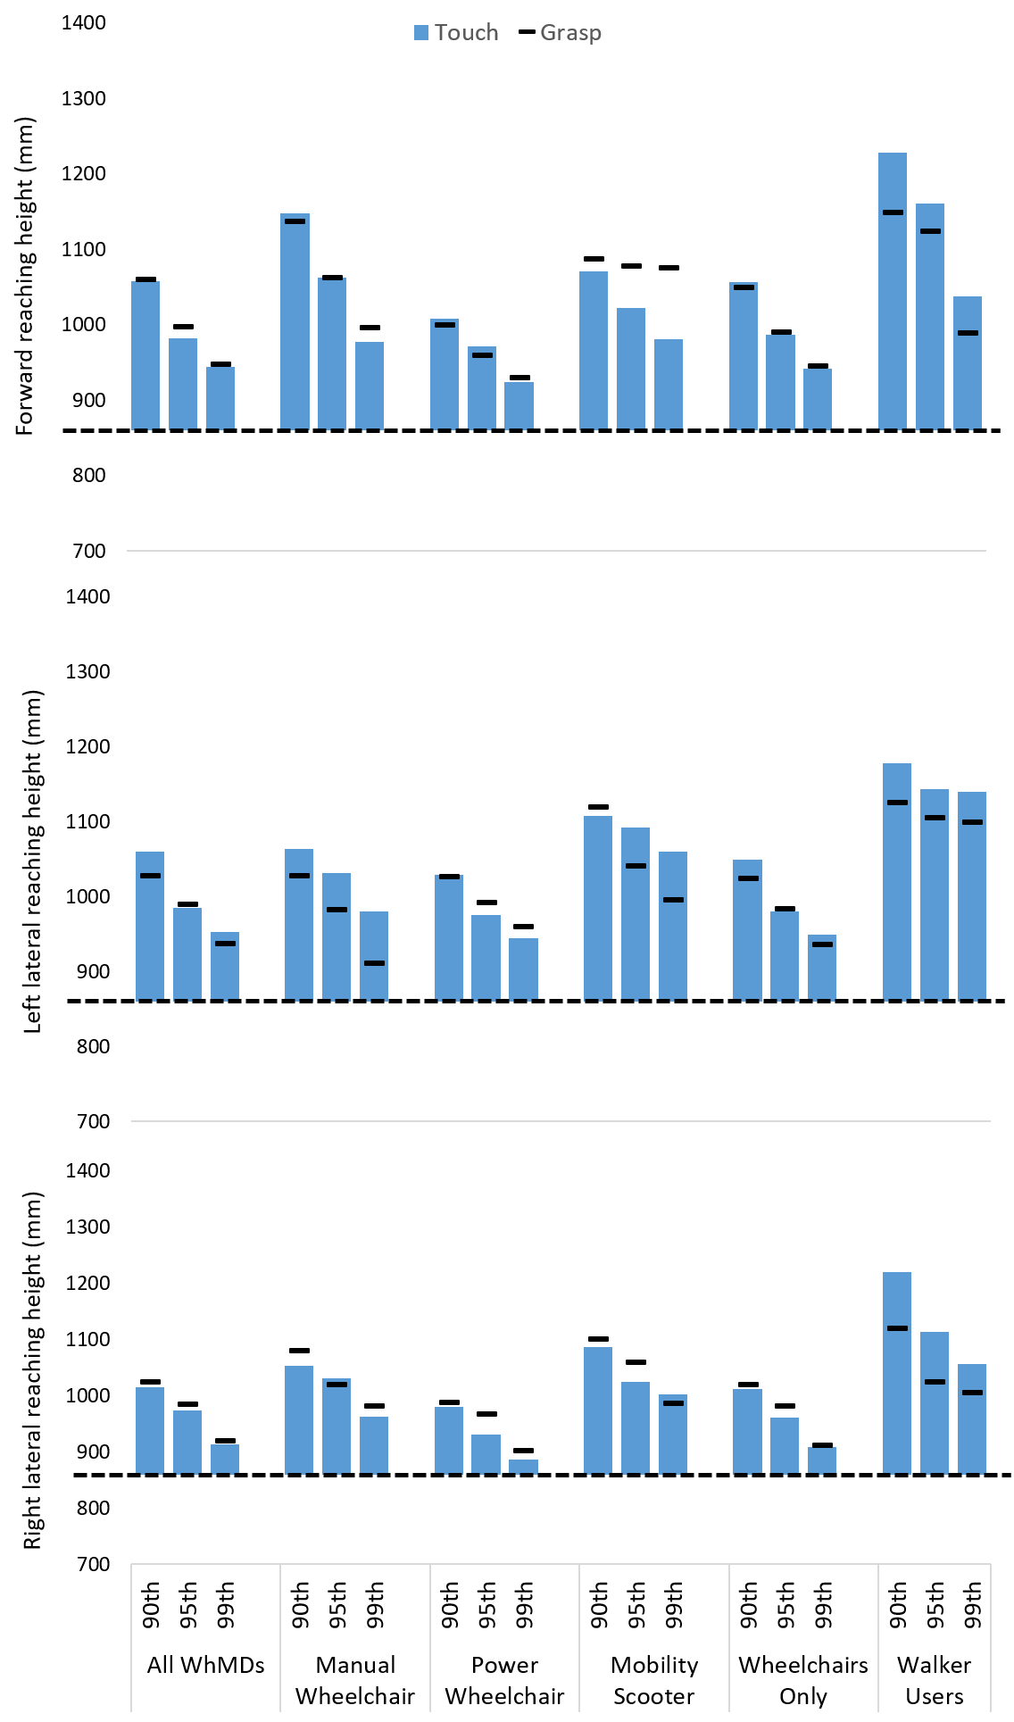
Figure 17. Obstructed reaching ranges of mobility device users (mm), across a 500 mm depth barrier, for reaching in the following directions: forward (top), lateral reaching to the left (middle), and lateral reaching to the right (bottom). Data are presented for the reaching ranges associated with the touch task (blue bars) that accommodate 90%, 95%, and 99% of participants; all WhMD users are presented as a summary, with each device type also presented individually. The maximum reaching height for the grasp task (black line) is included for comparison. Horizontal dashed line represents table height (860mm).

Summary of Recommendations, Obstructed Reach Ranges
The following summarizes our recommendations for space design where reach ranges over an obstruction are applied.
- Consideration of the depth of the obstruction
For this study, we evaluated obstructions that were 500 mm or 600 mm deep. Based on our results, the depth of an obstruction influenced participants’ ability to complete obstructed reaching tasks. A smaller proportion of participants were able to successfully perform reaching across the 600 mm depth obstruction compared to the 500 mm depth (see Figure 13). However, among those able to complete the task at both depths, maximum reach heights were generally similar, indicating that obstruction depth evaluated in this study did not substantially affect vertical reach performance once access was achieved. With this in mind, consideration of the lessened obstruction depth (i.e. 500 mm) is recommended for guiding reach range considerations. This approach supports greater inclusivity.

Of note, the ability to complete obstructed reaches was also dependent on whether participants could position their mobility device underneath the table surface, highlighting the importance of the under-surface clearance and device fit.

- Comparison with current Canadian standards and codes
Similar to unobstructed reaching, a maximum reach height of 1100 mm is recommended when reaching over an obstruction or barrier (e.g. table, counter, 500 mm depth; see Table 4), which generally applies to both forward and lateral directions (exception for ASC 2.3, which provides a lowered general maximum height of 860 mm for a lateral reach – see Table 4). Similar to unobstructed reach ranges, this maximum height may differ for specific elements such as faucets or visual display controls. Based on our collected sample, a maximum height of 1100 mm would accommodate approximately 80% to 87% of participants for touch and grasping tasks in both directions. However, the lowered height of 860 mm for lateral reaching would accommodate 100% of users in our collected sample.

- Maximum height when reaching over an obstruction to accommodate 95% of users
Similar to unobstructed reaching, recommendations for obstructed reach ranges are based on our laboratory-collected data rather than on bootstrapped estimates, to align with our conservative and inclusive approach to design recommendations. In practice, it may be difficult to anticipate whether a user will adopt a forward or lateral approach. Accordingly, our general recommendations are intended to accommodate both directions. To accommodate 95% of WhMD users in our collected sample, we recommend a maximum height of ~973 mm, supporting both forward and lateral approaches for both touch and grasp tasks.

Implications of space requirements among adult wheeled mobility device users: qualitative report
Alongside anthropometric and functional range assessments and maneuvering space testing, we undertook a qualitative, exploratory study to examine the lived experiences of WhMD users in public spaces. Interviews highlighted how design characteristics of existing environments (e.g., layout, features, spatial constraints) shape maneuverability, use, and navigation of WhMDs.

Qualitative methods
A subsample of community-dwelling adults who regularly used at least one type of WhMD was recruited to participate in qualitative interviews conducted by telephone or via videoconferencing (MS Teams). Participants were interviewed independently, with each interview session lasting approximately 1 hour. Using a prepared guide, semi-structured interviews focused on gathering one’s lived experiences with space-related barriers, facilitators, and general experiences when navigating public spaces. All interviews were recorded and transcribed. Thematic analysis was carried out following Braun and Clarke’s methodology (Braun & Clarke, 2006), with analysis being guided by the Social Model of Disability (SMD), and Critical Disability Studies (CDS) (Berghs, Atkin, Hatton, & Thomas, 2019; Goodley, 2014; Meekosha & Shuttleworth, 2009; Neubauer, Witkop, & Varpio, 2019; Oliver, 2013; Rodriguez & Smith, 2018). Following SMD frameworks, analysis focused on participant interactions with the built environment; specifically, how built environment design can create/act as barriers and how they impact their lived experiences. A CDS lens was added to support a focus on understanding how participants encounter ableism and experience disability in public spaces in ways that may be inequitable and exclusionary, and to hold researchers accountable for how they analyze results and share findings (Goodley, 2014; Meekosha & Shuttleworth, 2009).

Participant demographics
Thirteen participants completed interviews (n = 13). Participant demographics for this sub-sample are summarized in Table 38 below.

Table 38. Summary of participant demographics included in the qualitative interviews
ID | Gender | Age | Community | WhMD(s) | Years w/ WhMD(s)
Participant 1 | Female | 54 | Urban | MWC | 2
Participant 2 | Female | 42 | Urban | MWC + PWC | 20
Participant 3 | Female | 53 | Suburban | Scooter | 10
Participant 4 | Male | 40 | Suburban | MWC | 21
Participant 5 | Female | 68 | Urban | Scooter | 8
Participant 6 | Male | 62 | Urban | MWC | < 1
Participant 7 | Female | 44 | Urban | MWC | 2
Participant 8 | Female | 43 | Urban | PWC | 20
Participant 9 | Male | 75 | Urban | PWC | 50
Participant 10 | Male | 54 | Urban | PWC + Scooter | 35
Participant 11 | Female | 61 | Urban | Scooter | 40
Participant 12 | Female | 64 | Urban | MWC + PWC | 35
Participant 13 | Male | 28 | Urban | MWC + PWC | 5
MWC, manual wheelchair; PWC, power wheelchair

Summary of qualitative findings
Participants described their experiences navigating existing public spaces, identifying both enabling and disabling design elements and their impact on device maneuverability and overall user experience. Three key themes emerged, that were specific to afforded space, design, and maneuvering: (1) mental burden of maneuvering in the built environment, (2) accessibility does not include me, and (3) presence of other people (crowding) matters. These themes are summarized below and illustrated with exemplar quotes.

Theme 1: Mental burden of maneuvering in the built environment
When reflecting on their experiences of afforded space and maneuvering, our participants described the burden associated with encountering barriers in public spaces. Although their overall experiences could be described as “enjoyable” (Participant 12), but the presence of spatial design barriers led to fatigue or mental burden associated with maneuvering their WhMDs. One participant described her experience encountering a barrier, tight spaces:

“It's mentally and physically exhausting because, because to maneuver my wheelchair in tight spaces so as not to knock over displays or not to get caught on something. So, it, it is more fatiguing. To, to be more vigilant.”
- Participant 12 | MWC + PWC | 35 Years of Experience (YE)

While other participants similarly reported physical burden, they also emphasized the overall mental burden experienced, including frustration. This mental burden was largely attributed to the need for constant problem-solving when maneuvering WhMDs in the built environment, requiring heightened awareness of surroundings and careful attention to how devices were used and navigated. For example, one participant described his careful thought process when maneuvering into and using elevators:

“…it all depends on how fast the [elevator] door shuts and the how, how much force is the [elevator] door has when it shuts. Sometimes it can bang, bang your wheelchair and risk it, risk it working again. And things like getting into the elevator, it all depends on the size of the elevator, the shape. How many people are in it? How many people are coming out? That type of thing.”
- Participant 10 | PWC + Scooter | 35 YE

Participants described consistent need to problem-solve across a range of settings, including transition areas (e.g., building entrances and exits), washrooms and washroom stalls, elevators, store aisles, and ramps. Maneuvering challenges were primarily attributed to space design, including limited maneuvering space, layout, and environmental features such as the placement of operational controls (e.g., push buttons), door swing orientation, and the layout beyond doorways. Participants described an expectation to “find a way” (Participant 4) through these environments, even when this required uncomfortable or risky maneuvers. When asked why they would engage in such strategies, our participants shared that they could either adapt through problem-solving or avoid public spaces all together.


“I've really adapted to the barriers because it is it is an able-bodied world. And so in order to be happy living in an able-bodied world, I need to know which paths to take and which paths not to take. Like I, I, I'm the one who's doing the adapting.”
- Participant 12 | MWC + PWC | 35 YE

Theme 2: Accessibility does not include me
Maneuvering and experiences in spaces were also influenced by expectations about accessibility. For people who used comparatively larger devices, such as power wheelchairs and scooters, they shared how accessibility often just meant accessible only for people who used manual wheelchairs. Two participants shared their observations about accessible spaces:

“I often find that the, that the spaces that are built for, like, if you're looking at a wheelchair accessible space that you actually know as wheelchair accessible? Uh, they, they will have not, not accounted for the power wheelchair. So, the space is dependent on the manual wheelchair user and not the power wheelchair itself, which can be much larger.”
- Participant 2 | MWC + PWC | 20 YE

“people have the best of intentions, but it still wasn’t built for me, or I feel like I'm a, a square peg in a round hole.”
- Participant 8 | PWC | 20 YE

Feeling out of place can further mean struggling to problem-solve in order to use these spaces or elements. Participant 2 further shared that she felt maneuvering in and using washrooms was most challenging, going so far as to say that “the bathroom is my favorite nemesis” (Participant 2) because her disability was different than the disability types that accessible washrooms were designed around.

“Um, they, every single bathroom stall I've been into with the exception of newer ones, has been the whole concept where […] your toilet is right there and there's a little bit space beside the toilet and you're supposed to be able to somehow transfer from your chair to that toilet, as if you're like an amputee or spinal cord, and like, it's like, okay, but what do I do?”
- Participant 2 | MWC + PWC | 20 YE

Other participants have shared similar stories, with the placement of some accessible or support elements not being in the correct orientation for them, such as with grab bars, the placement of operating controls (e.g. buttons, light switches) and fixtures. Notably, while participants recognized that the placement or orientation of these features serve as a barrier, they referred to these as barriers only to them. From their perspectives, what is a barrier to them is not necessarily a barrier for someone else.

“And, and so again like is, is it accessible? 100%, it's accessible. Is it conducive to my needs? Not necessarily… I mean, it's not configured properly for me. It may be configured properly for somebody else with a disability, you know.”
- Participant 4 | MWC | 21 YE

“It's kind of like, I've come to expect it, but that's not how it should be, you know. I, just it's, it's something that I've gotten used to in my daily travels when I'm not home and when I have to go outside in community. I know that I'll have to, um, endure places that are not built for me. So… It's frustrating. It is frustrating. It is frustrating, but then I've kind of I, I've come to accept it. Which—which—which should not be, but it is what it is.”
- Participant 8 | PWC | 20 YE

Theme 3: Presence of other people (crowding) matters
The presence of other people, or crowding, emerged as a third theme influencing maneuvering. Participants reported that challenges arose when navigating public spaces shared with others, noting that spaces that were otherwise accessible or adequately sized became difficult to use when occupied by other people. Crowding was described as “frustrating” (Participant 6) across all WhMD types, with some participants highlighting that it substantially limited their ability to maneuver. One participant shared that:

“But I mean it, it's, it's in my experience it's not so much about the space as it is, and I talked about it, the saturation of people around me.”
- Participant 4 | MWC | 21 YE

Crowding is identified as a barrier by users of all WhMD types, from smaller manual wheelchairs to the comparatively larger power wheelchairs and scooters. Participant 7, a manual wheelchair user, emphasized that crowding was a primary factor affecting her maneuverability, stating that:

“Because that you have to think about it, but most, it’s enough space if it's empty and you’re the only one in there.”
- Participant 7 | MWC | 2 YE

Crowding in public spaces effectively reduces the available maneuvering space, making navigation difficult and inconvenient. In addition to these physical constraints, social factors further complicated maneuvering. For example, having to yield to others, wait longer for elevators, or communicate with people (e.g., asking someone to “back out of my way” (Participant 11)) to create space for their devices impacted experiences. The combination of limited space and social interactions was described as “anxiety-provoking” (Participant 3) by one participant. One participant described his typical encounter in grocery aisles:

“You know, it's, it's inconvenient for, for both, whoever's in the aisle, or one of us who has to turn around and go back and come around. In most cases the there's usually someone else in the aisle, so I can't go in those stores because it becomes so cumbersome.”
- Participant 9 | PWC | 50 YE

  - Implications of qualitative findings, and impact on recommendations
This sub-study aimed to understand how current and existing environments can impact experiences related to navigation, usability and maneuverability for WhMD users. Participants described and demonstrated how environments that may technically meet accessibility criteria may still present functional challenges, requiring additional physical effort, strategic maneuvering, or cognitive load to navigate successfully. Taken together, these findings identify gaps between technical compliance and lived experiences, and highlight areas requiring greater attention in future accessibility guidelines and standards.
Several key considerations for future accessibility guidance emerged:
- Design for shared and dynamic use: Built environments are rarely used in isolation. Crowding and social interaction with other users influence functional space requirements. Designing spaces with flexibility accommodate WhMD users alongside others will enhance usability and inclusion. When considered alongside our empirical laboratory findings, this suggests that environmental spaces designed using conservative space requirement estimates will best serve the broader population.

- Inaccessible spaces impact not only physical demands, but cognitive loads: Poor space design shifts the burden of adaptation onto the WhMD users, increasing mental load and impacting participation. Designing spaces that reduce the need for constant problem-solving is therefore essential to create truly inclusive and usable environments.

- Inclusive design to consider diversity of mobility devices and functional capacities: Accessibility solutions that work for one individual may not work for another. Accessible design recommendations should recognize variability across device types and user abilities rather than relying on a single representative or “typical” user profile. Recommendations for spaces should not assume average mobility device users and instead accommodate a broad spectrum of needs wherever possible. Consideration of diverse user groups in design recommendations can help ensure that accessible environments best reflect and support the full range of people they are intended to serve.

Part B: Pediatric mobility device users: summary of the state of knowledge related to guidelines for pediatric space design

As part of this project, we aimed to summarize existing guidance related specifically to the pediatric population in the design of the built environment. This included an environmental scan of accessibility standards relevant to the design of child-friendly spaces. In the absence of empirical data collected by our team for this population, we also conducted a rapid literature review to provide a summary of existing resources and literature that may help inform future pediatric-specific built environment design. Ongoing work by our research team seeks to address the current evidence gap by generating empirical data on the maneuvering and reaching capacities of children who use wheeled mobility devices or other assistive devices, analogous to the comprehensive dataset we have developed for the adult population.

Environmental scan of literature regarding accessibility guidelines and standards for children and youth
Due to the increasing number of codes and standards related to the built environment across Canada and internationally, an environmental scan was conducted to understand the extent to which pediatric wheeled mobility device users are considered within existing codes and standards. The goal of this environmental scan is to understand: a) if current standards and codes consider pediatric anthropometric measures in the design of spaces, and b) what anthropometric measures are used to guide the design of child-specific spaces. While not exhaustive, the results of this environmental scan may serve as a resource for accessibility codes and standards that provide measurements to guide the design of child-specific spaces within the built environment.

Search strategy
For Canadian documents, we referred to the publication A Canadian Roadmap for Canadian Accessibility Standards (Lau, et al., 2020), which outlines accessibility codes and standards used across Canada. Documents identified in this publication that relate to the built environment were reviewed, and the most current versions of each code or standard were consulted. In addition, the catalogues and databases of codes and standards published by the CSA Group and Accessibility Standards Canada were also reviewed.

We also conducted a search of available grey literature. Search parameters were defined with respect to geographic scope, inclusion criteria, search terms, and screening for relevant sources. Searches were performed using Google Search Engine by adapting the methodology used in other publications (Galipeau & Moher; Parker, Boulos, Visintini, & Ritchie, 2018). All searches were conducted in English, in the fall of 2025, for each geographic area of interest (i.e. Canada, United States, the United Kingdom, and Australia, along with other select international standards). For each search, the first 20 results were reviewed; if the first 20 results contained a relevant document, the next 20 results were reviewed. Relevancy was determined by assessing whether pertinent information (e.g., list of relevant terms) was present in the title of the result (s) and met our defined inclusion criteria. If unclear, a brief search within the document was conducted to determine the relevancy of the identified source.

Different combinations of search terms within the following categories were used to identify relevant documents:
- Context: Buildings, infrastructure, built environment, development committees, advisory councils
- Design requirements: Barrier-free design, inclusive design, universal design, accessibility
- Population: Pediatric, youth, children, children with mobility devices
- Document Type: Standards, codes, policies, regulations

Eligibility criteria and selection
In order for a document to be eligible for this environmental scan, the following inclusion criteria had to be met:
- Objective: consideration of pediatric anthropometry in design of space requirements
- Population: applicable to children between 2-17 years old
- Document type: code, standard
- Jurisdiction: national-level codes and standards
- Published in the past 20 years (2005-2025)

Data extraction
Information was recorded for each eligible source, including the context (e.g. public or private settings), geographic region, publication date, and whether the guidance applied to children generally or specifically to children with disabilities. We also documented the specific measurements and values provided (i.e. available technical requirements).
Prior to extracting detailed information, sources were reviewed to determine whether they included pediatric anthropometric, functional, or technical requirements. Specifically, we examined whether references were made to pediatric anthropometric requirements related to any or all of the following:
- Clear floor space (i.e., occupied device length and width)
- Seat depth and seat height (of wheeled mobility devices)
- Knee clearance
- Toe clearance
- Reaching ranges
- Clear width of the path of travel (including doorways)

Results, environmental scan
A total of 66 sources were reviewed. Of these, only 20 sources were deemed relevant and either reported general functional requirements for children (n = 9) or specific technical requirements (n = 11). Of the 11 sources with technical requirements, only 9 contained technical requirements referencing pediatric anthropometric measures of: clear floor space (i.e. occupied device length and width), seat depth and height (of WhMD), knee clearance, toe clearance, reaching ranges, clear width path of travel (including doorways), and turning area.

Figure 18. Summary of documents reviewed for inclusion in the environmental scan following screening for relevant pediatric anthropometric requirements.

The following resources were included in the final set of reviewed materials:
- Canadian Standards Association/Accessibility Standards Canada (2023). Accessible dwellings (CSA/ASC B652). Retrieved from https://www.csagroup.org/wp-content/uploads/2430606.pdf
- Canadian Standards Association (2007). Children’s playspaces and equipment standard (CAN/CSA Z614). Annex H: Children’s playspaces and equipment that are accessible to persons with disabilities. Retrieved from https://rfabc.com/wp-content/uploads/2022/08/playspac.pdf
- U.S. Department of Justice (2010). Americans with Disabilities Act (ADA) Standards for Accessible Design. Retrieved from https://www.ada.gov/assets/pdfs/2010-design-standards.pdf
- U.S. Access Board (2006). Americans with Disabilities Act (ADA) Standards for Transportation Facilities. Retrieved from https://www.access-board.gov/files/ada/ADAdotstandards.pdf
- U.S. Access Board (2015). Architectural Barriers Act (ABA) Accessibility Standards. Retrieved from https://www.access-board.gov/aba/
- Canadian Standards Association (2020). Children's Playground Equipment and Surfacing (CSA Z614). Retrieved from https://www.csagroup.org/store/product/CSA%20Z614%3A20/
- International Code Council (2017). Accessible and Usable Buildings and Facilities (ICC/ANSI A117.1). Retrieved from https://codes.iccsafe.org/content/ICCA117.12017P7
- Accessibility Standards Canada (2023). Outdoor spaces [draft] (CAN-ASC 2.1). Retrieved from https://accessible.canada.ca/creating-accessibility-standards/can-asc-21-outdoor-spaces?mode=full-html
- Accessibility Standards Canada (2026). Accessible childcare centres [draft] (CAN-ASC 2.9). Retrieved from https://accessible.canada.ca/creating-accessibility-standards/can-asc-29-accessible-childcare-centres

Design requirements in the built environment for pediatric populations
Table 39 summarizes the design requirements reported by Canadian and select international sources identified through our environmental scan that inform pediatric-specific built environment space design. Across sources, reaching ranges and knee clearances were the most commonly reported measures specific to pediatric populations and were relatively consistent in their reported values. The reaching ranges provided in these sources refer to unobstructed reaches, with some documents specifying reaching ranges separately for forward and/or lateral reaches. However, no differences were observed in the values provided across these specifications.

Table 39. Summary of guidance for pediatric-specific measurements in reviewed codes and standards
 | Requirement | Resource
Clear floor space | 760mm wide x 1220mm long  820mm wide x 1390mm long (single users); 1600mm wide x 1390mm long (two users)  Accessible water closet compartment for children's use: 1525mm wide and 1500mm deep  Wheelchair parking beside transfer platform: 1220mm in length | CAN/CSA Z614-07; ADA 2010; ABA 2015; CAN-ASC 2.1  CAN-ASC 2.9  ADA 2010; ADA 2006; ICC/ANSI A117.1  CAN/CSA Z614-07
Seat clearance | N/A
Knee clearance | 610mm x 430mm  For children under 5 years old, no knee clearance is required if the height of the rim surface is not greater than 790mm  Height at least 685mm or table height minus 40mm, whichever is less; depth at least 480mm | CAN/CSA Z614-07; ADA 2010; ADA 2006; ABA 2015; CSA Z614-20; ICC/ANSI A117.1; CAN-ASC 2.1  CAN/CSA Z614-07; CAN-ASC 2.1  CAN-ASC 2.9
Toe clearance | 305mm above the floor for children's use of an accessible water closet (WhMD user)  There should be 205mm of space beyond the stall door  Toe clearance is not required if the compartment is more than 1650mm deep | ADA 2010; ADA 2006; ABA 2015; ICC/ANSI A117.1  ICC/ANSI A117.1  ADA 2010; ADA 2006; ABA 2015
Eye Height | N/A
Reaching ranges | 3-4 years: 510 - 915mm  5-8 years: 456 - 1015mm  9-12 years: 406 - 1120mm  500 mm and 900 mm above the finished floor with an obstruction of less than 250 mm for all areas where equipment and toys for children are placed | CSA/ASC B652; CAN/CSA Z614-07; ADA 2010; ADA 2006; ABA 2015; CSA Z614-20; ICC/ANSI A117.1; CAN-ASC 2.1  CAN-ASC 2.9
Clear width path of travel | On elevated playground structures: 915mm clear width. A width of 813mm is permitted for 610mm to accommodate features of the structure  Clear width path of travel: 1524mm for two wheelchairs to pass side by side, min 914.4 (to make room for path obstructions such as trees) | CAN/CSA Z614-07; CSA Z614-20  CAN/CSA Z614-07
Turning area | T-shaped turn: arms and base = 915mm, longest side (top of the T) = 1524mm, height = 1524mm, base is 305mm from the arms on both sides  Turning circle: 1524mm diameter  Turning area: 2100 mm diameter | CAN/CSA Z614-07; CSA Z614-20  CAN/CSA Z614-07; CSA Z614-20; ICC/ANSI A117.1  CAN-ASC 2.9

Additional considerations in current standards specific to pediatric design
In addition to the technical requirements that guide the design of pediatric-specific spaces, many accessibility standards include performance-based considerations related to children’s use of the built environment. These performance-based considerations are often presented alongside technical requirements as general recommendations rather than prescriptive dimensions. In most cases, the technical requirements themselves are based on data derived from adults, while the accompanying functional statements acknowledge that children may also use these spaces but do not specify how the spaces should be designed to be accessible for them. For example, CSA/ASC B651:23 Accessible Design for the Built Environment notes that “if a facility is primarily to serve children, dimensions and other provisions should be adjusted to make them suitable for children.” However, the standard does not provide specific guidance on how such adjustments should be made.
Other examples include performance-based guidance for handrails, such as recommendations to provide handrails at multiple heights to accommodate adults, children, and individuals with physical impairments, and to consider installing a second handrail on stairs, particularly in settings such as schools, to support children and people of shorter stature. In outdoor play spaces, the Nova Scotia Built Environment Accessibility Standard Regulation (Government of Nova Scotia, 2025) specifies that clear floor space, turning space, and path widths should provide sufficient clearance to allow children and caregivers to manoeuvre within the space. While this language acknowledges the presence of both children and caregivers, it again does not provide specific dimensional guidance to support design decisions. Collectively, these examples demonstrate that while many standards acknowledge the needs of children functionally, they often do not provide the specific dimensional guidance needed to support consistent and accessible design for pediatric users.

Comparison of pediatric-specific measures and broader recommendations for inclusive space design of the built environment
Our environmental scan indicates that current accessibility standards offer limited pediatric-specific anthropometric guidance for the design of built environments. When pediatric considerations are included, they often differ slightly from our adult-specific recommendations. As an example, for reaching ranges that would guide installation of operating controls, children-specific measures indicate a lower bound of ~406 to 460 mm and upper bound of ~ 1020 mm to 1120 mm (see Table 39). Our adult-derived data suggests a tightened installation range for operating controls based on reaching capacities of WhMD users, with a lower bound of ~860 mm, to an upper bound of ~1015 mm. The emphasis on children to guide reach ranges and seated clearances for children friendly spaces is functionally logical since children have different body proportions than adults, where a reaching envelope with lower minimums may be appropriate to consider.
Conversely, the inclusion of reduced clear floor space requirements for children-specific spaces warrants reconsideration. Current pediatric specific guidance indicates clear floor spaces to be as small as 760 mm x 1220 mm (see Table 39), compared to our minimum recommendations based on adult devices of 845 mm x 1470 mm (with additional tolerances considered for transfer tasks). The recent draft standard CAN-ASC-2.9 (Accessible Childcare Centres) provides improved space recommendations (1600 mm x 1390 mm) that consider a child will be present with a caregiver. A turning circle in children specific documents we identified outlines a minimum space as low as 1524 mm diameter, whereas based on adult devices, a turning area should be at least 2035 mm x 2035 mm if allowing a three-point turn in a space without door location constraints. CAN-ASC-2.9 new version provides a slightly larger turning space (2100 mm diameter), improving upon other children-specific design requirements. While some children use wheeled mobility devices independently, many navigate environments with the assistance of adult caregivers. In these situations, applying adult-based data to guide transfer spaces and clear floor space requirements is functionally appropriate, as it provides greater flexibility for both the child and caregiver when performing tasks. Designing smaller transfer or clear floor spaces specifically for children may therefore be counterproductive. Instead, maintaining dimensions that accommodate adult users can better support the range of real-world use scenarios encountered by children who use wheeled mobility devices and those assisting them.

Available sources for guiding space design and operating control recommendations for children and youth
Based on the available accessibility documents described in Table 39 above, we have summarized the resources providing data that underlies pediatric-specific recommendations in our identified accessibility codes and standards. To complement and build on these identified resources, a rapid literature review of academic and grey literature was conducted to identify existing or emerging evidence that could inform future guidance for child-friendly spaces. In the absence of newly collected data, the summarized sources below may serve to guide the development of space and operating control designs that focus on children and youth.

Resources guiding existing accessibility requirements for pediatric-specific space design
Many of the identified accessibility standards in our pediatric environmental scan draw on one another for the data supporting their recommendations, resulting in similar measurements and specifications across sources.
For reviewed standards (Table 39) that cite a dataset or published resource containing child-specific information to support its development (or utilize a secondary source that includes a published dataset), a summary of that resource is provided below:

- Center for Accessible Housing, North Carolina State University (1992). Recommendations for Accessibility Standards for Children’s Environments. Report prepared for: Architectural and Transportation Barriers Compliance Board, Washington, D.C.
- Seeger BR, Bails JH (1990). Ergonomic Building Design for Physically Disabled Young People. Assistive Technology, 2(3), 79–92. https://doi.org/10.1080/10400435.1990.10132157

Rapid literature review to guide pediatric-specific space designs
To further support ongoing work in pediatric space design, we undertook a rapid review of the academic and grey literature to identify data sources reporting pediatric anthropometric measures, with a specific emphasis on children with disabilities. A rapid literature review is a streamlined evidence-synthesis method that allows the research team to quickly identify and summarize existing research on a topic, while maintaining methodological rigour.

For our rapid literature review, we consulted several relevant, academic databases, including Medline, and Scopus. Databases were searched in December 2025. Three individual searches were created, including the following distinct search categories:
- Search #1: Anthropometry (Precise) AND Pediatric AND Ergonomics
- Search #2: Anthropometry (Precise) AND Pediatric AND Mobility Aids
- Search #3: Anthropometry (Broad) AND Pediatric AND Ergonomics AND Mobility Aids
For each search category, relevant terms (e.g. pediatric, children, child, youth, etc.; mobility aids, assistive device, wheelchair, walker, etc.; ergonomics, maneuver, reach range, static measures, function, movement, etc) were included and expanded to ensure comprehensive retrieval of studies related to anthropometric considerations for pediatric populations. For precise searches, terms were searched in title and author keywords only, while broad searches looked for terms within the title, abstract and author keywords. Within the selected search terms, truncation and expansion were applied to capture a broader range of articles within these areas. All searches were limited to articles in English and published after 1980. We also hand-searched relevant literature to identify additional resources related to pediatric anthropometry.

Inclusion and exclusion criteria
To meet the inclusion criteria, articles had to: (1) include children (with or without disabilities), between the ages of 2 to 12 years old, (2) include measures of functional (e.g. reaching) or static (e.g. limb length, stature) anthropometry. Articles were excluded from the rapid review if they: (1) were not in English, (2) included only adults (>18 years old), (3) had anthropometry measures only related to body composition (e.g. skinfold thickness, body mass index), head/facial dimensions or hand size.

A primary focus for inclusion in the rapid review were resources from North America, given their relevance to Canadian standard development, though additional international resources have been included where appropriate.

Article selection
A total of 1390 articles were retrieved from the combined search (752 from Medline, 638 from Scopus). Articles were imported into Covidence and 275 duplicates were removed. Abstracts were reviewed by at least one member of the research team. Of the 1115 articles screened, 39 were selected for full text review, where two reviewers determined final inclusion in the results. A large proportion of articles identified in the rapid review focused on quantifying mismatches between school furniture dimensions and children’s seated height. As this body of literature has already been comprehensively synthesized in several systematic reviews, these articles were removed at the abstract review stage and instead the relevant systematic reviews have been included in our final resource list

Grey Literature
In addition to academic literature, we conducted an exploratory, non-systematic search of grey literature using Google Search Engine. This search aimed to capture publicly available datasets, reports, and online resources relevant to pediatric anthropometry. Given its exploratory nature, this component was not conducted systematically but rather served to complement our rapid literature review and ensure that potentially relevant non-academic resources are included in our final results.

Results, rapid literature review and review of grey literature
The academic and grey literature resources identified through our review are summarized below. Although not exhaustive, collectively these documents provide useful reference points for informing measurements and supporting the ongoing development of pediatric-specific built environment spaces, particularly in the absence of newly collected data focused on children with disabilities who use assistive devices.
North American resources, including children with and without disabilities:
- University of Michigan, Transportation Research Institute (2025) YouthShape.US https://youthshape.us/outcomes.html
- Jones MLH, Ebert SM, Miller CS, Park BKD, Jung H, Wood A, Robinson LE, Reed MP (2024). Laboratory Methods for a Pilot Study of the U.S. YouthShape Survey of Child and Youth Anthropometry and Physical Capability. Proceedings of the Human Factors and Ergonomics Society Annual Meeting, 68(1), 193-198.
- Fryar CD, Gu Q, Afful J, Carroll MD, Ogden CL (2025). Anthropometric Reference Data for Children and Adults: United States, August 2021-August 2023. Vital Health Stat 3. (50):1
- Fryar CD, Carroll MD, Gu Q, Afful J, Ogden CL (2021). Anthropometric Reference Data for Children and Adults: United States, 2015-2018. Vital Health Stat 3. (36):1-44.
- Shin, SJ.H., Maher, M. (2020). Reliability of Anthropometric Reference Data for Children’s Product Design. In: Di Bucchianico, G. (eds) Advances in Design for Inclusion. AHFE 2019. Advances in Intelligent Systems and Computing, vol 954. Springer, Cham. https://doi.org/10.1007/978-3-030-20444-0_34
- Pagano BT, Parkinson MB, Reed MP (2015). An updated estimate of the body dimensions of US children. Ergonomics. 58(6):1045-57. doi: 10.1080/00140139.2014.1000392.
- Patton IT, McPherson AC (2013). Anthropometric measurements in Canadian children: a scoping review. Can J Public Health. 104(5):e369-74. doi: 10.17269/cjph.104.4032.
- Norris RA, Wilder E, Norton J (2008). The functional reach test in 3- to 5-year-old children without disabilities. Pediatr Phys Ther. 20(1):47-52. doi: 10.1097/PEP.0b013e31815ce63f. PMID: 18300933.
- Reed M, Ebert-Hamilton S, Manary M, Klinich K, et al., (2005) A New Database of Child Anthropometry and Seated Posture for Automotive Safety Applications. SAE Technical Paper 2005-01-1837 https://doi.org/10.4271/2005-01-1837.

International resources:
- Alotaibi RS, Algabbani MF, Shaheen AAM, Albishi AM, Almurdi MM (2024) Normative values and factors affecting Pediatric Reach Tests in Saudi children aged 6–11 years in the eastern province: cross-sectional study. Front. Pediatr. 11:1240659. doi: 10.3389/fped.2023.1240659
- Susmartini S, Astuti RD, Mustikasari R, Rosyidi CN (2013). Redesigning manual wheelchair for disabled children using anthropometry data and biomechanical analysis. Applied Mech. Mater. 343:115-119
- TU Delft. KidsCAN Anthropometic Survey. Available from https://kidscantudelft.webflow.io/
- PeopleSize 2020. Available from: https://www.openerg.com/psz/anthropometry_data.html

Review papers related to design of school furniture for children:
- Arefi MF, Pouya AB, Poursadeqiyan M. (2021). Investigating the match between anthropometric measures and the classroom furniture dimensions in Iranian students with health approach: A systematic review. Journal of education and health promotion, 10, 38. https://doi.org/10.4103/jehp.jehp_516_20
- Castellucci HI, Arezes PM, Molenbroek JFM, de Bruin R, Viviani C. (2017). The influence of school furniture on students’ performance and physical responses: results of a systematic review. Ergonomics, 60(1), 93-110 https://doi.org/10.1080/00140139.2016.1170889
- Castellucci HI, Arezes PM, Molenbroek JF (2015). Equations for defining the mismatch between students and school furniture: A systematic review. International Journal of Industrial Ergonomics, 48, 117-126.

Review papers related to anthropometric measurements, including children:
- Bragança S, Castellucci I, Costa E, Arezes P, Carvalho M (2020). Anthropometric data for wheelchair users: a systematic literature review. Int J Occup Saf Ergon. (1):149-172. doi: 10.1080/10803548.2019.1567974.

Summary of findings, guidance for measurements applied to pediatric-specific spaces and operating controls.
To date, the inclusion of children-specific, prescriptive measurements in built environment accessibility codes and standards is limited, though performance-based statements are commonly used to support inclusion of children in the absence of specific guiding measurements. Although empirical data guiding children-focused space design is limited, recommendations based on several key documents are widely used likely due to limited alternatives.

In terms of guiding literature and resources, several large-scale anthropometric resources exist for children providing foundational measurements of height, limb lengths, and seated dimensions. These datasets generally form the basis for guiding product development for children, but may have application in accessible design of the built environment for child-specific spaces or design elements. However, no literature was identified that examines functional maneuverability or reaching capacity among children using wheeled mobility devices (e.g. analogous data to our adult-derived functional measures reported in this study). This remains an area of focus in our ongoing work. In the absence of pediatric-specific data, adult-derived recommendations may serve as guidance for determining child-appropriate clear floor, transfer, or turning spaces, though designs should also account for the presence of caregiver–child dyads to best support inclusivity. Given that children’s maximum reach capabilities are inherently lower than those of adults, operational controls in pediatric environments should not necessarily follow adult dimensions in a similar way.

Part C: Summary of recommendations, limitations, and future directions

Overview of findings
The primary results of this study provide empirically derived data on the physical space requirements and functional reaching abilities of adult wheeled mobility device (WhMD) users in the Canadian context. The findings are intended to support the development and refinement of accessibility requirements within the built environment. Our dataset includes users of manual wheelchairs, power wheelchairs, and mobility scooters, and incorporates functional laboratory-based testing of maneuvering space, clear floor requirements, and reaching capabilities alongside qualitative interviews to better understand the impact of available maneuvering space for the individual.

Our focus of this project was on wheeled mobility device users given that they typically have the largest spatial requirements, which are critical to accommodate in the design of inclusive and accessible built environments. However, we recognize that other individuals with disabilities may also be significantly affected by space constraints. To reflect this, we have collected data from additional representative groups, including people who use walkers or rollators and individuals navigating with guide dogs, to illustrate how our recommendations may influence a broader range of users. While we did not include all potential users of public spaces, these data also provide a valuable foundation for future comparisons with other individuals with disabilities not included in the present work.

In addition to adults, a focus of this work was intended to include pediatric populations. The maneuvering dimensions we present may be applicable to spaces designed specifically for children, as environments that accommodate adult wheelchairs or mobility scooters are generally expected to provide sufficient space for children’s mobility devices as well. However, this same principle may not apply directly to the placement of operating controls and other elements where reach ranges may be best informed by the functional reaching abilities of children who use WhMDs rather than adults. Collecting empirical data on children’s functional reach is therefore an important direction for future research. Although we planned to gather these data in the current project, recruitment barriers prevented this. Addressing this gap remains a priority for our ongoing work, and we will update our findings as additional data become available.

Overall, the results of this project provide a foundation for evidence-based, harmonized accessibility standards that reflect the diversity of wheeled mobility device users and the functional demands of real-world environments.

Defining minimum functional space and operating control placement in the built environment
Maneuvering space, clearance space, and access to reachable operating controls are fundamental components of an accessible built environment for people with disabilities. When these elements are insufficient, our interviews highlighted several important considerations. With insufficient space designs, individuals may be required to exert greater physical effort, engage in more complex cognitive planning, or face heightened safety risks in order to complete everyday tasks. In many cases, individuals may also adopt acceptance of inadequate accessibility as part of daily living or reduce their participation altogether.
These challenges underscore the importance of generating empirical evidence to inform improved design standards and practices. A key strength of our work is the focus on functional evaluation, which considers the combined influences of one’s preferred body posture, device configuration, and individual reach strategies. This integrated approach provides a more realistic understanding of how wheeled mobility device users interact with their environment and helps support the development of built environments that better reflect users’ needs and capabilities.
To date, the development of many current accessibility standards has been informed by earlier datasets considering maneuverability of wheeled mobility devices, including the widely cited work by Steinfeld at al. (2010). Our findings complement and extend this earlier work, by providing updated measurements derived from Canadians, including recommendations that reflect Canadian population device distributions. This is strength of the current dataset. Based on our project findings, the key anthropometric measures and functional space requirements evaluated in this study, along with the recommendations derived from our analyses and their potential applications within accessibility standards and design guidance are summarized in Table 40 below. The recommendations are informed by laboratory-based measurements of wheeled mobility device users performing functional tasks, resampled via bootstrapped estimates to reflect the population distribution of mobility device types in Canada when appropriate. Our recommendations reflect values that accommodate 95% of WhMD users, representing a balance between inclusivity and practical implementation within built environment standards.

Table 40 below is intended to support decision-makers, standards developers, and designers by providing clear, evidence-based guidance on minimum maneuvering spaces, circulation requirements, clear floor spaces, and functional reach ranges. Suggested applications are provided to illustrate how these values may be incorporated into accessibility provisions for elements such as circulation routes, turning spaces, operating control placement, and accessible approaches to fixtures and equipment. While the values presented represent recommended minimum requirements, designers and policymakers are encouraged to consider opportunities to provide additional space in order to improve usability, accommodate device variability, reflect real-world dynamic conditions, and support the presence of additional aids, support persons, or multiple users within a space. Providing space beyond the minimum values improves comfort, flexibility, and safety while reducing the effort required to maneuver. These considerations are particularly relevant in public environments where multiple users and competing spatial demands are common.

Table 40. Summary of recommendations for space and operating control built environment requirements and suggested application in accessibility standards
Dimension/Maneuver | Minimum Recommendations* | Suggested application in accessibility standards**
Occupied width and length | 820mm x 1430mm | Clear floor space, transfer space, spaces in seating area, passenger-elevating devices
Occupied area | 845mm x 1470mm | Clear floor space, transfer space, spaces in seating area, passenger-elevating devices
Knee clearance (height and depth) | 732mm x 393mm | Counters, tables, washroom facilities
Toe clearance (height and depth) | 296mm x 268mm | Counters, tables, washroom facilities
Eye height | 1065mm - 1320mm | Signage, visual displays, viewing elements
Turning area, continuous turn | 2750mm x 2750mm | Interior/exterior accessible routes, ramps, passenger-elevating devices, passenger pick-up areas
Turning area, three-point turn | 2035mm x 2035mm | Interior/exterior accessible routes, ramps, passenger-elevating devices, passenger pick-up areas
Turning area, middle entry/exit | 2720mm x 2720mm | Doors and doorways, washroom facilities, bathing facilities
Turning area, corner entry/exit | 2490mm x 2490mm | Doors and doorways, washroom facilities, bathing facilities
Width of corridor, 90 degree or L-Turn | 1135mm | Interior accessible routes, ramps
Width of corridor, turn around a barrier | 1280mm | Interior/exterior accessible routes, ramps
Width of corridor, clear path | 900mm | Interior accessible routes, doors and doorways
Width of corridor, passing area | 1800mm | Interior/exterior accessible routes, ramps, passenger-elevating devices, passenger pick-up areas
Unobstructed reach range | 860mm – 1015mm | Operating controls, drinking fountains, washroom facilities, bathing facilities
Max obstructed reach (over 860mm height, 500mm depth) | 973mm | Operating controls, drinking fountains, washroom facilities, bathing facilities
*recommendations align with 95th percentile of resampled population using population distributions (exception for reaching ranges); values represent minimum recommended dimensions

**tolerances added to the minimum recommended values should be considered when applying to functional tasks such as transfers, etc.

Value of population-based bootstrapping
A key methodological contribution of this study was the application of bootstrapping analysis, where appropriate, using population distributions of wheeled mobility device types in Canada (Statistics Canada, 2022). Although our dataset included users of several wheeled mobility device types, the sample did not adequately represent the current distribution of device prevalence in Canada. As a result, it was biased toward certain device types and may not fully reflect the broader Canadian population of wheeled mobility device users. Accessibility standards have historically been informed primarily by measurements of manual wheelchair users (Steinfeld et al., 2010), despite the fact that individuals using power wheelchairs may require greater space (Steinfeld et al., 2010). Bootstrapping of our dataset allowed the study sample to be resampled to reflect the Canadian population distribution of mobility device users, thereby enabling the development of recommendations that (a) better represent the broader population, and (b) are conservative to support inclusive design. This approach helps mitigate potential sampling biases and provides robust percentile estimates that can be used to best inform inclusive accessibility requirements.

Relevance to existing Canadian codes and standards
The findings from this project have direct implications for accessibility requirements across Canadian accessibility codes and standards. At the national level, accessibility provisions are found in multiple resources (e.g. National Building Code of Canada (2025), CSA/ASC B651 (2023), CAN-ASC 2.3 (2025), CAN-ASC 2.1 (2025), CSA B652 (2023)). Comparison of these standards indicates variation in the requirements for circulation, maneuvering space, and operating control placement and highlights the lack of harmonization across Canadian accessibility resources.

When compared to our findings, it is clear that the accessibility provisions within the National Building Code of Canada (2025) are generally insufficient to meet the space requirements suggested by our findings for 95% of wheeled mobility device users. However, the Code provides designers with the option to comply with CSA/ASC B651:23, which offers more comprehensive accessibility guidance. Regardless, changes to the current accessibility standards are still required in for some applications, to better reflect Canadian users of the spaces, and improve inclusive design. Use of the recommendations gathered through this project will support future efforts to harmonize accessibility requirements across national codes, standards, and sector-specific guidelines. Where appropriate, harmonization will benefit inclusive design practices, including those related to transportation systems, housing, heritage spaces, public infrastructure, etc.

Limitations and future directions
There are several study limitations and associated future directions that must be acknowledged. Firstly, we included a relatively smaller number of mobility scooter users, though users of both three-wheel and four-wheel mobility scooters completed our functional tasks. During recruitment, some individuals who typically use mobility scooters reported that they were unable to travel to the testing site due to accessibility barriers. Others reported choosing to use a different mobility device when traveling longer distances or visiting unfamiliar locations because of environmental accessibility challenges. In these cases, the potentially larger devices (and maneuvering capacities of these larger devices) may not have been captured through our current dataset. These observations further emphasize that limitations in the built environment may restrict the mobility of scooter users, which may inadvertently limit opportunities to collect data that would support improved design.

We encountered significant challenges in our efforts to collect maneuvering capability and reach-range data from pediatric wheeled mobility device users. Over the course of one year, our study team continuously contacted potentially eligible children, via their caregivers. The inability to enroll any pediatric device users during the data collection period represents a substantial limitation of this work. While our maneuvering space requirements collected through adult users may be applicable to children specific spaces (given that our recommendations are based on inclusion of various sized devices), the same may not apply to guidance for operating control installation specifically designed for children’s use. We remain committed to advancing this aspect of the research and are revising our protocols to facilitate easier participation for families. As soon as pediatric data become available, our dataset and associated findings will be updated accordingly and be made publicly available.
Finally, our protocol was carried out in a controlled laboratory environment, where conditions could be optimized and sources of variability minimized. While this approach permitted precise measurement, it did not allow us to incorporate the complexity of real-world settings. Factors such as crowding/the presence and movement of other people, unpredictable obstacles, and the dynamic nature of public environments were not captured in our assessments. Similarly, we were unable to evaluate how our recommendations perform when applied within everyday contexts where environmental demands, competing stimuli, varied spatial layouts, and user priorities may differ substantially from those observed in laboratory conditions. These gaps highlight an important direction for future research. Field-based studies, conducted in environments that reflect the lived experiences of wheeled mobility device users, will be essential for validating our recommendations to ensure their practical relevance and applicability. Regardless, this work serves as a critical foundation for the improvement in accessible space design and guiding harmonization of accessibility standards across Canada.

Copyright Statement
This document may be used and shared provided that the KITE Research Institute – University Health Network is credited as the source, the contents are not modified, and the use is non-commercial. For permission to modify the content and/or use it for commercial purposes, please contact the KITE Research Institute – University Health Network.

References
Accessibility Standards Canada. (2023). CAN-ASC-2.1 Outdoor spaces (draft). Retrieved from https://accessible.canada.ca/creating-accessibility-standards/can-asc-21-outdoor-spaces
Accessibility Standards Canada. (2024). CAN-ASC-2.3 Model standard for the built environment - accessibility for federally regulated entities as defined in the Accessible Canada Act (draft). Retrieved from https://accessible.canada.ca/creating-accessibility-standards/can-asc-23-model-standard-built-environment-accessibility-federally-regulated-entities-defined-accessible-canada-act
Accessibility Standards Canada. (2025). CAN-ASC-2.2 Emergency egress (draft). Retrieved from https://accessible.canada.ca/creating-accessibility-standards/can-asc-22-emergency-egress-exit
Accessibility Standards Canada. (2025). CAN-ASC-2.8:2025 Accessible-ready housing. Retrieved from https://accessible.canada.ca/creating-accessibility-standards/can-asc-282025-accessible-ready-housing
Accessibility Standards Canada. (2026). CAN-ASC 2.9 Accessible childcare centres (draft). Retrieved from https://accessible.canada.ca/creating-accessibility-standards/can-asc-29-accessible-childcare-centres
Alotaibi, R. S., Algabbani, M. F., Shaheen, A. A., Albishi, A. M., & Almurdi, M. M. (2024). Normative values and factors affecting Pediatric Reach Tests in Saudi children aged 6-11 years in the eastern province: cross-sectional study. Front. Pediatr., 11. Retrieved from https://doi.org/10.3389/fped.2023.1240659
Arefi, M. F., Pouya, A. B., & Poursadeqiyan, M. (2021). Investigating the match between anthropometric measures and the classroom furniture dimensions in Iranian students with health approach: A systematic review. Journal of education and health promotion, 10(38). Retrieved from https://doi.org/10.4103/jehp.jehp_516_20
ARUP Consultants. (2022). Access to and use of buildings: research on demographic and ergonomic requirements, final report. Department for Levelling Up, Housing and Communities (DLUHC). Retrieved from https://www.gov.uk/government/publications/access-to-and-use-of-buildings-research-on-demographic-and-ergonomic-requirements
Atkins-Jacobs Joint Venture. (2021). Reference Wheelchair Research Full Report. Department for Transport. Retrieved from https://www.gov.uk/government/publications/reference-wheelchair-standard-and-transport-design
Berghs, M., Atkin, K., Hatton, C., & Thomas, C. (2019). Do disabled people need a stronger social model: a social model of human rights? Disability & Society, 34(7-8), 1034-1039. Retrieved from https://doi.org/10.1080/09687599.2019.1619239
Bowling, A., Barber, J., Morris, R., & Ebrahim, S. (2006). Do perceptions of neighbourhood environment influence health? Baseline findings from a British survey of aging. Journal of Epidemiology and Community Health, 60, 476-483.
Bragança, S., Castellucci, I., Costa, E., Arezes, P., & Carvalho, M. (2020). Anthropometric data for wheelchair users: a systematic literature review. Int J Occup Saf Ergon, 26(1), 149-172. Retrieved from https://doi.org/10.1080/10803548.2019.1567974
Braun, V., & Clarke, V. (2006). Using thematic analysis in psychology. Qualitative Research in Psychology, 3(2), 77-101. Retrieved from https://doi.org/10.1191/1478088706qp063oa
Canadian Board for Harmonized Construction Codes. (2025). National Building Code of Canada. National Research Council Canada. Retrieved from https://nrc-publications.canada.ca/eng/view/object/?id=adf1ad94-7ea8-4b08-a19f-653ebb7f45f6
Canadian Standards Association. (2007). CAN/CSA Z614-Children’s playspaces and equipment standard, Annex H: Children’s playspaces and equipment that are accessible to persons with disabilities. Retrieved from https://rfabc.com/wp-content/uploads/2022/08/playspac.pdf
Canadian Standards Association. (2018). CAN/CSA B651-18 Accessible Design for the Built Environment. CSA Group. Retrieved from https://www.csagroup.org/store/product/B651-18/
Canadian Standards Association. (2020). CSA Z614 Children's Playground Equipment and Surfacing. Retrieved from https://www.csagroup.org/store/product/CSA%20Z614%3A20/
Canadian Standards Association. (2023). CSA/ASC B651:2023 Accessible design for the built environment. Retrieved from https://www.csagroup.org/store/product/CSA-ASC%20B651%3A23/
Canadian Standards Association. (2023). CSA/ASC B652:2023 Accessible dwellings. Retrieved from https://www.csagroup.org/store/product/CSA-ASC%20B652%3A23/
Caple, D., Morris, N., Oakman, J., Atherton, M., & Herbstreit, S. (2014). Research on spatial dimensions for occupied manual and powered wheelchairs project, final report. Australian Building Codes Board.
Castellucci, H. I., Arezes, P. M., & Molenbroek, J. F. (2015). Equations for defining the mismatch between students and school furniture: A systematic review. International Journal of Industrial Ergonomics, 48, 117-126.
Castellucci, H. I., Arezes, P. M., Molenbroek, J. F., de Bruin, R., & Viviani, C. (2017). The influence of school furniture on students' performance and physical responses: results of a systematic review. Ergonomics, 60(1), 93-110. Retrieved from https://doi.org/10.1080/00140139.2016.1170889
Center for Accessible Housing, North Carolina State University. (1992). Recommendations for Accessibility Standards for Children's Environments. Washington, D.C. : Architectural and Transportation Barriers Compliance Board.
Charette, C., Best, K. L., Smith, E. M., Miller, W. C., & Routhier, F. (2018). Walking Aid Use in Canada: Prevalence and Demographic Characteristics Among Community-Dwelling Users. Phys Ther, 98(7), 571-577.
Chong, S. F., & Choo, R. (2011). Introduction to Bootstrap. Proceedings of Singapore Healthcare, 20(3).
Clarke, P., Ailshire, J. A., & Lantz, P. (2009). Urban built environments and trajectories of mobility disability: findings from a national sample of community-dwelling American adults (1986-2001). Social Science & Medicine, 69, 964-970.
Clarke, P., Ailshire, J. A., Bader, M., Morenoff, J. D., & House, J. S. (2008). Mobility disability and the urban built environment. Am J Epidemiol. Am J Epidemiol, 168, 506-513.
Diciccio, T. J., & Romano, J. P. (1988). A Review of Bootstrap Confidence Intervals. Journal of the Royal Statistical Society: Series B (Methodological), 50(3), 338–354. Retrieved from https://doi.org/10.1111/j.2517-6161.1988.tb01732.x
D'Souza, C., Steinfeld, E., Paquet, V., & Feathers, D. (2010). Space Requirements for Wheeled Mobility Devices in Public Transportation: An Analysis of Clear Floor Space Requirements. Transportation Research Record, 2145(1), 66–71. Retrieved from https://doi.org/10.3141/2145-08
Fratiglioni, L., Paillard-Borg, S., & Winblad, B. (2004). An active and socially integrated lifestyle in late life might protect against dementia. The Lancet Neurology, 3, 343-353.
Fryar, C. D., Carroll, M. D., Gu, Q., Afful, J., & Ogden, C. L. (2021). Anthropometric Reference Data for Children and Adults: United States, 2015-2018. Vital & health statistics. Series 3, Analytical and epidemiological studies(36), 1-44.
Fryar, C. D., Gu, Q., Afful, J., Carroll, M. D., & Ogden, C. L. (2025). Anthropometric Reference Data for Children and Adults: United States, August 2021-August 2023. Vital & health statistics. Series 3, Analytical and epidemiological studies, 50(1).
Galipeau, R., & Moher, D. (n.d.). Repository of ongoing training opportunities in journalology. (W. A. Editors, Ed.) Winnetka, IL. Retrieved December 14, 2025, from https://wame.org/repository-of-ongoing-training-opportunities-in-journalology
Goodley, D. (2014). Critical Dis/ability Studies. In Dis/ability Studies (1st ed., pp. 153-175). Routledge. Retrieved from https://doi.org/10.4324/9780203366974-12
Government of Nova Scotia. (2025). Built Environment Accessibility Standard Regulations. Retrieved from https://novascotia.ca/accessibility/built-environment/
Greaves, C. J., & Farbus, L. (2006). Effects of creative and social activity on the health and well-being of socially isolated older people: outcomes from a multi-method observational study. J R Soc Promot Health, 126, 134-142.
Hirsch, J. A., Moore, K. A., Clarke, P. J., Rodriguez, D. A., Evenson, K. R., Shannon, J. B., . . . Diez Roux, A. V. (2014). Changes in the built environment and changes in the amount of walking over time: longitudinal results from the multi-ethnic study of artherosclerosis. Am J Epidemiol, 180, 799-809.
International Code Council. (2017). ICC/ANSI A117.1-2017 Accessible and usable buildings and facilities. Retrieved from https://codes.iccsafe.org/content/ICCA117.12017P7
Jones, M. L., Ebert, S. M., Miller, C. S., Park, B.-K. D., Jung, H., Wood, A., . . . Reed, M. P. (2024). Laboratory Methods for a Pilot Study of the U.S. YouthShape Survey of Child and Youth Anthropometry and Physical Capability. Proceedings of the Human Factors and Ergonomics Society Annual Meeting, 68(1), 193-198.
Kim, M., & Clarke, P. (2015). Urban social and built environments and trajectories of decline in social engagement in vulnerable elders: findings from Detroit's Medicaid home and community-based waiver population. Research on Aging, 37, 413-435.
King, E. C., Dutta, T., Gorski, S. M., Holliday, P. J., & Fernie, G. R. (2011). Design of built environments to accommodate mobility scooter users: part II. Disability and Rehabilitation: Assistive Technology, 6(5), 432-439.
Lau, S.-T., Nirmalanathan, K., Khan, M., Gauthier, C., Maisel, J., & Novak, A. C. (2020). A Canadian roadmap for accessibility standards. Canadian Standards Association. Retrieved from https://www.csagroup.org/article/research/a-canadian-roadmap-for-accessibility-standards/
Meekosha, H., & Shuttleworth, R. (2009). What's so 'critical' about critical disability studies? Australian Journal of Human Rights, 15(1), 47-75.
Ministry of Housing, Communities and Local Government. (2015). Approved Document M: access to and use of buildings, volume 2: buildings other than dwellings. Retrieved from https://www.gov.uk/government/publications/access-to-and-use-of-buildings-approved-document-m
Neubauer, B. E., Witkop, C. T., & Varpio, L. (2019). How phenomenology can help us learn from the experience of others. Perspectives on medical education, 8(2), 90-97. Retrieved from https://doi.org/10.1007/s40037-019-0509-2
Norris, R. A., Wilder, E., & Norton, J. (2008). The functional reach test in 3- to 5-year-old children without disabilities. Pediatr Phys Ther, 20(1), 47-52. Retrieved from https://doi.org/10.1097/PEP.0b013e31815ce63f
Oliver, M. (2013). The social model of disability: thirty years on. Disability & Society, 28(7), 1024-1026. Retrieved from https://doi.org/10.1080/09687599.2013.818773
Pagano, B. T., Parkinson, M. B., & Reed, M. P. (2015). An updated estimate of the body dimensions of US children. Ergonomics, 58(6), 1045-1057. doi:10.1080/00140139.2014.1000392
Paquet, V., Joseph, C., & D'Souza, C. (2012). Computer re-sampling for demographically representative user populations in anthropometry: A case of doorway and clear floor space widths. Work (Reading, Mass), 41(Suppl 1), 4098–4101. Retrieved from https://doi.org/10.3233/WOR-2012-0703-4098
Parker, R., Boulos, L., Visintini, S., & Ritchie, K. (2018). Environmental scan evaluation of best practices for online systematic review resources. J Med Libr Assoc, 106(2), 208-218.
Patton, I. T., & McPherson, A. C. (2013). Anthropometric measurements in Canadian children: a scoping review. Can J Public Health, e369-74. doi:10.17269/cjph.104.4032
PeopleSize 2020. (n.d.). Retrieved from https://www.openerg.com/psz/anthropometry_data.html
Reed, M., Ebert-Hamilton, S., Manary, M., Klinich, K., & Schneider, L. W. (2005). A New Database of Child Anthropometry and Seated Posture for Automotive Safety Applications. SAE Technical Paper 2005-01-1837. Retrieved from https://doi.org/10.4271/2005-01-1837
Rodriguez, A., & Smith, J. (2018). Phenomenology as a healthcare research method. Evidence-based nursing, 21(4), 96-98. Retrieved from https://doi.org/10.1136/eb-2018-102990
Seeger, B. R., & Bails, J. H. (1990). Ergonomic Building Design for Physically Disabled Young People. Assistive Technology, 2(3), 79–92. Retrieved from https://doi.org/10.1080/10400435.1990.10132157
Shin, S. H., & Maher, M. (2020). Reliability of Anthropometric Reference Data for Children’s Product Design. In G. D. Bucchianico (Ed.), Advances in Design for Inclusion. AHFE 2019. Advances in Intelligent Systems and Computing. vol 954. Springer, Cham. doi:https://doi.org/10.1007/978-3-030-20444-0_34
Smith, E. M., Giesbrecht, E. M., Mortenson, W. B., & Miller, W. C. (2016). Prevalence of wheelchair and scooter use among community-dwelling Canadians. Phys Ther, 96(8), 1135-1142.
Standards Australia. (2021). AS 1428.1:2021 Design for access and mobility, Part 1: General requirements for access - New building work. Retrieved from https://www.standards.org.au/standards-catalogue/standard-details?designation=as-1428-1-2021
Statistics Canada. (2022). Mobility aid for persons with disabilities age 15 years and over, Canada, 2022. Canadian Survey on Disability.
Steinfeld, E., Paquet, V., D'Souza, C., & Maisel, J. (2010). Anthropometry of wheeled mobility project, final report. University of Buffalo, Center for Inclusive Design and Environmental Access (IDeA),. Buffalo, USA: U.S. Access Board. Retrieved from http://idea.ap.buffalo.edu/wp-content/uploads/sites/110/2020/01/AnthropometryofWheeledMobilityProject_FinalReport.pdf.
Susmartini, S., Astuti, R. D., Mustikasari, T., & Rosyidi, C. N. (2013). Redesigning Manual Wheelchair for Disabled Children Using Anthropometry Data and Biomechanical Analysis. Applied Mechanics and Materials, 343, 115-119. Retrieved from https://doi.org/10.4028/www.scientific.net/amm.343.115
TU Delft. (2023). KidsCAN Anthropometric Survey. Retrieved from https://kidscantudelft.webflow.io/
U.S. Access Board. (2006). Americans with Disabilities Act (ADA) Standards for Transportation Facilities. Retrieved from https://www.access-board.gov/files/ada/ADAdotstandards.pdf
U.S. Access Board. (2015). Architectural Barriers Act (ABA) Accessibility Standards. Retrieved from https://www.access-board.gov/aba/
U.S. Department of Justice. (2010). 2010 ADA Standards for Accessible Design. Retrieved from https://www.ada.gov/law-and-regs/design-standards/2010-stds/
University of Michigan, Transportation Research Institute. (2025). YouthShape.US. Retrieved from https://youthshape.us/outcomes.html

Appendix A: Configuration of tested wheeled mobility devices
Within our collected sample, 85% of participants used a wheeled mobility device (WhMD), such as a manual wheelchair, power wheelchair, or mobility scooter. Table A-1 shows the specific configurations of the tested mobility devices and their prevalence within each sub-group.

Table A-1. Description of mobility device configurations
Wheeled Mobility Device Types | N | %
All WhMDs | 189 | 100.0%
Manual Wheelchairs | 70 | 37.0%
Plus Support Person | 4 | 5.7%
Plus Power Assist Attachment | 8 | 11.4%
Power Wheelchairs | 91 | 48.1%
Front-Wheel Drive | 18 | 19.8%
Mid-Wheel Drive | 60 | 65.9%
Rear-Wheel Drive | 9 | 9.9%
Electric Wheelchair* | 4 | 4.4%
Mobility Scooters | 28 | 14.8%
Three-Wheel Scooter | 17 | 60.7%
Four-Wheel Scooter | 11 | 39.3%
*rear-wheel electric wheelchair (e.g., travel chair, travel buggy)

Appendix B: Unoccupied vs. occupied measures of device width and length
Occupied measurements (3.2.1) incorporated the user and therefore reflect the functional fit between the individual and their mobility device (e.g., feet extending beyond footplates, arms extending beyond armrests), as well as personal belongings carried during device use. This approach was chosen to reflect how mobility devices are typically used in community settings, including when accessing public buildings. The unoccupied width and length of the devices were also collected, for completeness of the data, presented in Table A-2 & A-3 below.

Similar to occupied measurements, all unoccupied measurements were collected with the device configured for use, reflecting the participant’s typical/preferred positioning during functional activities (e.g. seat tilted back, foot rests extended). Except for participants using front-powered attachments (n=6), unoccupied measurements do not include any additional aids (e.g. service animals, white cane, support person), or removable personal items (e.g. bags, backpacks).

B.1. Unoccupied device width
Unoccupied device width (Table A-2) was measured as the horizontal distance between the most lateral points of the participant’s mobility device when unoccupied (e.g., armrests, wheelbase).

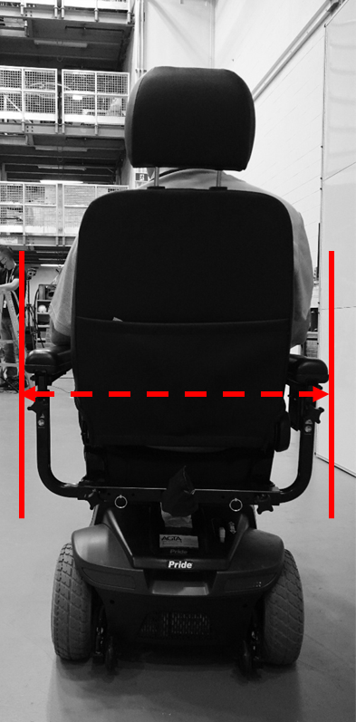

Figure A-1. Rear-view image of a scooter. The red, dashed arrows depict an example of the unoccupied measurement (e.g. from arm rest to arm rest, without considering the person)

Table A-2. Unoccupied device width (mm)
Data Source | N | Min | Mean | SD | 90th %ile | 95th  %ile | 99th %ile | Max
Laboratory-derived data
All WhMDs | 189 | 415 | 661 | 59 | 732 | 758 | 792 | 840
Manual Wheelchair | 70 | 520 | 667 | 57 | 740 | 751 | 799 | 840
Power Wheelchair | 91 | 605 | 670 | 50 | 745 | 773 | 792 | 810
Mobility Scooter | 28 | 415 | 613 | 71 | 675 | 717 | 727 | 730
Wheelchairs Only | 161 | 520 | 669 | 53 | 740 | 765 | 798 | 840
Bootstrapped estimates
All WhMDs | 188 | 415 | 650 | 65 | 727 | 746 | 793 | 840
Manual Wheelchair | 102 | 520 | 667 | 57 | 736 | 752 | 802 | 840
Power Wheelchair | 26 | 605 | 670 | 50 | 738 | 758 | 778 | 810
Mobility Scooter | 60 | 415 | 613 | 69 | 685 | 713 | 727 | 730
Wheelchairs Only | 128 | 520 | 668 | 55 | 737 | 756 | 804 | 840

B.2. Unoccupied device length
Unoccupied device length (Table A-3) was measured as the distance between the furthest anterior and posterior points of the participant’s mobility device (e.g. footplates, seat back) when unoccupied, including the addition of front-power attachments (n=6) if used.

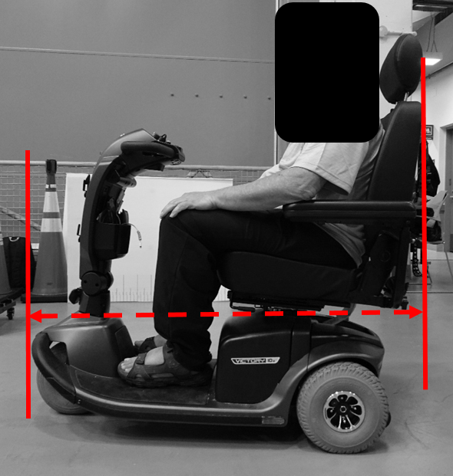
Figure A-2. Side-view image of a scooter. The red, dashed arrows depict an example of the unoccupied measurement (e.g. from front-most to rear-most point on device, without considering the person)

Table A-3. Unoccupied device length (mm)
Data Source | N | Min | Mean | SD | 90th %ile | 95th  %ile | 99th %ile | Max
Laboratory-derived data
All WhMDs | 189 | 775 | 1115 | 144 | 1270 | 1320 | 1470 | 1520
Manual Wheelchair | 70 | 775 | 1001 | 129 | 1135 | 1148 | 1281 | 1505
Power Wheelchair | 91 | 960 | 1172 | 96 | 1285 | 1320 | 1438 | 1465
Mobility Scooter | 28 | 860 | 1214 | 132 | 1362 | 1429 | 1501 | 1520
Wheelchairs Only | 161 | 775 | 1097 | 140 | 1255 | 1310 | 1447 | 1505
Bootstrapped estimates
All WhMDs | 188 | 775 | 1092 | 160 | 1260 | 1348 | 1494 | 1520
Manual Wheelchair | 102 | 775 | 1001 | 128 | 1135 | 1149 | 1311 | 1505
Power Wheelchair | 26 | 960 | 1171 | 95 | 1282 | 1323 | 1376 | 1465
Mobility Scooter | 60 | 860 | 1214 | 130 | 1361 | 1435 | 1499 | 1520
Wheelchairs Only | 128 | 775 | 1035 | 140 | 1183 | 1241 | 1411 | 1505

Considering the 95th percentile of our sampled wheeled mobility devices, occupied width and length increased by 8.7% and 8.0%, respectively, compared with unoccupied measurements (see Table A-4). Although many standards rely on occupied dimensions, some wheelchair anthropometry studies have used unoccupied device dimensions based on manufacturer-reported make and model specifications (Atkins-Jacobs Joint Venture, 2021). As demonstrated by differences between the 95th percentile values for unoccupied and occupied measures, reliance on device design alone would yield spatial recommendations that underestimate needed space.

Table A-4. Percentage change from laboratory-derived unoccupied to occupied measurements
95th Percentile | Unoccupied Width | Occupied Width | % Change | Unoccupied Length | Occupied Length | % Change
All WhMDs | 758 | 824 | 8.7% | 1320 | 1425 | 8.0%
Manual Wheelchair | 751 | 828 | 10.3% | 1148 | 1220 | 6.3%
Power Wheelchair | 773 | 823 | 6.5% | 1320 | 1415 | 7.2%
Mobility Scooter | 717 | 717 | 0.0% | 1429 | 1457 | 2.0%
All Wheelchairs | 765 | 826 | 8.0% | 1310 | 1371 | 4.7%

Appendix C: Maneuvering space for residential and private dwellings
For a targeted sub-sample of participants assessed between April 2025 and November 2025, the testing protocol was modified to allow individuals to perform maneuvers related to turning area (i.e. continuous turn, three-point turn, turning area with a varied entry/exit location of a fixed width) until they reached the absolute smallest possible area within which they could successfully complete the maneuver. This approach was implemented to better understand space requirements relevant to the design of residential and private dwellings, rather than public settings, where space constraints are often more restrictive than in public or institutional settings.

All methods have been previously described (3.3.1) however, for this sub-sample, participants continued the maneuver until they made contact with the walls, with no pre-set minimum space imposed. For all measures, descriptive statistics (minimum, maximum, mean, percentiles) are presented in the Tables below, including laboratory-derived data and via bootstrapping analysis using resampled data based on the distribution of mobility devices among the Canadian population. Primary results are presented for WhMD users (manual wheelchairs, power wheelchairs, and mobility scooters) and Wheelchairs only (e.g. excluding scooter users).

Table A-5. Continuous Turning Area (mm), without imposed minimum space restriction
Data Source | N | Min | Mean | SD | 90th %ile | 95th  %ile | 99th %ile | Max
Laboratory-derived data
All WhMDs | 96 | 1150 | 1752 | 454 | 2325 | 2738 | 3210 | 3400
Manual Wheelchair | 29 | 1150 | 1543 | 288 | 1800 | 1860 | 2476 | 2700
Power Wheelchair | 40 | 1250 | 1528 | 154 | 1805 | 1850 | 1850 | 1850
Mobility Scooter | 27 | 1600 | 2309 | 424 | 2900 | 3110 | 3348 | 3400
Wheelchairs Only | 69 | 1150 | 1534 | 219 | 1800 | 1850 | 2156 | 2700
Bootstrapped estimates
All WhMDs | 96 | 1150 | 1788 | 482 | 2438 | 2771 | 3171 | 3400
Manual Wheelchair | 52 | 1150 | 1543 | 282 | 1783 | 1993 | 2442 | 2700
Power Wheelchair | 13 | 1250 | 1527 | 152 | 1712 | 1759 | 1797 | 1850
Mobility Scooter | 31 | 1600 | 2308 | 415 | 2894 | 3088 | 3264 | 3400
Wheelchairs Only | 65 | 1150 | 1540 | 262 | 1779 | 1924 | 2413 | 2700

Table A-6. Turning area for a three-point turn (mm), without imposed minimum space restriction
Data Source | N | Min | Mean | SD | 90th %ile | 95th  %ile | 99th %ile | Max
Laboratory-derived data
All WhMDs | 87 | 1150 | 1598 | 236 | 1850 | 2085 | 2257 | 2300
Manual Wheelchair | 29 | 1150 | 1512 | 207 | 1720 | 1860 | 2044 | 2100
Power Wheelchair | 40 | 1250 | 1528 | 154 | 1805 | 1850 | 1850 | 1850
Mobility Scooter | 18 | 1500 | 1894 | 197 | 2145 | 2258 | 2292 | 2300
Wheelchairs Only | 69 | 1150 | 1521 | 177 | 1800 | 1850 | 1964 | 2100
Bootstrapped estimates
All WhMDs | 87 | 1150 | 1638 | 263 | 1990 | 2113 | 2253 | 2300
Manual Wheelchair | 47 | 1150 | 1513 | 204 | 1743 | 1877 | 2024 | 2100
Power Wheelchair | 12 | 1250 | 1526 | 152 | 1706 | 1753 | 1792 | 1850
Mobility Scooter | 28 | 1500 | 1894 | 192 | 2165 | 2231 | 2275 | 2300
Wheelchairs Only | 59 | 1150 | 1516 | 195 | 1746 | 1864 | 2019 | 2100

Table A-7. Turning area with a corner entry/exit (mm), without an imposed minimum space restriction
Data Source | N | Min | Mean | SD | 90th %ile | 95th  %ile | 99th %ile | Max
Laboratory-derived data
All WhMDs | 101 | 1150 | 1734 | 373 | 2200 | 2400 | 2750 | 3200
Manual Wheelchair | 31 | 1150 | 1558 | 274 | 1800 | 1875 | 2390 | 2600
Power Wheelchair | 44 | 1250 | 1589 | 204 | 1885 | 1950 | 2057 | 2100
Mobility Scooter | 26 | 1150 | 2188 | 322 | 2600 | 2738 | 3088 | 3200
Wheelchairs Only | 75 | 1150 | 1576 | 235 | 1850 | 1950 | 2230 | 2600
Bootstrapped estimates
All WhMDs | 101 | 1150 | 1762 | 402 | 2296 | 2522 | 2879 | 3200
Manual Wheelchair | 55 | 1150 | 1558 | 270 | 1815 | 1975 | 2359 | 2600
Power Wheelchair | 14 | 1250 | 1589 | 203 | 1846 | 1905 | 1959 | 2100
Mobility Scooter | 32 | 1850 | 2187 | 315 | 2592 | 2782 | 3000 | 3200
Wheelchairs Only | 69 | 1150 | 1564 | 258 | 1829 | 1956 | 2359 | 2600

Table A-8. Turning area with a middle entry/exit (mm), without an imposed minimum space restriction
Data Source | N | Min | Mean | SD | 90th %ile | 95th  %ile | 99th %ile | Max
Laboratory-derived data
All WhMDs | 93 | 1150 | 1764 | 412 | 2290 | 2710 | 2904 | 2950
Manual Wheelchair | 27 | 1150 | 1557 | 272 | 1820 | 1885 | 2344 | 2500
Power Wheelchair | 40 | 1350 | 1575 | 187 | 1850 | 1853 | 2022 | 2100
Mobility Scooter | 26 | 1850 | 2269 | 354 | 2800 | 2875 | 2938 | 2950
Wheelchairs Only | 67 | 1150 | 1568 | 224 | 1850 | 1885 | 2236 | 2500
Bootstrapped estimates
All WhMDs | 93 | 1150 | 1790 | 440 | 2456 | 2717 | 2886 | 2950
Manual Wheelchair | 50 | 1150 | 1557 | 266 | 1817 | 1996 | 2316 | 2500
Power Wheelchair | 13 | 1350 | 1576 | 186 | 1805 | 1859 | 1908 | 2100
Mobility Scooter | 30 | 1850 | 2271 | 348 | 2798 | 2863 | 2913 | 2950
Wheelchairs Only | 63 | 1150 | 1561 | 252 | 1824 | 1954 | 2310 | 2500

Summary of recommendations, turning area for residential/private dwellings
- Considerations of the users of the space to guide recommendations in residential/private dwellings
The purpose of this subsample analysis, in which participants were asked to turn within their true minimum space, was to better understand maneuvering requirements in restricted environments typical of residential settings. Although scooter users were included in the overall dataset, mobility scooters may be less likely to be used within private dwellings. As such, turning space recommendations for home environments may be more appropriately based on wheelchair users (i.e. manual and power wheelchairs).

Importantly, residential design should also account for caregiver presence and shared maneuvering space, particularly if larger mobility devices (e.g. mobility scooters) are not included in broader recommendations. Though not directly evaluated, the inclusion of mobility scooters in public design guidance is hypothesized to assist (at least in part) with accommodating caregiver support. This should be empirically evaluated in future work. While caregiver space requirements were not directly evaluated in this study, they remain an important consideration when developing accessibility guidance for home environments.

- Minimum turning area to accommodate the 95th percentile of wheelchair-only users (manual wheelchairs, powered wheelchairs)
For spaces without fixed-width doorways: When resampled to reflect the population distribution of wheeled mobility devices, a turning area of approximately 1924 mm x 1924 mm would be required to accommodate 95% all wheelchair users performing a continuous 180-degree turn. However, if a three-point (non-continuous) turn is permitted, a space of 1864 mm by 1864 mm is sufficient to accommodate 95% of wheelchair users. Of note, this recommended space in residential settings would only accommodate ~67% of mobility scooters evaluated in our study for non-continuous turns.

For spaces with smaller, fixed width doorways: When spaces are restricted by a fixed-width doorway, maneuverability is impacted for wheelchair users. When resampled to reflect the population distribution of wheeled mobility devices, the recommended turning area, where entry/exit must occur through a fixed-width doorway (~850 mm), is approximately 1950 mm x 1950 mm to accommodate 95% of all WhMD users (for both a door centrally located, and located to either side of the bounded space).

Appendix D: Turning and space demands of 3- and 4-wheel mobility scooters
Turning performance among scooter users appears to vary according to the number of wheels on the device. In our data, four-wheeled scooters generally demonstrated larger turning requirements than three-wheeled models, likely due to differences in wheelbase configuration, turning radius, and overall frame geometry.

These findings have important implications for accessible design. In environments where four-wheeled scooters are more prevalent, such as outdoor settings or other spaces, where users may prioritize stability and longer duration comfort over compact maneuverability, design specifications may need to account for their increased spatial demands. Individuals often select four-wheel scooters for enhanced stability, for reasons related to body size, personal comfort, or safety on uneven terrain; however, this choice may come at the expense of turning efficiency in constrained indoor environments.

We have summarized the space requirements for three-wheel vs. four-wheel scooters performing the following maneuvers (detailed methods previously described): continuous turn (3.3.1.1), three-point (non-continuous) turn (3.3.1.2), with and without fixed width entry/exits (3.3.2), L-turn (3.3.4.2), and turning around a barrier (0). Descriptive statistics for these maneuvers (minimum, maximum, mean, percentiles) are provided in the Tables below.

Table A-9. Turning area (mm) for 3-wheel (MS_3W) vs. 4-wheel scooters (MS_4W)
Continuous Turn | N | Min | Mean | SD | 90th | 95th | 99th | Max
Mobility Scooters | 28 | 1700 | 2291 | 426 | 2900 | 3095 | 3346 | 3400
MS_3W | 17 | 1700 | 2074 | 216 | 2320 | 2360 | 2392 | 2400
MS_4W | 11 | 1900 | 2627 | 458 | 3200 | 3300 | 3380 | 3400
Three-Point Turn
Mobility Scooter | 28 | 1700 | 1832 | 173 | 2100 | 2198 | 2287 | 2300
MS_3W | 17 | 1700 | 1759 | 105 | 1850 | 1900 | 2060 | 2100
MS_4W | 11 | 1700 | 1945 | 201 | 2250 | 2275 | 2295 | 2300
Turning area, corner entry/exit
Mobility Scooter | 27 | 1700 | 2167 | 332 | 2580 | 2735 | 3083 | 3200
MS_3W | 16 | 1700 | 2053 | 206 | 2300 | 2425 | 2485 | 2500
MS_4W | 11 | 1850 | 2332 | 415 | 2750 | 2975 | 3155 | 3200
Turning area, middle entry/exit
Mobility Scooter | 28 | 1700 | 2229 | 372 | 2800 | 2865 | 2937 | 2950
MS_3W | 17 | 1700 | 2024 | 214 | 2270 | 2340 | 2468 | 2500
MS_4W | 11 | 2050 | 2545 | 344 | 2900 | 2925 | 2945 | 2950

Table A-10. Clear turning width for 3-wheel vs. 4-wheel scooters
Corridor width for L-Turn | N | Min | Mean | SD | 90th | 95th | 99th | Max
Mobility Scooter | 28 | 1000 | 1041 | 64 | 1150 | 1183 | 1200 | 1200
MS_3W | 17 | 1000 | 1021 | 31 | 1050 | 1060 | 1092 | 1100
MS_4W | 11 | 1000 | 1073 | 88 | 1200 | 1200 | 1200 | 1200
Corridor width for U-turn around a barrier
Mobility Scooter | 28 | 1100 | 1170 | 98 | 1315 | 1383 | 1400 | 1400
MS_3W | 17 | 1100 | 1132 | 50 | 1200 | 1210 | 1242 | 1250
MS_4W | 11 | 1100 | 1227 | 120 | 1400 | 1400 | 1400 | 1400

Appendix E: Tolerances (distance from wall) associated with unobstructed functional reaching
For unobstructed functional reach tasks (touch, grasp), participants performed reaches at a self-selected distance from the wall. The distance between the wall and the nearest point of the participant’s device or body was measured and recorded as the tolerance (e.g., distance between toes/device and the board for forward reaches, or armrests and the wall for lateral reaches). Descriptive statistics (means, standard deviation, percentiles) for the measured tolerances are provided below

Table A-11. Unobstructed Reach Tolerances (device/person distance from wall) (mm)
Forward reach, maximum/minimum touch | N | Min | Mean | SD | 90th %ile | 95th %ile | 99th %ile | Max
Laboratory-derived data
All WhMDs | 174 | 0 | 27 | 36 | 80 | 107 | 138 | 180
Manual Wheelchair | 71 | 0 | 18 | 30 | 60 | 85 | 123 | 130
Power Wheelchair | 76 | 0 | 32 | 39 | 83 | 111 | 165 | 180
Mobility Scooter | 27 | 0 | 39 | 41 | 102 | 109 | 110 | 110
Wheelchairs Only | 147 | 0 | 25 | 35 | 77 | 100 | 146 | 180
Walker Users | 30 | 0 | 30 | 40 | 76 | 108 | 137 | 140

Forward reach, maximum grasp | N | Min | Mean | SD | 90th %ile | 95th %ile | 99th %ile | Max
Laboratory-derived data
All WhMDs | 176 | 0 | 30 | 43 | 88 | 110 | 173 | 300
Manual Wheelchair | 71 | 0 | 25 | 49 | 70 | 110 | 209 | 300
Power Wheelchair | 78 | 0 | 32 | 36 | 82 | 111 | 165 | 180
Mobility Scooter | 27 | 0 | 39 | 40 | 102 | 109 | 110 | 110
Wheelchairs Only | 149 | 0 | 29 | 43 | 80 | 113 | 175 | 300
Walker Users | 30 | 0 | 43 | 48 | 121 | 130 | 137 | 140

Left lateral reach, maximum/minimum touch | N | Min | Mean | SD | 90th %ile | 95th %ile | 99th %ile | Max
Laboratory-derived data
All WhMDs | 178 | 0 | 159 | 81 | 292 | 312 | 361 | 370
Manual Wheelchair | 69 | 0 | 141 | 69 | 226 | 268 | 321 | 345
Power Wheelchair | 81 | 0 | 162 | 83 | 290 | 320 | 362 | 370
Mobility Scooter | 28 | 45 | 196 | 91 | 313 | 327 | 356 | 365
Wheelchairs Only | 150 | 0 | 152 | 77 | 271 | 310 | 355 | 370
Walker Users | 30 | 25 | 162 | 89 | 283 | 316 | 341 | 350

Left lateral reach, maximum grasp | N | Min | Mean | SD | 90th %ile | 95th %ile | 99th %ile | Max
Laboratory-derived data
All WhMDs | 173 | 20 | 177 | 90 | 310 | 354 | 410 | 460
Manual Wheelchair | 69 | 30 | 159 | 74 | 242 | 306 | 380 | 400
Power Wheelchair | 76 | 20 | 183 | 99 | 335 | 373 | 441 | 460
Mobility Scooter | 28 | 45 | 208 | 94 | 323 | 340 | 360 | 365
Wheelchairs Only | 145 | 20 | 172 | 88 | 300 | 358 | 420 | 460
Walker Users | 30 | 0 | 214 | 97 | 330 | 341 | 386 | 400

Right lateral reach, maximum/minimum touch | N | Min | Mean | SD | 90th %ile | 95th %ile | 99th %ile | Max
Laboratory-derived data
All WhMDs | 181 | 0 | 147 | 78 | 240 | 290 | 367 | 430
Manual Wheelchair | 69 | 0 | 128 | 67 | 200 | 252 | 283 | 290
Power Wheelchair | 84 | 15 | 156 | 83 | 287 | 317 | 366 | 395
Mobility Scooter | 28 | 50 | 163 | 82 | 222 | 293 | 403 | 430
Wheelchairs Only | 153 | 0 | 144 | 77 | 240 | 290 | 344 | 395
Walker Users | 30 | 10 | 138 | 92 | 271 | 311 | 340 | 340

Right lateral reach, maximum grasp | N | Min | Mean | SD | 90th %ile | 95th %ile | 99th %ile | Max
Laboratory-derived data
All WhMDs | 175 | 0 | 177 | 92 | 300 | 362 | 446 | 470
Manual Wheelchair | 69 | 0 | 153 | 84 | 262 | 305 | 386 | 410
Power Wheelchair | 78 | 55 | 190 | 94 | 323 | 369 | 446 | 450
Mobility Scooter | 28 | 50 | 203 | 98 | 327 | 395 | 459 | 470
Wheelchairs Only | 147 | 0 | 173 | 91 | 294 | 354 | 429 | 450
Walker Users | 30 | 80 | 237 | 99 | 342 | 410 | 450 | 450

Appendix F: Reach ranges over a 600 mm depth obstruction
As described in 3.4.3 (Obstructed Reach Ranges), participants were asked to complete the touch and grasp tasks over a fixed-height counter/table of two depths: 500 mm and 600 mm. Primary results are presented in 3.4.3 for reaching heights related to the 500 mm depth obstruction. Below, we provide the measured reaching heights for both the touch and grasp tasks, when reaching over the 600 mm depth obstruction.

F.1. Maximum reach heights over 600 mm depth obstruction for a touch task
Table A-12. Maximum forward reaching heights over a 600 mm depth obstruction, for a touch task (mm)
Data Source | N | Min | Mean | SD | 10th %ile | 5th %ile | 1st %ile | Max
Laboratory-derived data
All WhMDs | 129 | 910 | 1259 | 189 | 1024 | 974 | 937 | 1730
Manual Wheelchair | 62 | 980 | 1321 | 178 | 1067 | 1041 | 986 | 1730
Power Wheelchair | 60 | 910 | 1213 | 184 | 979 | 960 | 922 | 1670
Mobility Scooter | 7 | 970 | 1106 | 123 | 994 | 982 | 972 | 1300
Wheelchairs Only | 122 | 910 | 1268 | 189 | 1035 | 980 | 935 | 1730
Walker Users | 27 | 1040 | 1411 | 241 | 1160 | 1125 | 1058 | 1930
Bootstrapped estimates
All WhMDs | 129 | 910 | 1237 | 188 | 1010 | 979 | 963 | 1730
Manual Wheelchair | 70 | 980 | 1321 | 177 | 1080 | 1039 | 998 | 1730
Power Wheelchair | 18 | 910 | 1212 | 183 | 1010 | 980 | 955 | 1670
Mobility Scooter | 41 | 970 | 1105 | 114 | 982 | 972 | 970 | 1300
Wheelchairs Only | 88 | 910 | 1299 | 184 | 1056 | 1014 | 966 | 1730

Table A-13. Maximum lateral reaching heights when reaching to the left over a 600 mm depth obstruction (mm), for a touch task
Data Source | N | Min | Mean | SD | 10th %ile | 5th %ile | 1st %ile | Max
Laboratory-derived data
All WhMDs | 134 | 890 | 1228 | 183 | 995 | 970 | 922 | 1680
Manual Wheelchair | 60 | 950 | 1248 | 182 | 1013 | 989 | 962 | 1650
Power Wheelchair | 51 | 890 | 1192 | 187 | 975 | 928 | 905 | 1555
Mobility Scooter | 23 | 1005 | 1256 | 170 | 1072 | 1057 | 1016 | 1680
Wheelchairs Only | 111 | 890 | 1222 | 186 | 990 | 970 | 921 | 1650
Walker Users | 23 | 1130 | 1499 | 225 | 1153 | 1150 | 1134 | 1940
Bootstrapped estimates
All WhMDs | 134 | 890 | 1243 | 178 | 1017 | 986 | 947 | 1680
Manual Wheelchair | 72 | 950 | 1248 | 180 | 1014 | 985 | 963 | 1650
Power Wheelchair | 19 | 890 | 1191 | 185 | 980 | 955 | 931 | 1555
Mobility Scooter | 43 | 1005 | 1256 | 166 | 1070 | 1047 | 1019 | 1680
Wheelchairs Only | 91 | 890 | 1236 | 183 | 1000 | 976 | 940 | 1650

Table A-14. Maximum lateral reaching maximum heights when reaching to the right over a 600 mm depth obstruction (mm), for a touch task
Data Source | N | Min | Mean | SD | 10th %ile | 5th %ile | 1st %ile | Max
Laboratory-derived data
All WhMDs | 130 | 860 | 1225 | 188 | 990 | 962 | 920 | 1685
Manual Wheelchair | 60 | 940 | 1254 | 187 | 990 | 980 | 958 | 1680
Power Wheelchair | 44 | 860 | 1197 | 191 | 962 | 925 | 886 | 1650
Mobility Scooter | 26 | 960 | 1207 | 182 | 1015 | 1003 | 970 | 1685
Wheelchairs Only | 104 | 860 | 1230 | 190 | 983 | 961 | 920 | 1680
Walker Users | 28 | 1020 | 1482 | 215 | 1201 | 1161 | 1054 | 1900
Bootstrapped estimates
All WhMDs | 130 | 860 | 1231 | 185 | 999 | 975 | 939 | 1685
Manual Wheelchair | 70 | 940 | 1254 | 185 | 1003 | 980 | 959 | 1680
Power Wheelchair | 18 | 860 | 1197 | 188 | 987 | 953 | 922 | 1650
Mobility Scooter | 42 | 960 | 1208 | 179 | 1015 | 997 | 974 | 1685
Wheelchairs Only | 88 | 860 | 1242 | 187 | 995 | 972 | 932 | 1680

F.2. Maximum reach heights over 600 mm depth obstruction for a grasp task
Table A-15. Maximum forward reaching heights over a 600 mm depth obstruction, for a grasp task (mm)
Data Source | N | Min | Mean | SD | 10th %ile | 5th %ile | 1st %ile | Max
Laboratory-derived data
All WhMDs | 137 | 900 | 1275 | 183 | 1020 | 998 | 947 | 1720
Manual Wheelchair | 64 | 990 | 1325 | 169 | 1122 | 1025 | 1003 | 1720
Power Wheelchair | 64 | 900 | 1237 | 190 | 1000 | 980 | 925 | 1665
Mobility Scooter | 9 | 1070 | 1189 | 138 | 1078 | 1074 | 1071 | 1510
Wheelchairs Only | 128 | 900 | 1281 | 185 | 1019 | 994 | 945 | 1720
Walker Users | 30 | 960 | 1402 | 230 | 1142 | 1083 | 989 | 1920
Bootstrapped estimates
All WhMDs | 137 | 900 | 1269 | 172 | 1073 | 1034 | 984 | 1720
Manual Wheelchair | 74 | 990 | 1325 | 168 | 1117 | 1047 | 1005 | 1720
Power Wheelchair | 19 | 900 | 1236 | 189 | 1016 | 987 | 960 | 1665
Mobility Scooter | 44 | 1070 | 1187 | 129 | 1076 | 1071 | 1070 | 1510
Wheelchairs Only | 93 | 900 | 1307 | 176 | 1073 | 1016 | 977 | 1720

Table A-16. Maximum lateral reaching maximum heights when reaching to the left over a 600 mm depth obstruction (mm), for a grasp task
Data Source | N | Min | Mean | SD | 10th %ile | 5th %ile | 1st %ile | Max
Laboratory-derived data
All WhMDs | 145 | 900 | 1248 | 175 | 1010 | 980 | 942 | 1690
Manual Wheelchair | 61 | 980 | 1283 | 167 | 1050 | 1035 | 989 | 1650
Power Wheelchair | 60 | 900 | 1211 | 179 | 980 | 970 | 921 | 1600
Mobility Scooter | 24 | 950 | 1252 | 174 | 1066 | 1043 | 971 | 1690
Wheelchairs Only | 121 | 900 | 1247 | 176 | 1000 | 980 | 942 | 1650
Walker Users | 25 | 1010 | 1459 | 244 | 1152 | 1108 | 1032 | 1960
Bootstrapped estimates
All WhMDs | 144 | 900 | 1263 | 171 | 1049 | 1005 | 958 | 1690
Manual Wheelchair | 78 | 980 | 1283 | 166 | 1074 | 1031 | 994 | 1650
Power Wheelchair | 20 | 900 | 1211 | 177 | 997 | 975 | 952 | 1600
Mobility Scooter | 46 | 950 | 1253 | 171 | 1065 | 1026 | 976 | 1690
Wheelchairs Only | 98 | 900 | 1268 | 170 | 1045 | 1002 | 969 | 1650

Table A-17. Maximum lateral reaching maximum heights when reaching to the right over a 600 mm depth obstruction (mm), for a grasp task
Data Source | N | Min | Mean | SD | 10th %ile | 5th %ile | 1st %ile | Max
Laboratory-derived data
All WhMDs | 135 | 900 | 1258 | 180 | 1030 | 990 | 950 | 1715
Manual Wheelchair | 62 | 950 | 1280 | 177 | 1059 | 1006 | 974 | 1715
Power Wheelchair | 48 | 900 | 1242 | 186 | 997 | 987 | 928 | 1680
Mobility Scooter | 25 | 950 | 1234 | 175 | 1041 | 1007 | 962 | 1690
Wheelchairs Only | 110 | 900 | 1263 | 181 | 1029 | 990 | 951 | 1715
Walker Users | 28 | 955 | 1468 | 234 | 1183 | 1136 | 1000 | 1960
Bootstrapped estimates
All WhMDs | 135 | 900 | 1259 | 177 | 1037 | 1000 | 955 | 1715
Manual Wheelchair | 73 | 950 | 1279 | 175 | 1061 | 1017 | 976 | 1715
Power Wheelchair | 19 | 900 | 1242 | 184 | 1037 | 1002 | 966 | 1680
Mobility Scooter | 43 | 950 | 1233 | 172 | 1034 | 1002 | 967 | 1690
Wheelchairs Only | 92 | 900 | 1272 | 178 | 1049 | 1004 | 962 | 1715

Appendix G: Confidence intervals for bootstrapping analysis
For our bootstrapping estimates, the associated confidence intervals are provided below. The confidence intervals are not intended to guide recommendations, rather to demonstrate the accuracy of our percentile values or the variability present within the population depending on the measurement of interest. A smaller confidence interval (i.e. a smaller range of values) indicates our estimation of the percentile is more accurate whereas a larger confidence interval indicates variability within the population.

The confidence intervals presented below are determined by obtaining the percentile of interest (e.g. 95th percentile) for each of the simulated datasets and analyzing the range within these percentile values. The 2.5th and 97.5th percentile values of these values are determined and provide the upper and lower bounds of the 95% confidence interval.

G.1. Confidence intervals for static measurements
Table A-18. Confidence intervals for the unoccupied device width (mm)
Unoccupied Width | N | 90th %ile | Confidence Interval | 95th %ile | Confidence Interval | 99th %ile | Confidence Interval
All WhMDs | 188 | 727 | 720 - 740 | 746 | 730 - 760 | 793 | 756 - 840
Manual Wheelchair | 102 | 736 | 720 - 754 | 752 | 739 - 780 | 802 | 755 - 840
Power Wheelchair | 26 | 738 | 693 - 780 | 758 | 715 - 800 | 778 | 729 - 810
Mobility Scooter | 60 | 685 | 650 - 720 | 713 | 660 - 730 | 727 | 714 - 730
Wheelchairs Only | 128 | 737 | 720 - 755 | 756 | 740 - 780 | 804 | 759 - 840

Table A-19. Confidence intervals for the unoccupied device length (mm)
Unoccupied Length | N | 90th %ile | Confidence Interval | 95th %ile | Confidence Interval | 99th %ile | Confidence Interval
All WhMDs | 188 | 1260 | 1237 - 1293 | 1348 | 1270 - 1450 | 1494 | 1398 - 1520
Manual Wheelchair | 102 | 1135 | 1120 - 1150 | 1149 | 1135 - 1180 | 1311 | 1150 - 1505
Power Wheelchair | 26 | 1282 | 1220 - 1390 | 1323 | 1234 - 1429 | 1376 | 1273 - 1465
Mobility Scooter | 60 | 1361 | 1270 - 1450 | 1435 | 1350 - 1520 | 1499 | 1415 - 1520
Wheelchairs Only | 128 | 1183 | 1150 - 1222 | 1241 | 1188 - 1317 | 1411 | 1261 - 1505

Table A-20. Confidence intervals for the occupied device width (mm)
Occupied Width | N | 90th %ile | Confidence Interval | 95th %ile | Confidence Interval | 99th %ile | Confidence Interval
All WhMDs | 187 | 793 | 775 - 814 | 820 | 799 - 840 | 864 | 830 - 904
Manual Wheelchair | 101 | 812 | 790 - 830 | 830 | 810 - 845 | 863 | 830 - 890
Power Wheelchair | 26 | 785 | 738 - 865 | 818 | 749 - 950 | 871 | 768 - 990
Mobility Scooter | 60 | 700 | 660 - 720 | 717 | 700 - 730 | 727 | 714 - 730
Wheelchairs Only | 127 | 810 | 790 - 825 | 829 | 810 - 845 | 875 | 830 - 964

Table A-21. Confidence intervals for the occupied device length (mm)
Occupied Length | N | 90th %ile | Confidence Interval | 95th %ile | Confidence Interval | 99th %ile | Confidence Interval
All WhMDs | 187 | 1364 | 1312 - 1390 | 1430 | 1384 - 1460 | 1517 | 1460 - 1560
Manual Wheelchair | 101 | 1209 | 1190 - 1220 | 1234 | 1210 - 1390 | 1432 | 1220 - 1560
Power Wheelchair | 26 | 1349 | 1290 - 1465 | 1393 | 1310 - 1500 | 1445 | 1329 - 1510
Mobility Scooter | 60 | 1435 | 1390 - 1460 | 1465 | 1440 - 1520 | 1504 | 1454 - 1520
Wheelchairs Only | 127 | 1260 | 1225 - 1315 | 1331 | 1269 - 1423 | 1483 | 1347 - 1560

Table A-22. Confidence intervals for the clear floor area (m²)
Clear Floor Area | N | 90th %ile | Confidence Interval | 95th %ile | Confidence Interval | 99th %ile | Confidence Interval
All WhMDs | 186 | 0.95 | 0.93 - 0.97 | 1.01 | 0.96 - 1.09 | 1.15 | 1.05 - 1.23
Manual Wheelchair | 100 | 0.94 | 0.91 - 0.96 | 0.97 | 0.94 - 1.04 | 1.09 | 0.96 - 1.19
Power Wheelchair | 26 | 1.04 | 0.94 - 1.20 | 1.10 | 0.97 - 1.24 | 1.17 | 1.00 - 1.26
Mobility Scooter | 60 | 0.95 | 0.92 - 0.97 | 0.99 | 0.94 - 1.09 | 1.06 | 0.97 - 1.09
Wheelchairs Only | 126 | 0.96 | 0.93 - 1.01 | 1.01 | 0.96 - 1.14 | 1.16 | 1.03 - 1.24

Table A-23. Confidence intervals for the seat height (mm)
Seat Height | N | 90th %ile | Confidence Interval | 95th %ile | Confidence Interval | 99th %ile | Confidence Interval
Wheelchairs Only | 156 | 708 | 700 – 735 | 745 | 711 – 770 | 787 | 759 – 821
Manual Wheelchair | 125 | 687 | 675 – 700 | 700 | 685 – 705 | 707 | 704 – 710
Power Wheelchair | 31 | 772 | 750 – 805 | 788 | 760 - 823 | 807 | 770 - 835

Table A-24. Confidence intervals for the seat depth (mm)
Seat Depth | N | 90th %ile | Confidence Interval | 95th %ile | Confidence Interval | 99th %ile | Confidence Interval
Wheelchairs Only | 156 | 815 | 790 - 840 | 850 | 825 - 890 | 928 | 877 - 973
Manual Wheelchair | 125 | 806 | 780 - 836 | 849 | 806 - 890 | 923 | 870 - 960
Power Wheelchair | 31 | 825 | 780 - 850 | 849 | 805 - 945 | 893 | 825 - 990

Table A-25. Confidence intervals for the knee height (mm)
Knee Height | N | 90th %ile | Confidence Interval | 95th %ile | Confidence Interval | 99th %ile | Confidence Interval
Wheelchairs Only | 155 | 707 | 685 - 723 | 732 | 710 - 761 | 787 | 749 - 831
Manual Wheelchair | 124 | 680 | 670 - 699 | 699 | 680 - 710 | 717 | 705 - 725
Power Wheelchair | 31 | 768 | 730 - 800 | 787 | 750 - 833 | 813 | 764 - 855

Table A-26. Confidence intervals for the knee depth (mm)
Knee Depth | N | 90th %ile | Confidence Interval | 95th %ile | Confidence Interval | 99th %ile | Confidence Interval
Wheelchairs Only | 155 | 368 | 355 - 388 | 393 | 370 - 410 | 450 | 405 - 477
Manual Wheelchair | 124 | 368 | 355 - 400 | 392 | 369 - 410 | 440 | 401- 470
Power Wheelchair | 31 | 363 | 320 - 430 | 393 | 340 - 470 | 432 | 357 - 485

Table A-27. Confidence intervals for the toe height (mm)
Toe Height | N | 90th %ile | Confidence Interval | 95th %ile | Confidence Interval | 99th %ile | Confidence Interval
Wheelchairs Only | 155 | 273 | 260 - 280 | 296 | 275 - 345 | 404 | 321 - 517
Manual Wheelchair | 124 | 258 | 240 - 270 | 270 | 259 - 275 | 277 | 274 - 280
Power Wheelchair | 31 | 364 | 290 - 450 | 406 | 323 - 523 | 464 | 352 - 595

Table A-28. Confidence intervals for the toe depth (mm)
Toe Depth | N | 90th %ile | Confidence Interval | 95th %ile | Confidence Interval | 99th %ile | Confidence Interval
Wheelchairs Only | 155 | 258 | 250 - 265 | 268 | 260 - 280 | 290 | 275 - 307
Manual Wheelchair | 124 | 258 | 250 - 265 | 268 | 259 - 280 | 289 | 273 - 300
Power Wheelchair | 31 | 255 | 240 - 270 | 264 | 248 - 293 | 279 | 256 - 315

Table A-29. Confidence intervals for the eye height - minimum (mm)
Eye Height | N | 1st %ile | Confidence Interval | 5th %ile | Confidence Interval | 10th %ile | Confidence Interval
All WhMDs | 188 | 969 | 915 - 1059 | 1065 | 1050 - 1085 | 1088 | 1069 - 1110
Manual Wheelchair | 102 | 951 | 915 - 1050 | 1046 | 940 - 1065 | 1070 | 1051 - 1090
Power Wheelchair | 26 | 1045 | 960 - 1138 | 1092 | 985 - 1160 | 1124 | 1068 - 1170
Mobility Scooter | 60 | 1096 | 1090 - 1129 | 1120 | 1090 - 1170 | 1157 | 1105 - 1200
Wheelchairs Only | 128 | 953 | 915 - 1053 | 1052 | 973 - 1070 | 1074 | 1060 - 1090

Table A-30. Confidence intervals for the eye height - maximum (mm)
Eye Height | N | 90th %ile | Confidence Interval | 95th %ile | Confidence Interval | 99th %ile | Confidence Interval
All WhMDs | 188 | 1298 | 1285 - 1310 | 1319 | 1305 - 1358 | 1359 | 1334 - 1365
Manual Wheelchair | 102 | 1261 | 1235 - 1294 | 1287 | 1255 - 1310 | 1310 | 1295 - 1315
Power Wheelchair | 26 | 1319 | 1278 - 1363 | 1340 | 1293 - 1370 | 1356 | 1304 - 1375
Mobility Scooter | 60 | 1318 | 1290 - 1360 | 1344 | 1310 - 1360 | 1358 | 1336 - 1360
Wheelchairs Only | 128 | 1281 | 1257 - 1305 | 1304 | 1285 - 1315 | 1343 | 1309 - 1370

G.2. Confidence intervals for functional maneuvers
Table A-31. Confidence intervals for the continuous turning area (floor) (mm)
Continuous Turning Area (Floor) | N | 90th %ile | Confidence Interval | 95th %ile | Confidence Interval | 99th %ile | Confidence Interval
All WhMDs | 185 | 2363 | 2250 - 2550 | 2752 | 2400 - 2900 | 3226 | 2900 - 3400
Manual Wheelchair | 100 | 1703 | 1700 - 1800 | 1761 | 1700 - 1900 | 2215 | 1800 - 2700
Power Wheelchair | 26 | 1712 | 1700 - 1850 | 1743 | 1700 - 1850 | 1792 | 1700 - 1850
Mobility Scooter | 59 | 2912 | 2550 - 3200 | 3123 | 2900 - 3400 | 3335 | 3026 - 3400
Wheelchairs Only | 126 | 1702 | 1700 - 1700 | 1756 | 1700 - 1850 | 2166 | 1800 - 2700

Table A-32. Confidence intervals for the three point turning area (floor) (mm)
3-Point Turning Area (Floor) | N | 90th %ile | Confidence Interval | 95th %ile | Confidence Interval | 99th %ile | Confidence Interval
All WhMDs | 185 | 1859 | 1830 - 1900 | 2035 | 1850 - 2100 | 2241 | 2100 - 2300
Manual Wheelchair | 100 | 1700 | 1700 - 1700 | 1733 | 1700 - 1900 | 1952 | 1701 - 2100
Power Wheelchair | 26 | 1711 | 1700 - 1850 | 1743 | 1700 - 1850 | 1793 | 1700 - 1850
Mobility Scooter | 59 | 2098 | 1900 - 2250 | 2201 | 2070 - 2300 | 2278 | 2163 - 2300
Wheelchairs Only | 126 | 1700 | 1700 - 1700 | 1733 | 1700 - 1850 | 1945 | 1700 - 2100

Table A-33. Confidence intervals for the turning area, corner entrance (floor) (mm)
Corner Entrance (Floor) | N | 90th %ile | Confidence Interval | 95th %ile | Confidence Interval | 99th %ile | Confidence Interval
All WhMDs | 176 | 2252 | 2150 - 2400 | 2488 | 2400 - 2700 | 2917 | 2625 - 3200
Manual Wheelchair | 95 | 1714 | 1700 - 1800 | 1801 | 1700 - 1900 | 2195 | 1803 - 2600
Power Wheelchair | 25 | 1783 | 1700 - 1950 | 1854 | 1700 - 2070 | 1944 | 1738 - 2100
Mobility Scooter | 56 | 2595 | 2400 - 2750 | 2798 | 2488 - 3200 | 3074 | 2723 - 3200
Wheelchairs Only | 120 | 1727 | 1700 - 1800 | 1823 | 1700 – 1903 | 2192 | 1841 - 2600

Table A-34. Confidence intervals for the turning area, middle entrance (floor) (mm)
Middle Entrance (Floor) | N | 90th %ile | Confidence Interval | 95th %ile | Confidence Interval | 99th %ile | Confidence Interval
All WhMDs | 178 | 2378 | 2200 - 2650 | 2719 | 2500 - 2800 | 2901 | 2800 - 2950
Manual Wheelchair | 96 | 1705 | 1700 - 1800 | 1778 | 1700 - 1900 | 2145 | 1800 - 2500
Power Wheelchair | 25 | 1749 | 1700 - 1850 | 1802 | 1700 - 2040 | 1885 | 1700 - 2100
Mobility Scooter | 57 | 2802 | 2650 - 2900 | 2871 | 2800 - 2950 | 2930 | 2844 - 2950
Wheelchairs Only | 121 | 1708 | 1700 - 1800 | 1794 | 1700 - 1900 | 2130 | 1840 - 2500

Table A-35. Confidence intervals for the L-turn (mm)
L-Turn | N | 90th %ile | Confidence Interval | 95th %ile | Confidence Interval | 99th %ile | Confidence Interval
All WhMDs | 184 | 1077 | 1050 - 1100 | 1135 | 1100 - 1200 | 1197 | 1158 - 1200
Manual Wheelchair | 99 | 1050 | 1050 - 1050 | 1064 | 1050 - 1100 | 1140 | 1051 - 1200
Power Wheelchair | 26 | 1057 | 1000 - 1150 | 1091 | 1000 - 1150 | 1123 | 1050 - 1150
Mobility Scooter | 59 | 1146 | 1100 - 1200 | 1181 | 1150 - 1200 | 1198 | 1171 - 1200
Wheelchairs Only | 125 | 1050 | 1050 - 1050 | 1074 | 1050 - 1100 | 1152 | 1088 - 1200

Table A-36. Confidence intervals for the Barrier U-turn (mm)
Barrier U-Turn | N | 90th %ile | Confidence Interval | 95th %ile | Confidence Interval | 99th %ile | Confidence Interval
All WhMDs | 184 | 1194 | 1150 - 1235 | 1277 | 1200 - 1350 | 1389 | 1309 - 1400
Manual Wheelchair | 99 | 1100 | 1100 - 1100 | 1113 | 1100 - 1150 | 1168 | 1101 - 1200
Power Wheelchair | 26 | 1120 | 1100 - 1150 | 1138 | 1100 - 1225 | 1165 | 1100 - 1250
Mobility Scooter | 59 | 1327 | 1250 - 1400 | 1376 | 1300 - 1400 | 1397 | 1371 - 1400
Wheelchairs Only | 125 | 1101 | 1100 - 1100 | 1125 | 1100 - 1150 | 1173 | 1138 - 1238

Table A-37. Confidence intervals for the Clear width path of travel (mm)
Clear Path | N | 90th %ile | Confidence Interval | 95th %ile | Confidence Interval | 99th %ile | Confidence Interval
All WhMDs | 184 | 900 | 900 - 900 | 902 | 900 – 942 | 965 | 900 – 1008
Manual Wheelchair | 99 | 900 | 900 - 900 | 914 | 900 – 950 | 967 | 901 - 1000
Power Wheelchair | 26 | 902 | 850 - 950 | 920 | 888 - 1013 | 960 | 900 - 1050
Mobility Scooter | 59 | 850 | 850 - 850 | 850 | 850 - 850 | 850 | 850 - 850
Wheelchairs Only | 125 | 900 | 900 - 900 | 915 | 900 - 950 | 976 | 900 - 1038

Maneuvering in residential and private dwelling
Table A-38. Confidence intervals for the Continuous turning area, no restriction on minimum space (mm)
Continuous Turning Area (True Min) | N | 90th %ile | Confidence Interval | 95th %ile | Confidence Interval | 99th %ile | Confidence Interval
All WhMDs | 96 | 2438 | 2250 - 2775 | 2771 | 2400 - 2975 | 3171 | 2853 - 3400
Manual Wheelchair | 52 | 1783 | 1600 - 1900 | 1993 | 1745 - 2700 | 2442 | 1800 - 2700
Power Wheelchair | 13 | 1712 | 1550 - 1850 | 1759 | 1600 - 1850 | 1797 | 1600 - 1850
Mobility Scooter | 31 | 2894 | 2400 - 3400 | 3088 | 2700 - 3400 | 3264 | 2885 - 3400
Wheelchairs Only | 65 | 1779 | 1630 - 1880 | 1924 | 1780 - 2700 | 2413 | 1850 - 2700

Table A-39. Confidence intervals for the three-point turning area, no restriction on minimum space (mm)
3-Point Turning Area (True Min) | N | 90th %ile | Confidence Interval | 95th %ile | Confidence Interval | 99th %ile | Confidence Interval
All WhMDs | 87 | 1990 | 1850 - 2100 | 2113 | 1900 - 2250 | 2253 | 2100 - 2300
Manual Wheelchair | 47 | 1743 | 1600 - 1900 | 1877 | 1650 - 2100 | 2024 | 1800 - 2100
Power Wheelchair | 12 | 1706 | 1550 - 1850 | 1753 | 1573 - 1850 | 1792 | 1595 - 1850
Mobility Scooter | 28 | 2165 | 1960 - 2300 | 2231 | 2083 - 2300 | 2275 | 2100 - 2300
Wheelchairs Only | 59 | 1746 | 1600 - 1900 | 1864 | 1700 - 2100 | 2019 | 1841 - 2100

Table A-40. Confidence intervals for the corner entrance turning area, no restriction on minimum space (mm)
Corner Entrance (True Min) | N | 90th %ile | Confidence Interval | 95th %ile | Confidence Interval | 99th %ile | Confidence Interval
All WhMDs | 101 | 2296 | 2100 - 2500 | 2522 | 2200 - 2750 | 2879 | 2600 - 3200
Manual Wheelchair | 55 | 1815 | 1700 - 1900 | 1975 | 1800 - 2600 | 2359 | 1850 - 2600
Power Wheelchair | 14 | 1846 | 1620 - 2040 | 1905 | 1703 - 2100 | 1959 | 1750 - 2100
Mobility Scooter | 32 | 2592 | 2380 - 3155 | 2782 | 2400 - 3200 | 3000 | 2607 - 3200
Wheelchairs Only | 69 | 1829 | 1710 - 1910 | 1956 | 1800 - 2600 | 2359 | 1900 - 2600

Table A-41. Confidence intervals for the turning area, middle entrance, no restriction on minimum space (mm)
Middle Entrance (True Min) | N | 90th %ile | Confidence Interval | 95th %ile | Confidence Interval | 99th %ile | Confidence Interval
All WhMDs | 93 | 2456 | 2200 - 2770 | 2717 | 2500 - 2900 | 2886 | 2800 - 2950
Manual Wheelchair | 50 | 1817 | 1700 - 1960 | 1996 | 1755 - 2500 | 2316 | 1876 - 2500
Power Wheelchair | 13 | 1805 | 1600 - 2050 | 1859 | 1670 - 2100 | 1908 | 1700 - 2100
Mobility Scooter | 30 | 2798 | 2550 - 2950 | 2863 | 2733 - 2950 | 2913 | 2800 - 2950
Wheelchairs Only | 63 | 1824 | 1700 - 1900 | 1954 | 1800 - 2500 | 2310 | 1869 - 2500

G.3. Confidence intervals for reaching ranges
Table A-42. Confidence intervals for the unobstructed forward touch – maximum reaching height (mm)
Unobstructed Forward Touch - Maximum | N | 1st %ile | Confidence Interval | 5th %ile | Confidence Interval | 10th %ile | Confidence Interval
All WhMDs | 174 | 1004 | 915 - 1079 | 1103 | 1053 - 1163 | 1163 | 1110 - 1197
Manual Wheelchair | 94 | 1099 | 1090 - 1147 | 1139 | 1100 – 1197 | 1200 | 1122 - 1265
Power Wheelchair | 24 | 932 | 820 - 1072 | 991 | 841 – 1146 | 1049 | 929 - 1237
Mobility Scooter | 56 | 1072 | 1050 - 1150 | 1127 | 1050 - 1170 | 1168 | 1125 - 1220
Wheelchairs Only | 118 | 987 | 843 - 1092 | 1100 | 1053 - 1176 | 1162 | 1100 - 1239

Table A-43. Confidence intervals for the unobstructed forward touch – minimum reaching height (mm)
Unobstructed Forward Touch - Minimum | N | 90th %ile | Confidence Interval | 95th %ile | Confidence Interval | 99th %ile | Confidence Interval
All WhMDs | 174 | 809 | 764 - 860 | 866 | 820 – 932 | 982 | 899 - 1000
Manual Wheelchair | 94 | 652 | 560 - 735 | 733 | 645 - 900 | 876 | 716 - 930
Power Wheelchair | 24 | 778 | 677 - 860 | 814 | 731 – 945 | 859 | 765 - 960
Mobility Scooter | 56 | 877 | 820 - 990 | 948 | 841 - 1000 | 991 | 919 - 1000
Wheelchairs Only | 118 | 704 | 640 - 770 | 779 | 702 - 900 | 896 | 782 - 955

Table A-44. Confidence intervals for the unobstructed forward grasp – maximum reaching height (mm)
Unobstructed Forward Grasp - Maximum | N | 1st %ile | Confidence Interval | 5th %ile | Confidence Interval | 10th %ile | Confidence Interval
All WhMDs | 176 | 928 | 860 - 960 | 1029 | 956 - 1098 | 1111 | 1055 - 1183
Manual Wheelchair | 95 | 989 | 930 - 1058 | 1055 | 1020 - 1110 | 1111 | 1054 - 1205
Power Wheelchair | 25 | 876 | 735 - 985 | 937 | 772 - 1110 | 990 | 892 - 1137
Mobility Scooter | 56 | 1018 | 960 - 1188 | 1141 | 960 - 1196 | 1190 | 1185 - 1200
Wheelchairs Only | 120 | 918 | 770 - 1020 | 1017 | 930 - 1070 | 1080 | 1040 - 1150

Table A-45. Confidence intervals for the left unobstructed lateral touch – maximum reaching height (mm)
Unobstructed Left Lateral Touch - Maximum | N | 1st %ile | Confidence Interval | 5th %ile | Confidence Interval | 10th %ile | Confidence Interval
All WhMDs | 178 | 958 | 834 – 1095 | 1135 | 1060 – 1227 | 1243 | 1155 - 1338
Manual Wheelchair | 96 | 997 | 900 - 1110 | 1140 | 1060 – 1250 | 1239 | 1150 - 1340
Power Wheelchair | 25 | 914 | 780 – 1151 | 1017 | 810 – 1216 | 1112 | 890 - 1287
Mobility Scooter | 57 | 1199 | 1130 - 1391 | 1342 | 1130 - 1428 | 1408 | 1380 - 1470
Wheelchairs Only | 121 | 928 | 804 - 1069 | 1098 | 980 - 1200 | 1203 | 1110 - 1260

Table A-46. Confidence intervals for the left unobstructed lateral touch – minimum reaching height (mm)
Unobstructed Left Lateral Touch - Minimum | N | 90th %ile | Confidence Interval | 95th %ile | Confidence Interval | 99th %ile | Confidence Interval
All WhMDs | 178 | 679 | 630 - 715 | 737 | 710 - 800 | 833 | 780 - 926
Manual Wheelchair | 96 | 539 | 470 - 655 | 652 | 520 - 780 | 785 | 680 - 830
Power Wheelchair | 25 | 754 | 610 - 900 | 816 | 656 - 948 | 883 | 728 - 980
Mobility Scooter | 57 | 701 | 640 - 715 | 728 | 687- 800 | 776 | 712 - 800
Wheelchairs Only | 121 | 627 | 550 - 725 | 733 | 630 - 820 | 846 | 766 - 945

Table A-47. Confidence intervals for the left unobstructed lateral grasp – maximum reaching height (mm)
Unobstructed Left Lateral Grasp - Maximum | N | 1st %ile | Confidence Interval | 5th %ile | Confidence Interval | 10th %ile | Confidence Interval
All WhMDs | 172 | 867 | 835 - 940 | 995 | 890 - 1076 | 1095 | 1011 - 1170
Manual Wheelchair | 93 | 867 | 835 - 1005 | 992 | 860 - 1120 | 1104 | 1004 - 1220
Power Wheelchair | 24 | 894 | 850 - 990 | 933 | 856 - 1088 | 980 | 887 - 1138
Mobility Scooter | 55 | 1040 | 1010 - 1138 | 1114 | 1010 - 1230 | 1184 | 1100 - 1260
Wheelchairs Only | 117 | 858 | 835 - 906 | 948 | 860 - 1060 | 1057 | 960 - 1144

Table A-48. Confidence intervals for the right unobstructed lateral touch – maximum reaching height (mm)
Unobstructed Right Lateral Touch - Maximum | N | 1st %ile | Confidence Interval | 5th %ile | Confidence Interval | 10th %ile | Confidence Interval
All WhMDs | 181 | 944 | 869 - 1020 | 1078 | 1020 - 1220 | 1221 | 1130 - 1295
Manual Wheelchair | 98 | 976 | 880 - 1140 | 1161 | 1020 - 1290 | 1284 | 1196 - 1361
Power Wheelchair | 25 | 929 | 825 - 1069 | 988 | 852 - 1123 | 1045 | 918 - 1250
Mobility Scooter | 58 | 1066 | 1020 - 1209 | 1175 | 1020 - 1366 | 1261 | 1180 - 1395
Wheelchairs Only | 123 | 925 | 837 - 1028 | 1060 | 966 - 1220 | 1199 | 1057 - 1304

Table A-49. Confidence intervals for the right unobstructed lateral touch – minimum reaching height (mm)
Unobstructed Right Lateral Touch - Minimum | N | 90th %ile | Confidence Interval | 95th %ile | Confidence Interval | 99th %ile | Confidence Interval
All WhMDs | 181 | 669 | 610 - 720 | 748 | 700 - 830 | 866 | 798 - 895
Manual Wheelchair | 98 | 567 | 450 - 630 | 655 | 559 - 830 | 808 | 634 - 840
Power Wheelchair | 25 | 745 | 622 - 840 | 790 | 672 - 880 | 834 | 720 - 890
Mobility Scooter | 58 | 701 | 640 - 730 | 753 | 659 - 895 | 850 | 719 - 895
Wheelchairs Only | 123 | 627 | 566 - 740 | 739 | 628 - 830 | 836 | 777 - 880

Table A-50. Confidence intervals for the right unobstructed lateral grasp – maximum reaching height (mm)
Unobstructed Right Lateral Grasp - Maximum | N | 1st %ile | Confidence Interval | 5th %ile | Confidence Interval | 10th %ile | Confidence Interval
All WhMDs | 176 | 860 | 780 - 943 | 975 | 920 - 1050 | 1069 | 990 - 1143
Manual Wheelchair | 95 | 888 | 830 - 970 | 984 | 920 - 1092 | 1077 | 986 - 1227
Power Wheelchair | 25 | 826 | 700 - 992 | 899 | 732 - 1088 | 970 | 830 - 1126
Mobility Scooter | 56 | 990 | 960 - 1100 | 1072 | 960 - 1223 | 1154 | 1050 - 1265
Wheelchairs Only | 120 | 843 | 725 - 930 | 950 | 865 - 1048 | 1040 | 957 - 1135

Table A-51. Confidence intervals for the obstructed (500mm barrier) forward touch – maximum reaching height (mm)
500mm Barrier Forward Touch - Maximum | N | 1st %ile | Confidence Interval | 5th %ile | Confidence Interval | 10th %ile | Confidence Interval
All WhMDs | 146 | 955 | 894 - 977 | 1012 | 970 - 1065 | 1077 | 1040 - 1128
Manual Wheelchair | 79 | 987 | 935 - 1066 | 1070 | 1000 - 1150 | 1137 | 1060 - 1210
Power Wheelchair | 20 | 959 | 860 - 1077 | 1001 | 860 - 1149 | 1045 | 959 - 1191
Mobility Scooter | 47 | 974 | 970 - 1014 | 999 | 970 - 1082 | 1049 | 970 - 1120
Wheelchairs Only | 99 | 957 | 860 - 1048 | 1037 | 969 - 1114 | 1105 | 1050 - 1190

Table A-52. Confidence intervals for the obstructed (500mm barrier) forward grasp – maximum reaching height (mm)
500mm Barrier Forward Grasp - Maximum | N | 1st %ile | Confidence Interval | 5th %ile | Confidence Interval | 10th %ile | Confidence Interval
All WhMDs | 151 | 977 | 933 - 1030 | 1054 | 1010 - 1080 | 1086 | 1070 - 1120
Manual Wheelchair | 82 | 1002 | 970 - 1062 | 1069 | 1010 - 1147 | 1139 | 1060 - 1192
Power Wheelchair | 21 | 959 | 905 - 1056 | 991 | 905 - 1080 | 1027 | 940 - 1150
Mobility Scooter | 48 | 1075 | 1075 - 1080 | 1078 | 1075 - 1089 | 1086 | 1075 - 1116
Wheelchairs Only | 103 | 969 | 906 - 1030 | 1032 | 970 - 1086 | 1095 | 1030 - 1160

Table A-53. Confidence intervals for the left 500mm barrier lateral touch – maximum reaching height (mm)
500mm Barrier Left Lateral Touch - Maximum | N | 1st %ile | Confidence Interval | 5th %ile | Confidence Interval | 10th %ile | Confidence Interval
All WhMDs | 152 | 977 | 945 - 1008 | 1035 | 980 - 1066 | 1075 | 1050 - 1110
Manual Wheelchair | 82 | 985 | 980 - 1037 | 1025 | 980 - 1081 | 1075 | 1030 - 1142
Power Wheelchair | 21 | 975 | 945 - 1064 | 1002 | 945 - 1090 | 1034 | 945 - 1130
Mobility Scooter | 49 | 1061 | 1050 - 1095 | 1086 | 1050 - 1120 | 1108 | 1082 - 1140
Wheelchairs Only | 103 | 973 | 945 - 981 | 1010 | 980 - 1060 | 1060 | 997 - 1110

Table A-54. Confidence intervals for the left 500mm barrier lateral grasp – maximum reaching height (mm)
500mm Barrier Left Lateral Grasp - Maximum | N | 1st %ile | Confidence Interval | 5th %ile | Confidence Interval | 10th %ile | Confidence Interval
All WhMDs | 156 | 932 | 860 - 986 | 996 | 970 - 1024 | 1039 | 998 - 1110
Manual Wheelchair | 84 | 915 | 860 - 980 | 987 | 940 - 1043 | 1037 | 980 - 1112
Power Wheelchair | 22 | 982 | 935 - 1042 | 1007 | 938 - 1058 | 1031 | 980 - 1121
Mobility Scooter | 50 | 1002 | 990 - 1066 | 1046 | 990 - 1134 | 1105 | 1013 - 1180
Wheelchairs Only | 106 | 919 | 860 - 980 | 987 | 940 - 1029 | 1028 | 985 - 1085

Table A-55. Confidence intervals for the right 500mm barrier lateral touch – maximum reaching height (mm)
500mm Barrier Right Lateral Touch - Maximum | N | 1st %ile | Confidence Interval | 5th %ile | Confidence Interval | 10th %ile | Confidence Interval
All WhMDs | 152 | 948 | 891 - 990 | 1006 | 965 - 1046 | 1050 | 1011 - 1105
Manual Wheelchair | 82 | 977 | 960 - 1030 | 1028 | 965 - 1062 | 1067 | 1030 - 1121
Power Wheelchair | 21 | 920 | 860 - 1012 | 952 | 860 - 1070 | 987 | 905 - 1095
Mobility Scooter | 49 | 1007 | 1000 - 1056 | 1034 | 1000 - 1119 | 1086 | 1008 - 1190
Wheelchairs Only | 103 | 939 | 861 - 990 | 996 | 960 - 1050 | 1044 | 995 - 1098

Table A-56. Confidence intervals for the right 500mm barrier lateral grasp – maximum reaching height (mm)
500mm Barrier Right Lateral Grasp - Maximum | N | 1st %ile | Confidence Interval | 5th %ile | Confidence Interval | 10th %ile | Confidence Interval
All WhMDs | 149 | 954 | 905 - 990 | 1009 | 965 - 1060 | 1064 | 1019 - 1110
Manual Wheelchair | 80 | 983 | 950 - 1020 | 1030 | 998 - 1090 | 1079 | 1020 - 1133
Power Wheelchair | 21 | 943 | 900 - 1025 | 972 | 900 - 1085 | 1003 | 905 - 1110
Mobility Scooter | 48 | 992 | 965 - 1078 | 1047 | 965 - 1124 | 1099 | 1025 - 1170
Wheelchairs Only | 101 | 952 | 900 - 1000 | 1006 | 950 - 1075 | 1050 | 1015 - 1110

Table A-57. Confidence intervals for the obstructed (600mm barrier) forward touch – maximum reaching height (mm)
600mm Barrier Forward Touch - Maximum | N | 1st %ile | Confidence Interval | 5th %ile | Confidence Interval | 10th %ile | Confidence Interval
All WhMDs | 129 | 963 | 924 - 970 | 979 | 970 - 1010 | 1010 | 978 - 1048
Manual Wheelchair | 70 | 998 | 980 - 1042 | 1039 | 990 - 1085 | 1080 | 1039 - 1162
Power Wheelchair | 18 | 955 | 910 - 1043 | 980 | 910 - 1075 | 1010 | 942 - 1112
Mobility Scooter | 41 | 970 | 970 - 970 | 972 | 970 - 1010 | 982 | 970 - 1010
Wheelchairs Only | 88 | 966 | 910 - 1019 | 1014 | 977 - 1060 | 1056 | 1015 - 1111

Table A-58. Confidence intervals for the obstructed (600mm barrier) forward grasp – maximum reaching height (mm)
600mm Barrier Forward Grasp - Maximum | N | 1st %ile | Confidence Interval | 5th %ile | Confidence Interval | 10th %ile | Confidence Interval
All WhMDs | 137 | 984 | 929 - 1014 | 1034 | 1000 - 1070 | 1073 | 1047 - 1100
Manual Wheelchair | 74 | 1005 | 990 - 1046 | 1047 | 1010 - 1150 | 1117 | 1020 - 1175
Power Wheelchair | 19 | 960 | 900 - 1036 | 987 | 900 - 1106 | 1016 | 948 - 1134
Mobility Scooter | 44 | 1070 | 1070 - 1074 | 1071 | 1070 - 1080 | 1076 | 1070 - 1086
Wheelchairs Only | 93 | 977 | 900 - 1010 | 1016 | 990 - 1082 | 1073 | 1011 - 1155

Table A-59. Confidence intervals for the left 600mm barrier lateral touch – maximum reaching height (mm)
600mm Barrier Left Lateral Touch - Maximum | N | 1st %ile | Confidence Interval | 5th %ile | Confidence Interval | 10th %ile | Confidence Interval
All WhMDs | 134 | 947 | 902 - 977 | 986 | 970 - 1012 | 1017 | 990 - 1060
Manual Wheelchair | 72 | 963 | 950 - 990 | 985 | 961 - 1020 | 1014 | 990 - 1080
Power Wheelchair | 19 | 931 | 890 - 1001 | 955 | 890 - 1030 | 980 | 918 - 1048
Mobility Scooter | 43 | 1019 | 1005 - 1070 | 1047 | 1005 - 1081 | 1070 | 1015 - 1110
Wheelchairs Only | 91 | 940 | 890 - 970 | 976 | 950 - 1003 | 1000 | 970 - 1050

Table A-60. Confidence intervals for the left 600mm barrier lateral grasp – maximum reaching height (mm)
600mm Barrier Left Lateral Grasp - Maximum | N | 1st %ile | Confidence Interval | 5th %ile | Confidence Interval | 10th %ile | Confidence Interval
All WhMDs | 144 | 958 | 922 - 986 | 1005 | 976 - 1045 | 1049 | 1010 - 1105
Manual Wheelchair | 78 | 994 | 980 - 1035 | 1031 | 993 - 1101 | 1074 | 1028 - 1120
Power Wheelchair | 20 | 952 | 900 - 1004 | 975 | 900 - 1063 | 997 | 935 - 1110
Mobility Scooter | 46 | 976 | 950 - 1049 | 1026 | 950 - 1080 | 1065 | 995 - 1108
Wheelchairs Only | 98 | 969 | 900 - 995 | 1002 | 979 - 1048 | 1045 | 995 - 1114

Table A-61. Confidence intervals for the right 600mm barrier lateral touch – maximum reaching height (mm)
600mm Barrier Right Lateral Touch - Maximum | N | 1st %ile | Confidence Interval | 5th %ile | Confidence Interval | 10th %ile | Confidence Interval
All WhMDs | 130 | 939 | 877 - 970 | 975 | 960 - 1000 | 999 | 980 - 1030
Manual Wheelchair | 70 | 959 | 940 - 980 | 980 | 956 - 1000 | 1003 | 979 - 1080
Power Wheelchair | 18 | 922 | 860 - 1050 | 953 | 860 - 1062 | 987 | 902 - 1077
Mobility Scooter | 42 | 974 | 960 - 1010 | 997 | 960 - 1030 | 1015 | 1000 - 1041
Wheelchairs Only | 88 | 932 | 860 - 972 | 972 | 940 - 990 | 995 | 974 - 1066

Table A-62. Confidence intervals for the right 600mm barrier lateral grasp – maximum reaching height (mm)
600mm Barrier Right Lateral Grasp - Maximum | N | 1st %ile | Confidence Interval | 5th %ile | Confidence Interval | 10th %ile | Confidence Interval
All WhMDs | 135 | 955 | 917 - 993 | 1000 | 957 - 1034 | 1037 | 1000 - 1079
Manual Wheelchair | 73 | 976 | 950 - 1022 | 1017 | 980 - 1090 | 1061 | 1005 - 1103
Power Wheelchair | 19 | 966 | 900 - 1094 | 1002 | 900 - 1117 | 1037 | 960 - 1138
Mobility Scooter | 43 | 967 | 950 - 1021 | 1002 | 950 - 1050 | 1034 | 960 - 1075
Wheelchairs Only | 92 | 962 | 900 - 999 | 1004 | 972 - 1055 | 1049 | 1000 - 1100

